Blindata Release Note 4.5.8 

24 July 2009

Bug Fixes and Enhancements

2747. Order Processing > Orders

If ‘Make Customer Reference Mandatory’ or ‘Make Customer order Number’ = true, and if the user entered details on the first tab (General), then goes to the ‘Blind Details’ tab and tries to enter the order detail line, a message appears saying:

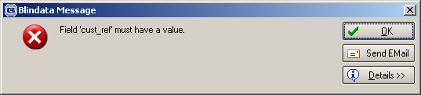

When the user goes back to the ‘General’ tab, the fields that have been changed in the ‘General’ tab are lost. They are now still there.

2749. Acknowledgement – Laser Print

If ‘Hide Totals on Order Acknowledgement’ = true in the order, then the totals no longer print on the report.

2750. Reports > Receipts By Type

The criteria form was not displaying properly. Fixed.

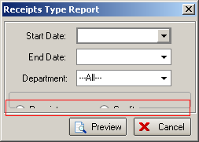

2753. Acknowledgement – Bespoke 20

If ‘Hide Totals on Order Acknowledgement’ = true in the order, then the totals do not print on the report. We have checked all the order acknowledgement reports for this.

New Work and Customer Requests

1437. Order Processing > Quotation / Orders

It is possible that a quotation may be given for a customer, and then the currency is changed for the customer. If the quotation is changed into an order or the quotation is amended, it will show the wrong price. For example, if a quote is for £100 (UK STG) and the customer currency is then changed to US dollars, then it will print out as $100 (USD). This means the quote is now for a lower amount because of the exchange rate.

To resolve this, we have made two changes. Firstly, if the customer currency rate is changed, the quotation or order now prints in the currency it was entered in. We now store the currency type against the quotation/order.

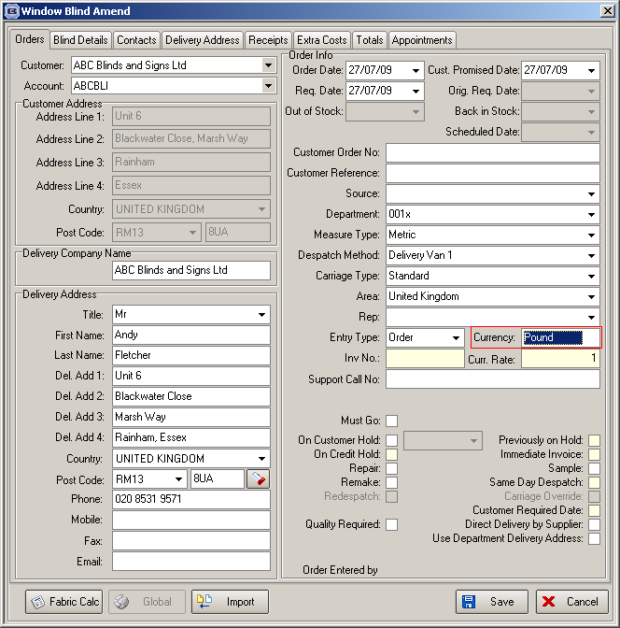

There is an advanced permission for this in Users.

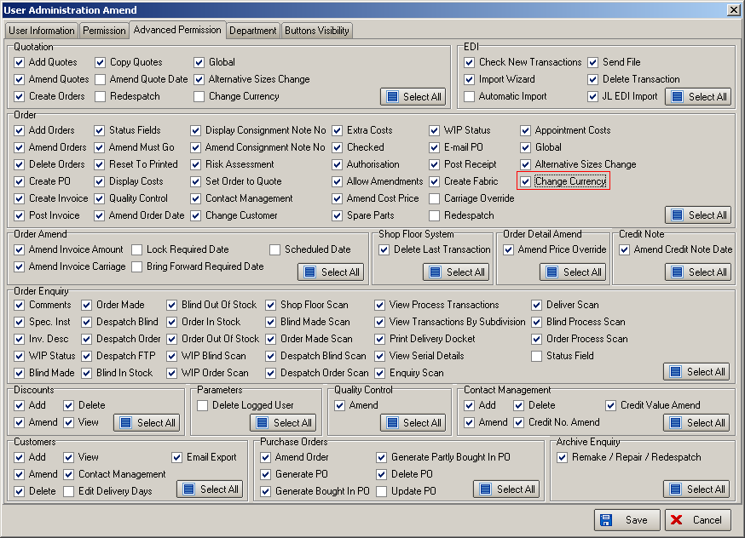

1438. Order Processing > Quotations / Orders

In the blind type record, we can set ‘Cost Price Related’ = true. When the quotation/order detail line is entered, the base price is generated from the BOM costs. We have introduced functionality to be able to alter cost prices for specific quotations/orders. This means we hold specific cost prices against stock items related to orders. There is a new table to hold order id, fabric id and cost price. When the order detail line is entered, when the bill of materials is displayed, it is possible to amend the cost prices. If a cost price is amended in the first detail line, then that cost price should be used for all subsequent detail lines entered. (The cost price in the actual stock item should remain unchanged).

The cost price can be held against the order only or against the customer record.

