Blindata Release Note 4.5.6 

10 July 2009

Bug Fixes and Enhancements

2742. Order Processing

If you entered an Eq Tap or Eq Inv Tap blind shape the program correctly calculated the LH Offset. If you then added a new blind the information from the previous blind is copied over, including the LH Offset. If you then changed the blind shape (to one that is not Eq Tap or Eq Inv Tap) the LH offset remained and is not removed. It is now removed.

New Work and Customer Requests

279. Order Processing > Order Enquiry

We now have the ability to change the status of details lines as well as that of the order. There is a new button on this form that allows you to set back the detail status.

This is required because someone may accidentally change a blind detail line to manufactured and it has to be set back to ‘Awaiting Manufacture’, for example.

There is a button for this on the ‘Order Enquiry’ form called ‘Status Field’. It has an advanced permission in Administration > Users.

301. Order History Print

It is now possible to print out the history of an order. This can be done by right clicking on the ‘History’ form.

1402. Vertical Vane Production Report

This report is required for a customer that has a Modra vertical fabric cutting machine. The report can be printed at the same time as the works orders in ‘Production Documentation’. There is a new parameter in Parameters > Report Parameters called ‘Print Modra Vertical Vane Report’. If this is set to true, then this report will print immediately after the works orders. The report only print for blind types where blind identifier = ‘Vertical’ or ‘Vanes Only’.

In the report the barcode signifies:
Size = Blind Type Code
Ref = Order Detail ID & Sequence Number,
Qty = 1 (always)
Drop = Man Drop – Headrail Depth
Slats = Number of Vanes
Temp = Fabric Temperature (from Fabrics table)
Time = Iron Time (from Fabrics table)
Usage = Quantity of fabric used

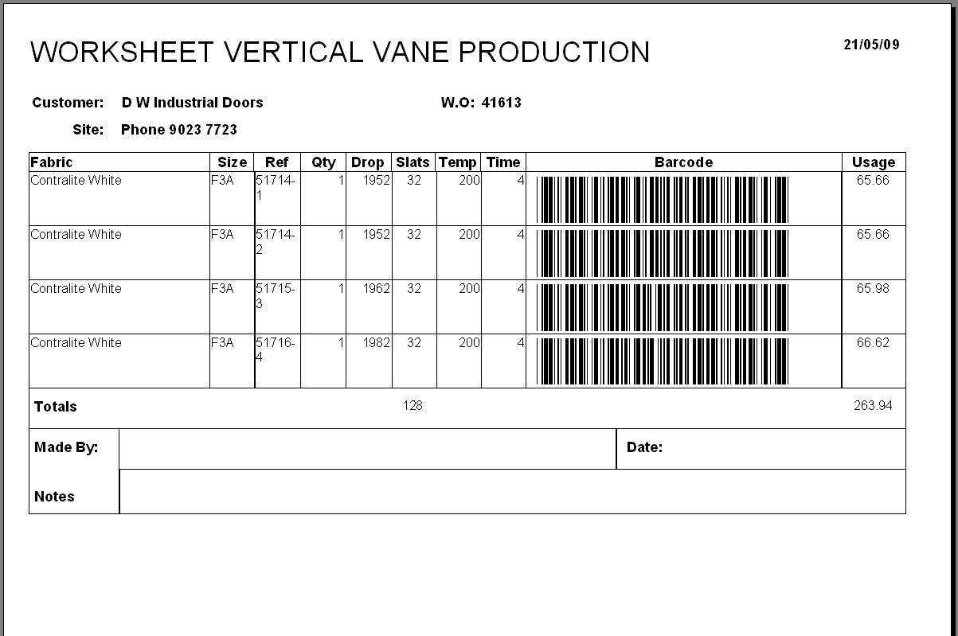

T5 = "*"
O5 = DHex(Prog, 2) Always 0A
P5 = DHex(Drop, 3) Hex of (Man Drop – Headrail Depth)
Q5 = DHex(Quantity, 2) Hex of Number of Vanes
R5 = DHex(VTemp, 1) Hex of Fabric Temperature (Fabrics)
S5 = DHex(VTime, 1) Hex of Iron Time (Fabrics)
V5 = Special Always A
BSBarCode = T5 & O5 & P5 & Q5 & R5 & S5 & V5 & T5

Example:

*0A43E15C4A*

The barcode font is ‘ABC Code 39 Regular’.

1425. EDI Import

We have a customer that wants to import EDI XML files to Blindata. The files are in the same format as our standard EDI format except that the product code will include the fabric and options as well. For example:

Product Code Blind Type Fabric Option

DEDESV35BABE 35mm Venetian Baltic Beech Tape
DEDESV35BACO 35mm Venetian Baltic Cocoa Tape
DEDESV35CHBE 35mm Venetian Chalk Beech Tape

There is a new table called ‘EDI Product Codes’ which contain fields for ‘Product Code’, ‘Blind Type’, ‘Fabric’ and ‘Option1’, ‘Option2’ and ‘Option3’.

There is a form for this in the ‘Stock Setup’ menu with the menu option called ‘EDI Product Codes’.

When the EDI import is run, it checks this table to see if any of the product codes are there. If so, the blind type, fabric and options should be selected.

1426. Sales Analysis > Sales Analysis Fabric Summary

There is a new sales analysis report called ‘Sales Analysis Fabric Summary’.

It is grouped by blind identifier. It then shows totals by supplier, then blind type, then fabric group, then fabric.

1427. New Works Order

A new works order has been created, called ‘Works Order – Bespoke 27’.

1431. Sales Analysis by Customer

We made a change in dev 1419 to ‘Sales Analysis by Customer’ to include extra fields. We have one customer that wants the original report as well as the new one. We have changed the name of the new report to ‘Sales Analysis by Customer Profit’ and the pre 1419 report is still be called ‘Sales Analysis by Customer’.

1432. Reports > System Reports > WIP Report

There is a new report in Reports > System Reports that will calculate ‘Work In Progress’ at a given point. This show a list of orders with a status of ‘Work In Progress’ at a give point along with their value. The user first has to enter a ‘Work In Progress At:’ date. The report shows order number, order date, customer, blind types (1 L89, 2 V25 style) and then the nett value.

1433. Pricing > Velux Price Table

There is new functionality to copy one set of Velux price tables to another. We can select ‘Blind Type’, ‘Velux Code’, ‘Fabric Group’ and ‘Price Code’ and copy it to another set of choices. Each choice should have an ‘All’ option. For example, we might want to copy all Velux codes and fabric groups to another blind type.

The new form can be accessed via the ‘Copy’ button on the Velux Price Table form.

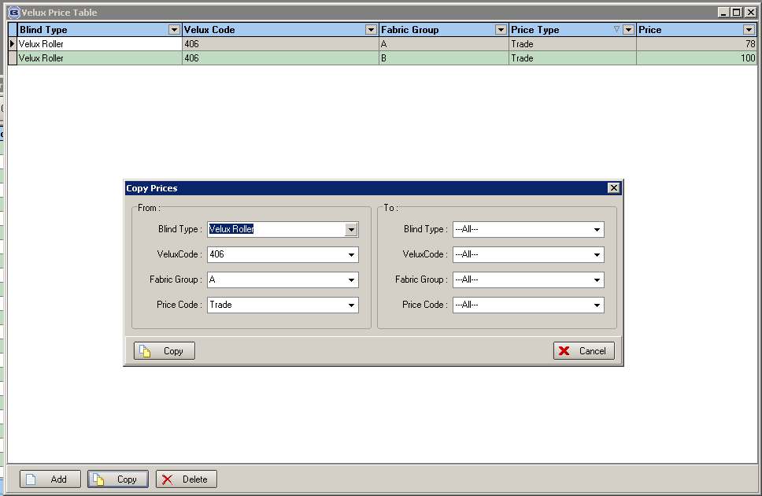

1434. Sales Analysis by Department by Customer by Fabric

There is a new sales analysis report called ‘Sales Analysis by Department by Customer by Fabric’.

The report is separated and grouped by blind identifier.

1435. Sales Analysis by Fabric

There is a new sales analysis report called ‘Sales Analysis by Fabric’.

The report is separated and grouped by blind identifier.

1436. Invoice – Bespoke 28

There is a new invoice layout called ‘Invoice – Bespoke 28’..

