Blindata Release Note 4.5.4 

19 June 2009

Bug Fixes and Enhancements

2737. Stock Setup > Purchase Order Enquiry > Generate Bought In PO

It was not possible to generate a bought in PO in this form because the ‘Direct Delivery To Supplier’ was set to true in the sales order. It is now possible to do this.

New Work and Customer Requests

1421. Order Processing > Orders

If an order is flagged as ‘Same Day Despatch’, then it is now possible to set it to a particular despatch method. We have done this by having a flag against the ‘Despatch Method’ record called ‘Same Day Despatch’. Only one of the records in the ‘Despatch Method’ table can have ‘Same Day Despatch’ = true.

If an order is entered (or imported via EDI) and ‘Same Day Despatch’ = true, then if a despatch method record has ‘Same Day Despatch’ = true, that despatch method is used for the order.

1422. Order Processing > Order Enquiry > Blind Scan

When the last blind in an order is scanned as ‘Blind Made’, the user is asked if they want to change the manufacturing date in the order. We have had a request from a customer that does not want to see this form to change the date ie the order should just be changed to status ‘Order Manufactured’ and the manufactured date = current date.

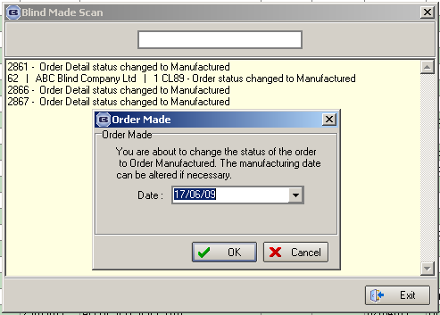

Therefore we have created a flag in the Parameters table called ‘Auto Set Manufacturing Date in Scan’. If this is set to true, then the ‘Order Made’ form with the date prompt is not displayed.

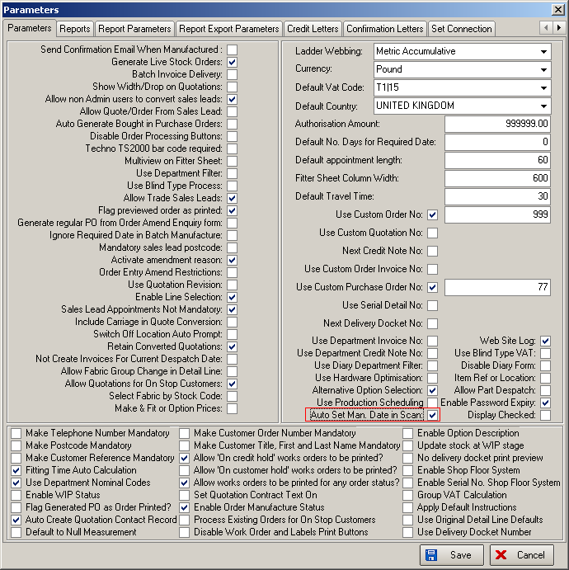

1423. Invoice – Bespoke 12

The contents of boxes 1 and 2 have been swapped around ie 1 is now where 2 is, and 2 where 1 is.
