Blindata Release Note 4.5.3 

12 June 2009

Bug Fixes and Enhancements

2731. Invoice – Batched by Cust

- The totals now only print on the last page.
- The page number has been moved up a bit.

2732. Receipt Report

If the title has been entered, it now appears in front of the contact name.

New Work and Customer Requests

1408. Raytech Table Generation

Phase 1

We have created a new table in Blindata called ‘CuttingTableDetails’. The table has the following records and is required for passing data to the Raytech table PC.

FabricStockCode | Stock code from Blindata |  | [Text - 50]
Batch_Code | Batch No generated from Blindata fabric optimisation |  | [Text – 8]
Job_Code | Order number (Order_id) from Blindata |  | [Text - 15]
Date_Required | Required/Scheduled Date from Blindata |  | [DateTime]
LineItemIndex | Serial number from Blindata |  | [Number - Long]
CutWidth | Blind cut width in mm |  | [Number - Single]
CutDrop | Blind cut drop in mm |  | [Number - Single]
RaytechStockCodeUpdated | Set to Yes by Raytech when StockCode updates identified |  | [Yes/No]
RaytechStockCodeAdded | Set to Yes by Raytech when new StockCode added |  | [Yes/No]
LineItemImportedByRaytech | Set to Yes by Raytech when new items imported |  | [Yes/No]
RaytechTransactTimestamp | Raytech sets date when transaction occurs |  | [DateTime]

1413. Order Processing > Production Lists > Production List Summary By Day

There is a new production report called ‘Production List Summary by Day’. This report show the number of blinds that need to be manufactured, by day across the way. Anything that is greater than 5 days goes into the ‘Future’ column. It is grouped by blind identifier then blind type.

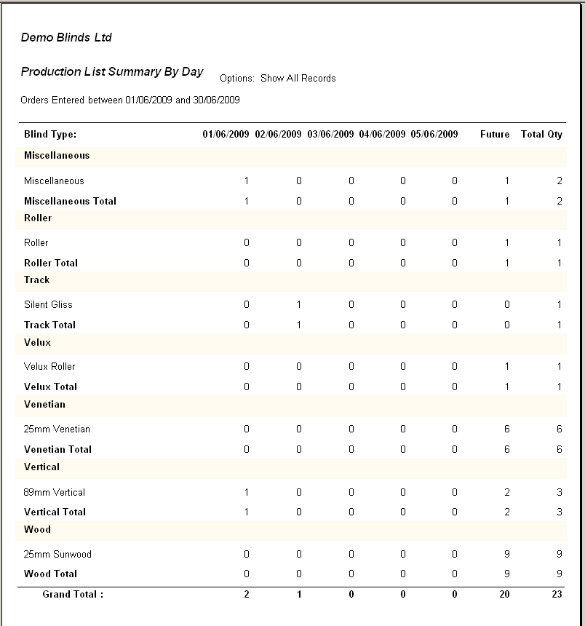

1415. Order Processing > Production Lists > Production List Summary

The report is now grouped by blind identifier and has sub totals by blind identifier.

1417. Blind Details > Blind Types

There is a new flag called ‘Exclude From Reports’. This should be placed here.

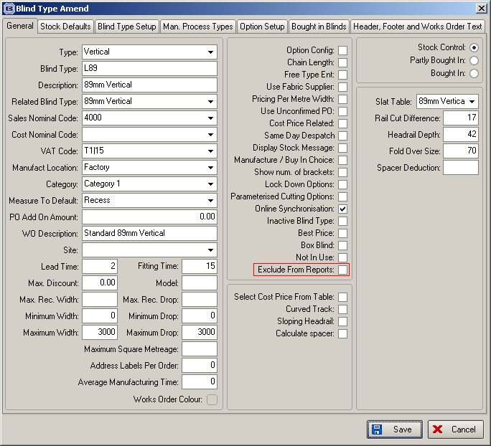

If this is set to true, then these blind types do not appear on any of the ‘Production List’ or ‘Sales Analysis’ reports.

1418. Reports > Stock Valuation Report

We have changed this report completely. The criteria for the report is now blind type (with choice for all) and by supplier (with choice for all).

There are also options to group by blind type or supplier.

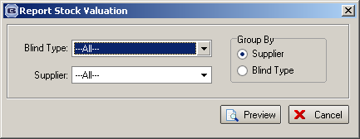

The report shows stock code, stock description, unit of sale, cost price, quantity, stock value (cost price * quantity).

1419. Sales Analysis > Sales Analysis by Customer

Instead of only a column for ‘Actual Nett’, the columns are now the same as those used in ‘Sales Analysis’ ie Sales Value, Cost, Profit, Sales Quantity, Sales Value %.

