Blindata Release Note 4.5.2 

5 June 2009

Bug Fixes and Enhancements

2725. Reports > Sales Analysis

The width and drop now default to 9999 (no comma ie not 9,999).

2726. Sales Analysis Reports > Sales Analysis by Blind Type

The ‘Sales Value %’ column is now lined up properly.

2727. EDI Import

When an order is entered on Blindata Online, and then imported via EDI, the user name in the ‘Order History’ is now ‘EDI Import User’, not whoever was logged in.

2729. EDI Import

When an order is imported via EDI from Blindata Online, the order and order history are now being updated properly. The order ‘Operator Name’ is ‘Online Customer’.

The order history ‘Login User’ is the account code for the online customer.

2730. EDI Import

If an order has been entered online with Imperial measurements, it was not importing properly. The order was entered as 45.25 width and 34.5 drop, but it had imported as 4525 and 345. Fixed.

New Work and Customer Requests

1401. Sales Files > Customers

There is now an option called ‘Show Prices On Delivery Docket’ held against the customer. Previously when an order was entered, the default for ‘Show Prices On Delivery Docket’ was taken from Parameters. The program now also looks at the Customers record to see if it is different. The default for this field in the Customer record is the same as the Parameter record.

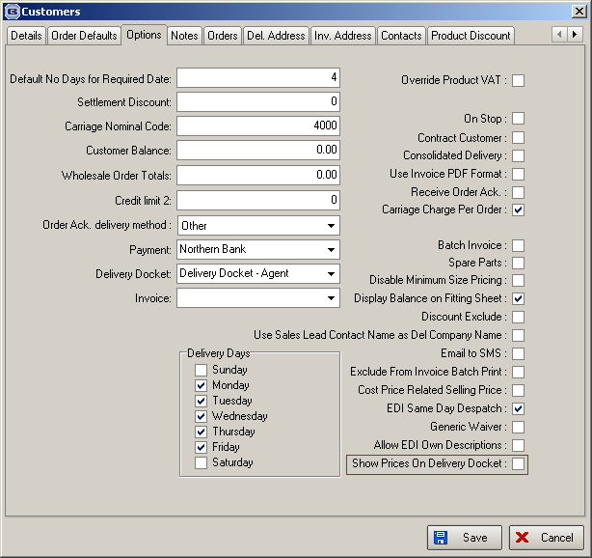

1404. Order Processing > Orders > Scheduled Date

The scheduled date is not calculated if it is an order where the number of blinds exceeds the ‘Maximum Scheduling Number’ held against the manufacturing location. It must therefore be entered manually.

1410. Blind Types > Link Options

There is a ‘Duplicate’ button in the middle form.

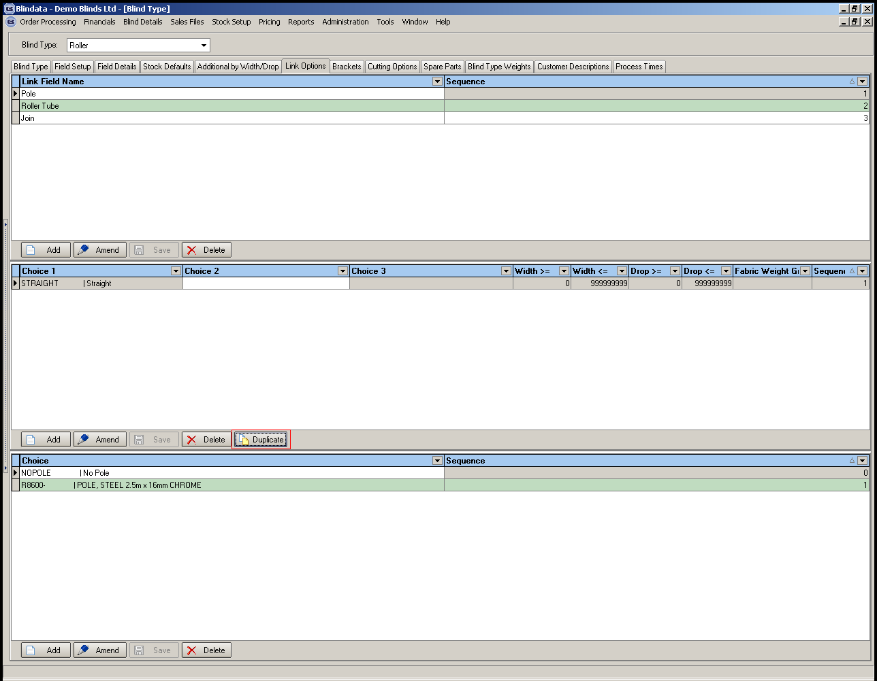

When this is selected, the user is able to select another stock item. This will then be stored in the middle section, and all the stock items held in the bottom third will be copied to the new item.

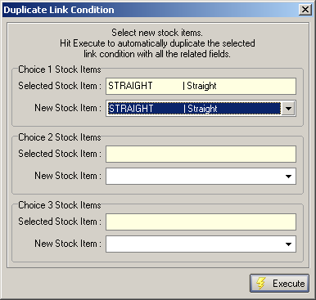

1411. Order Status ‘Order Made’

We have removed the status ‘Order Made’, as it is the same as ‘Order Manufactured’.

