Blindata Release Note 4.5.1 

29 May 2009

Bug Fixes and Enhancements

2716. Delivery Docket - Agent

The VAT number on this report is now taken from the customer record, not the ‘Company Details’ record.

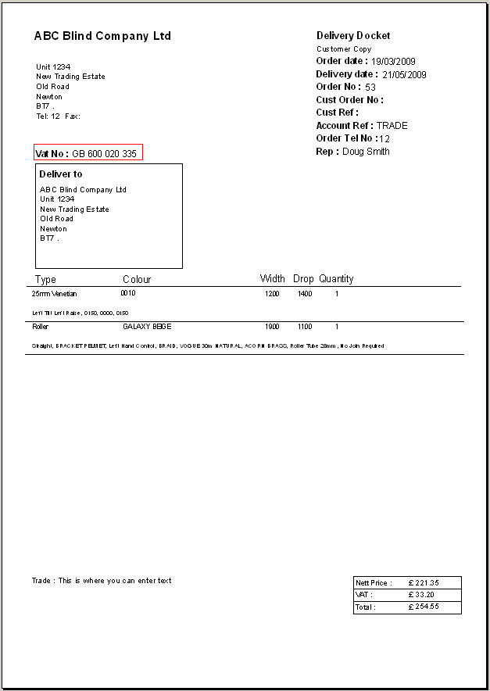

2717. Invoice – Bespoke 2

The contract text was printing twice on this invoice. It now only prints once.

2718. Production Lists > Production List Summary

The totals were printing one line too low. Fixed.

2721. EDI Import

An order that has been imported via EDI from Blindata Online is now not ‘Checked’ if there are special instructions in any of the detail lines and ‘Display Checked’ is switched on in Administration > Parameters.

2722. EDI Import

An order that has been imported via EDI from Blindata Online is now not ‘Checked’ if the large quantity is exceeded (in manufacturing location).

New Work and Customer Requests

1399. Delivery Docket – Bespoke 26

There is a new delivery docket layout called ‘Delivery Docket – Bespoke 26’.

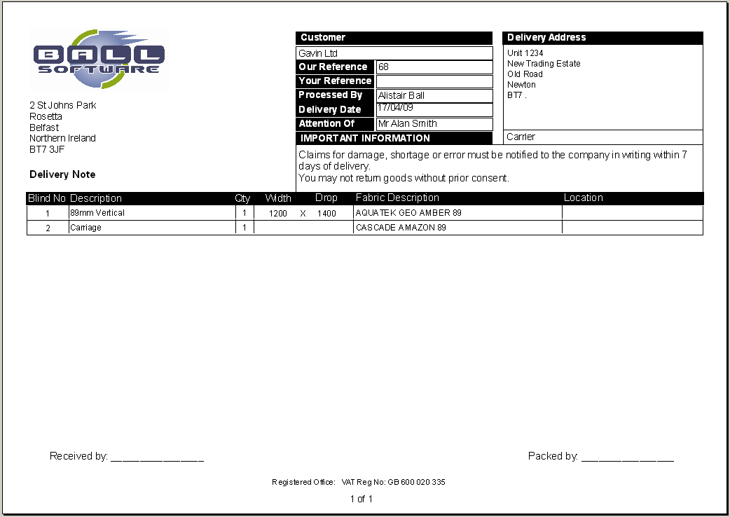

1400. Sales Files > Customers > Secondary Price Table

We now hold a ‘Secondary Price Table’ against the customer record. If there is a price table or an option price table held in the system, then it is used instead of the main price table. The reason we want to do this is so that a specific price table can be used for a customer for a specific blind type or option.

Example: a customer has ‘Trade’ as the standard price table and ‘Trade Special’ as the secondary price table. There are price table for blind type = Roller for price code = Trade and another price table for blind type = Roller and price code = Trade special. There are also price tables for blind type = 89mm Vertical and price table = Trade, but no price code = Trade Special. This customer will then have roller prices taken from the ‘Trade Special’ table and 89mm Vertical prices taken from the ‘Trade’ price table. The same logic applies to the option price tables.

The same logic has been applied to the EDI import.

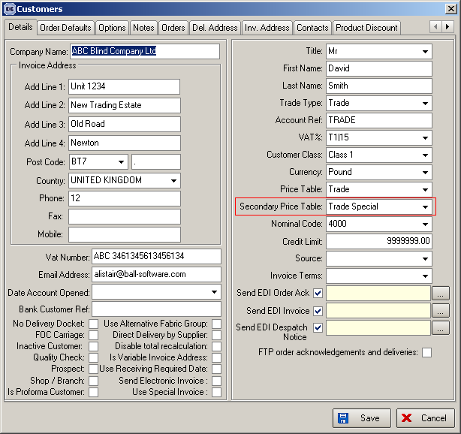

1403. Order Processing > Production Lists

There is now an option to enter start and end ‘Scheduled Date’ as well as order date and required date for the Production List reports. All the reports have been changed so they can be printed by ‘Scheduled Date’ as well as ‘Order Date’ and ‘Required Date’.

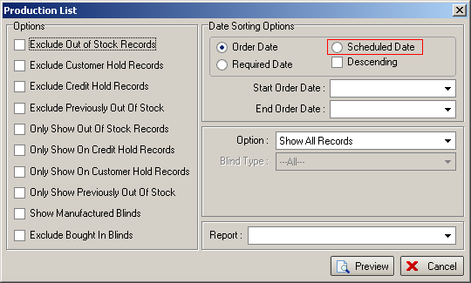

1405. Display Of Currency Sign On Forms

We have one client that uses a mixture of Euros and Sterling, depending on the customer. We have therefore removed the currency sign from all forms. The reports remain the same.

1409. Works Order – Label 1

For ‘Repairs’, the comments now print where the special instructions print for normal detail lines.

