Blindata Release Note 4.5.0 

22 May 2009

Bug Fixes and Enhancements

2714. Acknowledgement – Laser Print

If ‘Hide Detail Line Discount’ is switched on in the Totals tab, the price and discount percentage in the option price no longer appear in the detail line.

2715. Order Processing > Quotations / Orders > Global

If a detail line is entered as an ‘Imperial’ measurement and then ‘Global’ is used to change the blind type and the fabric, an error occurred. Fixed.

New Work and Customer Requests

549. Quotations / Orders > Import Detail Lines from Spreadsheet

A button has been created on the ‘Quotation/Order Entry’ form so that detail lines can be imported from a spreadsheet. This is required because sometimes very large quotes/orders have to be done with a lot of detail lines and they are sent to the Blindata customer in a spreadsheet. The spreadsheet has the following layout:

Blind type code, Measure To, Fabric Code, Width, Drop.

The records will be imported with default options and default metric/imperial (from the customer record). The import rules are the same as the import EDI functionality and a log file is produced for any sizes that won’t import. The log file prints in a window with the spreadsheet cell number (similar to the log that is produced in the Import from Excel routine).

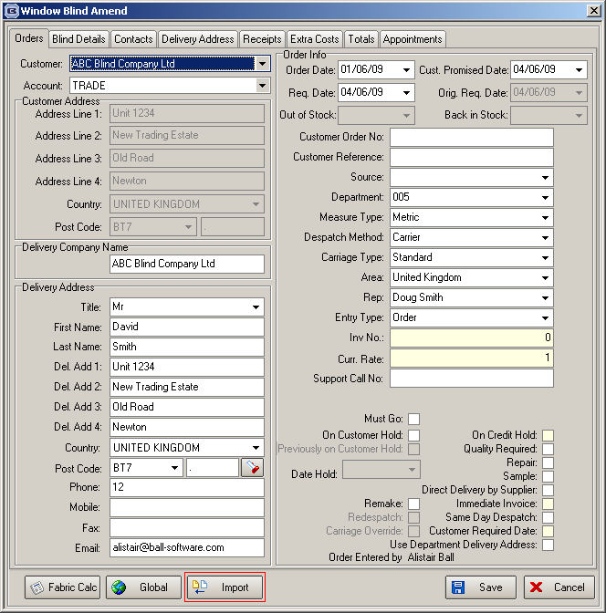

1386. Maintenance Invoicing

There is now functionality for maintenance invoicing. For example, if you offer a service where maintenance is carried out on an item after it has been sold (eg an awning) after a certain period of time, then the timing of the work can be stored and an invoice generated.

This is done by entering a contact management record against the order. This could be entered against an order that has any status from ‘Order Entered’ to ‘Invoice Posted’. A new action type called ‘Maintenance’ (1) (2) could be created so all maintenance records can be identified. We will also need to store a monetary value. This could be held in the current ‘Credit Value’ field (3).

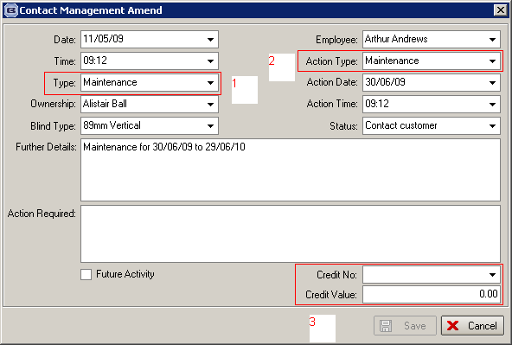

There is a new report which will show all records between two action dates that are for maintenance. This is held in Reports > System Reports and is called ‘Maintenance Records’. The report shows ‘Action Date’, ‘Customer’, ‘Further Dates’.

An appointment can then be created for the maintenance record by using ‘Assign to Service’ This can be done with the existing functionality.

There is a new button on the Contact Management form called ‘Create Invoice’ so an invoice can be created from the contact record. This will create an order that has a status of ‘Invoice Created’ and will have an invoice number. There will be a detail line that will be a miscellaneous item – we need to have a stock item called ‘MAINT’ that could be used as the fabric code. The ‘Further Details’ from the contact record will then be copied into the ‘Invoice Comment’ field in the order detail line.

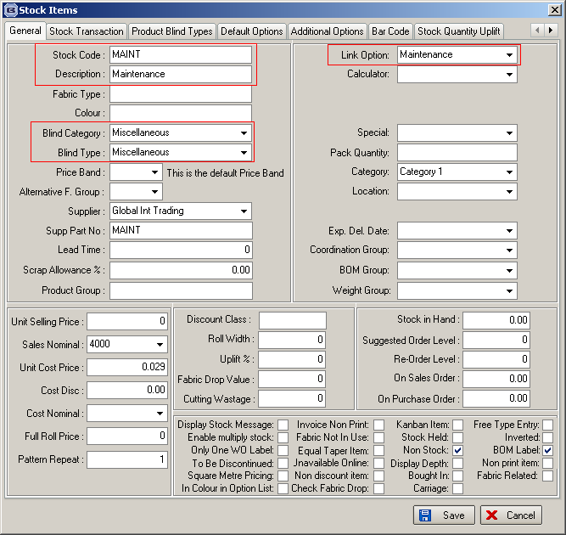

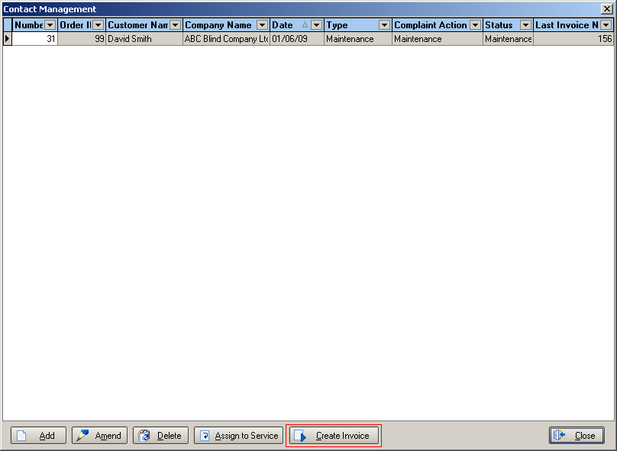

1394. Production Scheduling Phase 2

If Administration > Parameters > ‘Use Production Scheduling’ is set to true, then the scheduled date is calculated by the following method.

When the order is saved, the manufacturing time for making the blind is calculated. This could check two places because we can either hold the manufacturing time against the blind type record (Average Manufacturing Time) or hold the process times for the blind type in Blind Types > Process Times. If there are no records against the blind type process time, then the average manufacturing time is used.

The program then checks the first available time that the blind can be made when the detail line is being saved. We work out the next available manufacturing time by looking at the availability in the schedule. This is done by checking the average manufacturing time for the blinds in the order by manufacturing location and then using the latest manufacturing time as the scheduled date. We also take into account whether the order is for a same day despatch or not.

The scheduled date is not calculated if the order detail line is flagged out of stock. Once the detail line is flagged as being back in stock, the scheduled date is then calculated.

