Blindata Release Note 4.4.9 

15 May 2009

New Work and Customer Requests

1391. Works Order A4 Individual 2

A new works order has been created called ‘Works Order A4 Individual 2’. It is based on ‘Works Order A4 Individual’ but includes manufacturing time and some layout changes.

1392. Sales Files > Customers > Preview Labels > Customer Label 4” x 2”

When you print label ‘Customer Label 4” x 2” ‘ here, it is also possible to print the entered contact name on the label.

1393. Blind Types > Process Times tab

There is a new tab on the Blind Types form called ‘Process Times’. This is used to store manufacturing times for process types. It is very similar to the ‘Blind Type Weights’ form, except we add records for ‘Process Type’ instead of ‘Fabric Weight Group’ and then enter minutes in the grid instead of weights.

1395. Order Enquiry > Blind Process Scan / Order Process Scan

There is now an employee lookup in these forms in the same way as in the ‘Blind Made Scan’ and ‘Order Made Scan’ forms. When the scan is done, the employee is saved in the process transaction record.

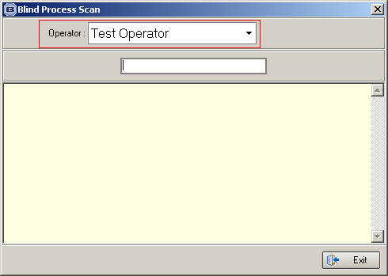

1396. Fabric Drop Value

On Perfect Fit Rollers there are drop restrictions on some fabrics because of the thickness of the fabric when rolled up which hinders the operation. ‘Perfect Fit’ is normally set up as an option so we now have a flag against the option to indicate that the fabric thickness should be checked.

We have used the ‘Cloth Weight’ field in the stock record because it is not used for anything else. It has been renamed to ‘Fabric Drop Value’. The maximum drop should be entered here. There is also a new field called ‘Check Fabric Drop’. If this is set to true for an option, then the order detail entry check the value held in the fabric ‘Fabric Drop Value’ stock item record. If it is less than the entered drop then a message appears saying ‘The maximum drop for this fabric with this option is n (where n is the ‘Fabric Drop Value’ value).

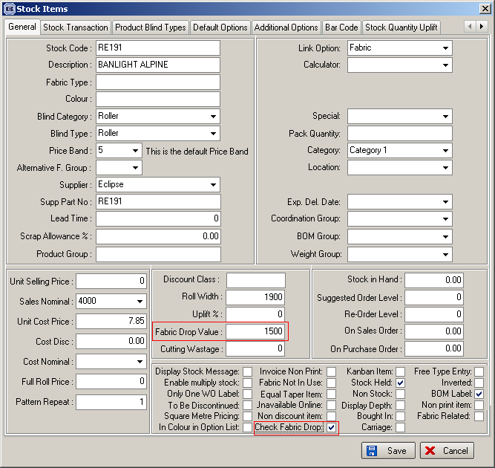

1397. Stock Setup > Fabric Group Setup > Update (All Buttons)

This warning message is now in two parts, as we have had a couple of users make big mistakes here. There is a further message that says ‘This is going to change ALL the records you have selected, and the change is irreversible. Do you want to continue?’.

