Blindata Release Note 4.4.8 

8 May 2009

Bug Fixes and Enhancements

New Work and Customer Requests

882. Order Processing > Orders

It is now possible to pick the contact name from the customer in the quote/order. Previously the contact name was picked up from the customer record, unless it had been copied through from a sales lead.

There is a facility to select the contact name from the list of contact names that are held against the customer record.

There is now a tab on the form for ‘Contacts’, so we can select a contact in the same way that we select a delivery address. The ‘Contact’ tab is between the ‘Blind Details’ tab and the ‘Delivery Address’ tab.

When a contact is selected, the first name and last name is updated (we split the field into first and last name) and if there is an email address held against the contact, it is updated to the quotation/order as well.

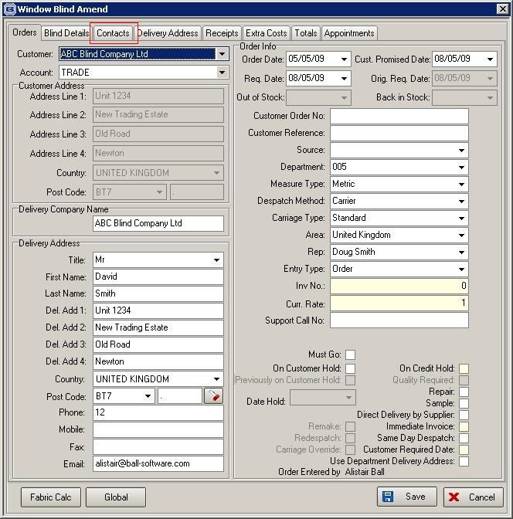

1119. Production Scheduling

We want to start holding a ‘Scheduled Date’ for each detail line when we enter an order. We need to be able to calculate scheduled dates from required dates when entering orders by analysing how much production capacity is available. We will do this by storing the minutes available and the minutes already used up for production for days. We need to make sure this does not have an impact on performance when entering orders. Therefore we need to decide if the ‘Scheduled Date’ should be held against the order detail line or in a separate table. If ‘Display Checked’ is ticked, the scheduling should only be done when the order is flagged as checked.

The following changes have been made.

Phase 1

Administration > Parameters

A new parameter has been created called ‘Use Production Scheduling’. If this is set to true, then the scheduled date calculation will be done when the order is saved as checked if ‘Display Checked’ = true or just saved if ‘Display Checked’ = false.

We also hold a field called ‘Maximum Scheduling Number’. This holds the maximum number of blinds that can be in an order for production scheduling. If the blinds in the order exceed this number, then the scheduling should be done manually.

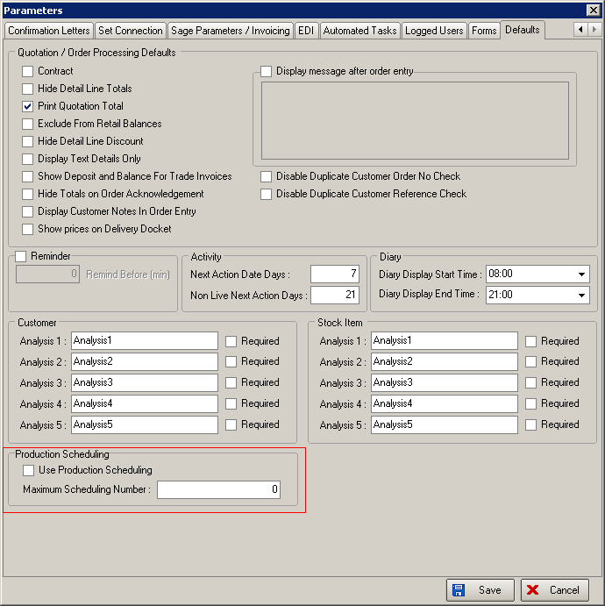

Administration > Manufacturing Location

It is now possible to hold dates and time (in minutes) for normal orders and also Same Day Despatch orders against manufacturing locations.

There is also a method of filling dates in advance. The system now holds default values against the manufacturing location for ‘Normal’ and ‘Same Day Despatch’ minutes. There is a facility to ‘fill’ the minutes from a start date to an end date with the defaults.

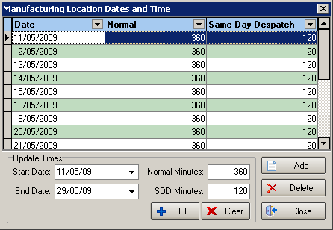

Blind Details > Blind Types

There is a new field called ‘Average Manufacturing Time’. This holds the average number of minutes it takes to make a blind.

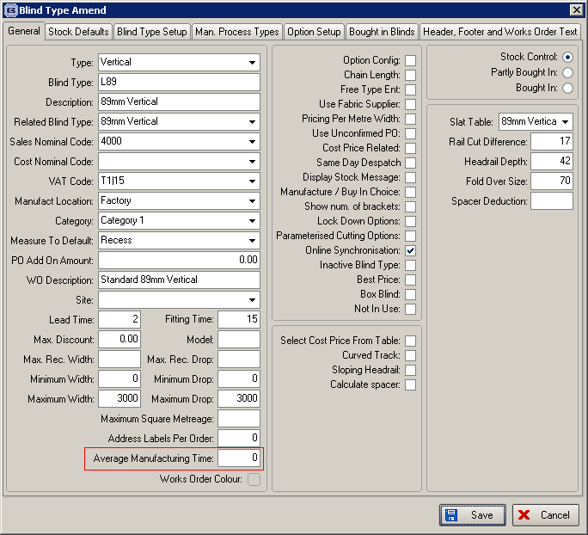

1284. Blind Details > Blind Types > Bought In Blinds

There is now a ‘Save’ button on the ‘Bought In’ tab.

1302. Pricing > Option Price Enquiry

There is a new button on this form so we can export option prices in the same format as the option price import in Administration > Import from Excel > Option Price Table.

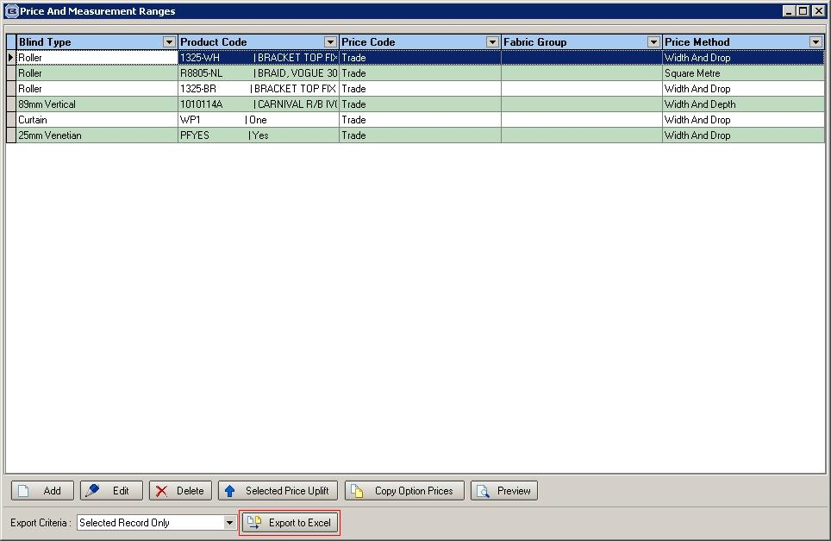

1387. Financials > Post Invoices to Sage

If a customer has ‘Batch Invoice’ = true, when the orders are posted to Sage, they are now grouped and posted by invoice number. So if two orders have the same invoice number, they will appear as one sales transaction in Sage. At the moment they are posted as two transactions.

1389. Order Processing > Orders / Quotations

The flags that appear in the Totals tab have been tidied up.

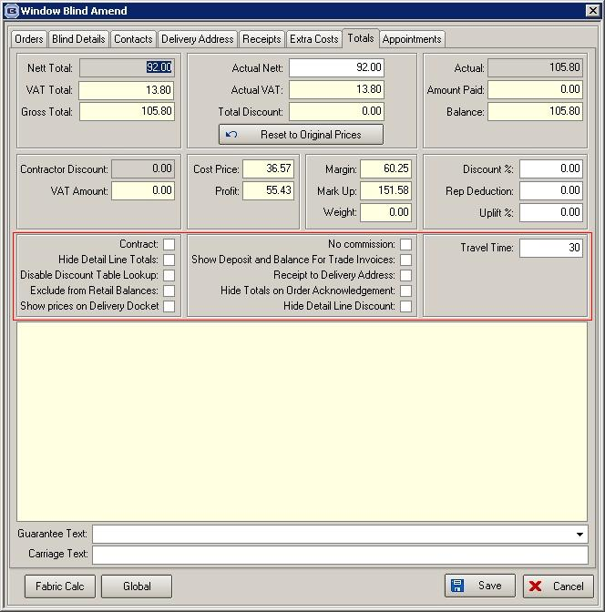

1390. Administration > Parameters > Report Parameters

There is a new parameter called ‘Print Contact Name on Acknowledgement’. If this is set to true, then the contact name will print on the bottom left of ‘Order Acknowledgement – Laser’.

