Blindata Release Note 4.4.6 

24 April 2009

Bug Fixes and Enhancements

2693. Box Assembly Report

The detail lines now print out in the same order as those in the ‘Hardware Cutting Sheet’.

2698. Order Processing > Orders

If you enter an order like this, with no options that have ‘Equal Taper Item’ = true, the LH Offset Width does not get recalculated as being equal to the RH Offset Width.

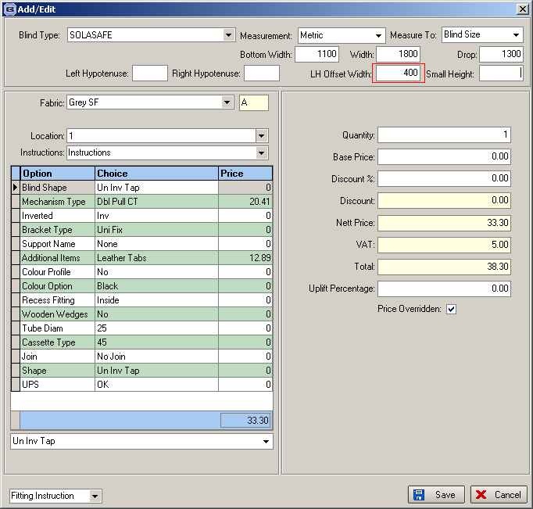

2699. Works Order – Landscape Metric

The vane length is now correct. It is:

Vane length = Man Drop – Headrail depth. In this example, headrail depth = 40, Fold over size = 100, Recess to Blind Size diff = 10, so Vane length = (1400 – 10) – 40 = 1350.

2700. Label Print – 3 ½ x 1 – Standard

If blind identifier = ‘Headrail Only’, the ‘Headrail Cut’ figure now appears (similar to blind identifier = Vertical).

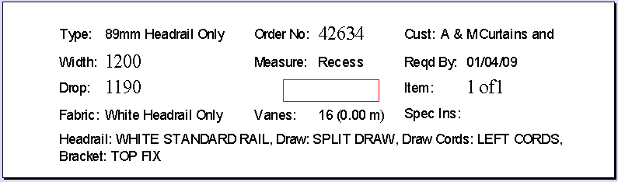

2702. Quotation – Bespoke 21

The title field has been removed from contact name.

2703. Invoice – Bespoke 15

In the batch print of this report, the logo printed out too small. It now prints out the same size as it does in the individual invoice print.

2704. Film Cutting Sheet

If the shape is ‘Eq Tap’ or ‘Eq Inv Tap’, it now prints the LH Offset Width and RH Offset Width on this report.

2705. Order Processing > Quotations > Copy Quotation

When you copied a ‘live’ quotation, the next contact date was being calculated from the ‘Non Live Next Action Days’ in Administration > Parameters > Defaults. It is now calculated from ‘Next Action Date Days’.

New Work and Customer Requests

1381. Order Processing > Orders > Receipts Posting

When a receipt is posted to Sage, it displays a message ‘Receipt posted successfully to Sage’. This message has been improved so it shows the transaction number in Sage, the customer account in Sage that it has been posted to, and the bank nominal code it has posted to.

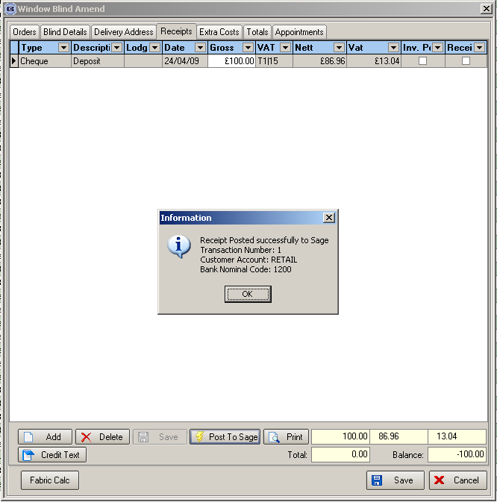

1383. Email PDF Name

When an email is sent out by Blindata, the pdf name is now the company name (from Company Details). In this case it should be ‘Demo Blinds Ltd Quotation 8.pdf’. This should apply to all pdfs that are sent.

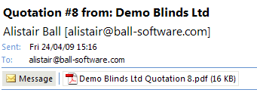

1384. Export Orders / Invoice For Customs / Invoice For Payment Prints

In all these reports, if the customer record has ‘Is Proforma’ = true, the reports now print ‘The above total is due now’ instead of the text in the rectangle.

