Blindata Release Note 4.4.5 

21 April 2009

Bug Fixes and Enhancements

2686. Order Processing > Orders

The bill of materials was calculated incorrectly for a roller blind with an option where the calculator = Drop, and the width of the blind entered > roll width of the fabric used. Fixed.

2688. Partly Bought In Purchase Order

- The ‘Width’ and ‘Drop’ no longer appear if ‘Parameterised Cutting Options’ = true.
- The quantity is now the quantity from the order detail line.
- If ‘Show Cost Price on PO’ = false in Report Parameters, then the cost price does not print.

2689. EDI Import

If EDI orders are set to import automatically, then EDI orders that have detail lines with options that have not been mapped previously, do not get mapped. Previously they were mapped to the default.

2690. Works Order – Landscape Metric

- The ‘Vane Length’ calculation was wrong. It is now Exact Drop – Headrail Depth.

2691. Works Order – Landscape Metric

The ‘Headrail Cut’ calculation is now correct if ‘Blind Identifier’ = ‘Austrian/Roman’.

2692. Order Processing > Quotations

If you copied a quotation, when you looked at the batch number on the copied quotation detail lines, it started at 2. It now starts at 1.

2694. Order Processing > Orders

If you entered an Eq Tap or Eq Inv Tap blind shape the program correctly calculates the LH Offset. If you then added a new blind the information from the previous blind is copied over, including the LH Offset. If you then changed the blind shape the LH offset remained so if the user forgets to take out the offset, then the LH Offset is printed on the documentation causing confusion.

If the ‘Blind Shape’ option is changed to one where, in the stock record ‘Equal Taper Item’ = true, the LH Offset figure is now removed (ie blank).

2695. Quotation Technical Sheet

If the blind shape is for an item that has ‘Equal Taper Item’ = true in the stock record, then the LH Taper Offset is no longer printed.

2696. Export Order / Invoice For Payment / Invoice For Customs

The title has been removed from the contact name.

2697. Export Despatch Note

The fields below the delivery address now have the same layout as the export order.

New Work and Customer Requests

854. Blind Details > Blind Types

This form has been redesigned. The fields now look like this.

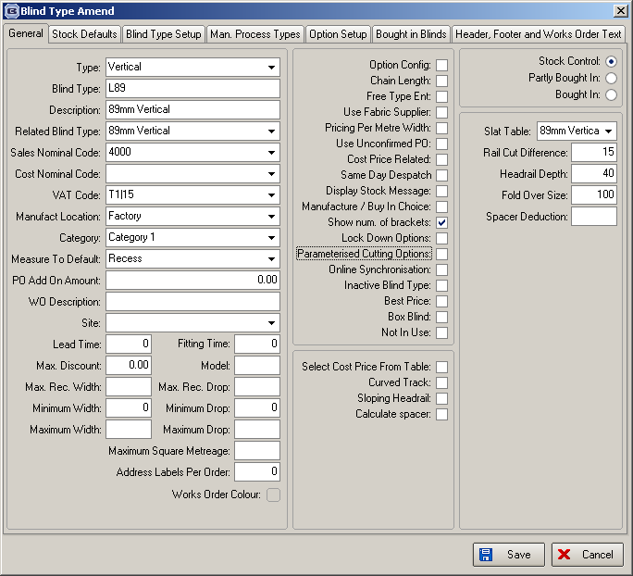

1368. Delivery Docket – A4 Preprinted

The ‘Delivery Notes’ now appear on the report, in the bottom left.

1369. Delivery Docket – Customer Special

The ‘Delivery Notes now appear on this report.

1370. Acknowledgement – Laser Print

If ‘Print Stock Code on Invoices’ is switched on, then the stock code now prints in front of the stock description if blind identifier = Miscellaneous.

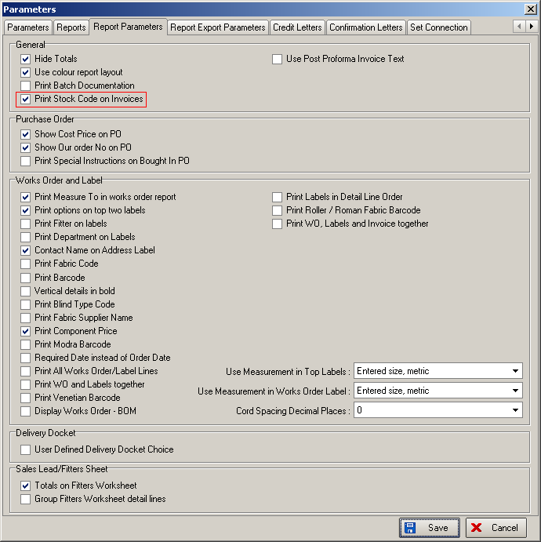

1371. Delivery Docket – Laser Print Non Itemised

If ‘Print Stock Code on Invoices’ is switched on, then the stock code now prints in front of the stock description if blind identifier = Miscellaneous.

1372. Sales Analysis by Customer by Quarterly Comparison 2

There is another version of ‘Sales Analysis by Customer by Quarterly Comparison’ called ‘Sales Analysis by Customer by Quarterly Comparison 2’. The columns for ‘% Diff’ have been replaced by a ‘Diff’ column which is just the actual difference between Q1 and Q2 (Q1 – Q2) etc.

1373. EDI File

The ‘Delivery Notes’ field is now included in the EDI file that is created. It is now possible to import the ‘Delivery Notes’ in the EDI import.

1374. Order Processing > Orders

Functionality has now been introduced for handling large orders. There is a new field created in System Tables > Manufacturing Location called ‘Large Quantity’, which is an integer. This defaults to zero.

If a single order comes in where the number of blinds exceeds the quantity set on the manufacturing location, the order processor should check with the factory in case the required date will need to be manually amended. When the user clicks save, Blindata checks if the order has any ‘large quantities’. If so a warning appears stating the order has a large volume and the required date should be checked with the factory. The message says ‘This is a large order. Please check with production to confirm the required date’. If the ‘Manufacturing Location’ quantity is set to zero, then this logic does not apply.

1375. EDI Import

If special instructions exist in a detail line of an EDI order then when the order is imported it is not flagged as ‘Checked’.
Orders imported with large quantities (see dev 1374) are not be flagged as checked.
Any orders created via EDI that have a special carriage type (ie NOT Standard) are flagged as ‘Must Go’.

1376. Password Expiry

It is now possible to set the number of days to the next expiry date in the User record.

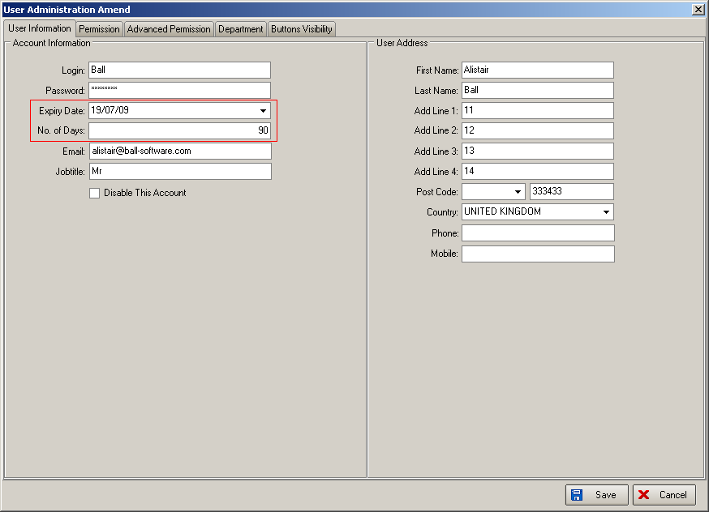

When the ‘Enable password Expiry’ is switched on in Parameters, the default of 90 days should remain.

1377. Order Processing > Production Documentation

There is a new system table called ‘Site’. This field is also held against the blind type records (but is not mandatory). The purpose of holding this field against the blind type is so that reports in ‘Production Documentation’ can be run by ‘Site’.

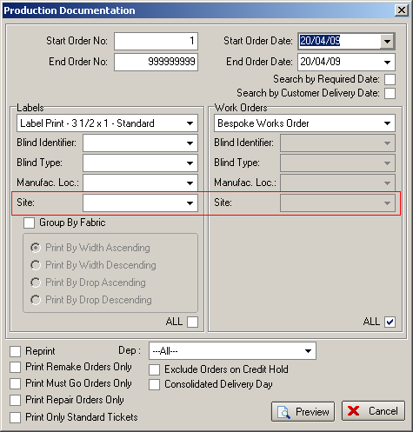

1379. Bespoke Works Order

The ‘Cutting Sizes’ are now printed on this report.

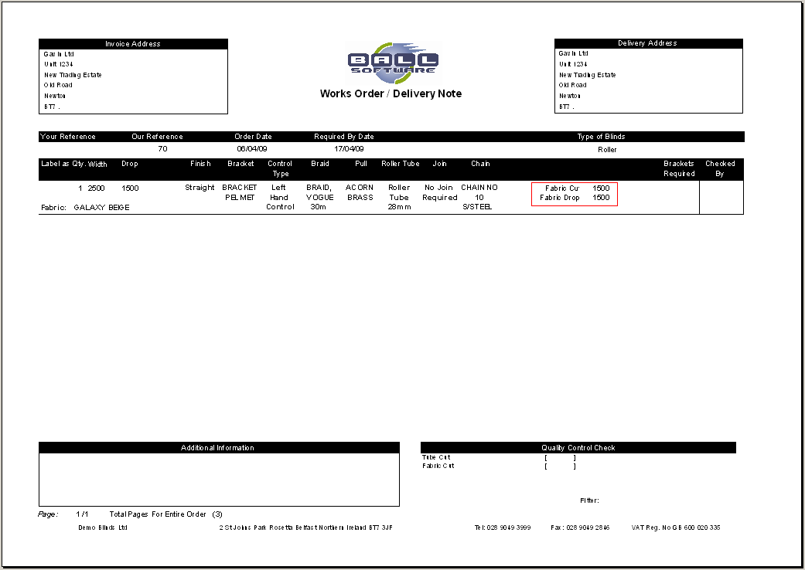

1380. Reports > Stock Usage Report

There are new columns for ‘Unit Cost Price’, ‘Total Cost’ and ‘Total Purchase Cost’ on this report. There are also sub totals and grand totals for ‘Total Cost’ and ‘Total Purchase Cost’.

