Blindata Release Note 4.4.4 

10 April 2009

Bug Fixes and Enhancements

2676. All Reports

The report now says 100% complete when it is complete.

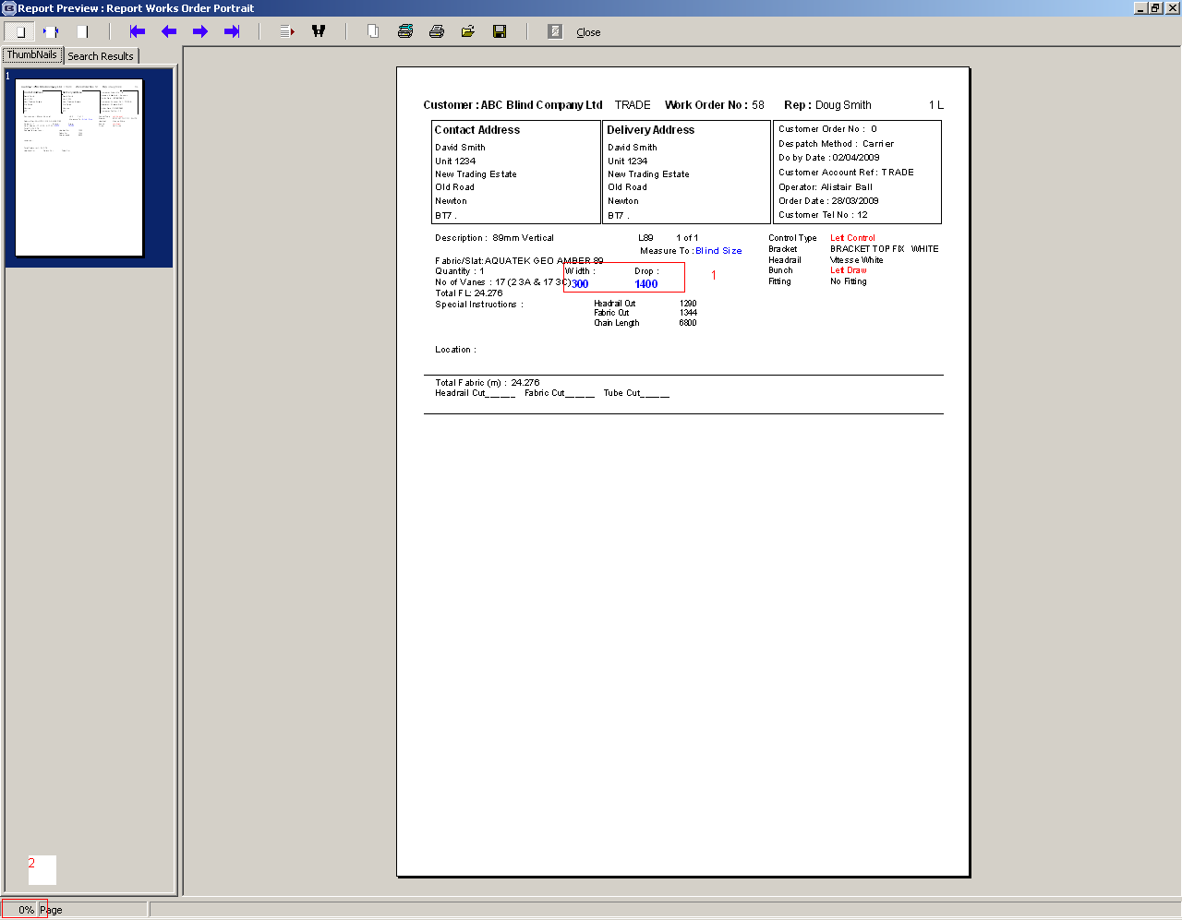

2687. Works Order – Landscape Metric

If blind identifier = Austrian/Roman, ‘Vane Length’ no longer appears on the report.

New Work and Customer Requests

1358. Stock Setup > Fabric Group Setup

There are now two more fields that can be updated here: ‘Unit Cost Price’ and ‘Cost Disc’.

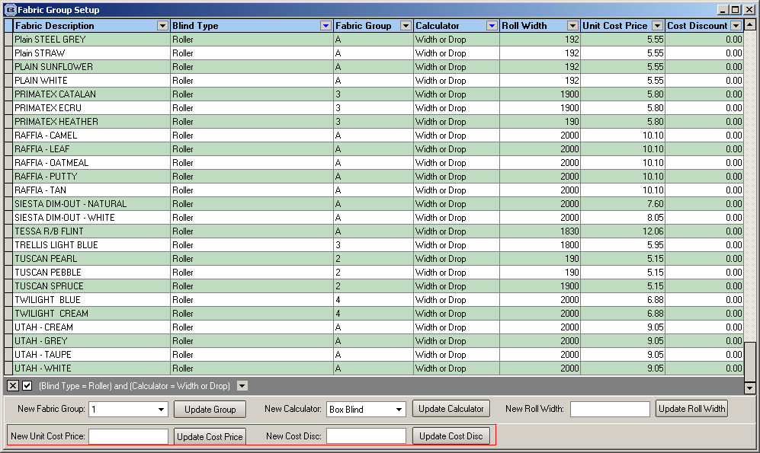

1359. Reports > System Reports > Customer Product Discount

There is a new report called ‘Customer Product Discount’. This prints all the discount records that are held against customers in the ‘Product Discount’ tab.

The report is grouped by customer, and then shows Product Description / Category, Quantity, Price / Percentage Discount.

It is possible to select by customer or choose all.

1360. Reports > Action Required Reports

There is a new menu option that displays a form that will give a snapshot of the progress of sales leads, quotations and orders within the system.

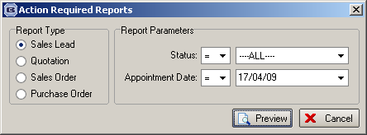

The following information is printed on the reports:

Sales leads – the report shows sales lead date taken, sales lead number, contact name.

Quotations– the report shows quotation number, quotation date, company name (customer), last contact date

Sales orders – the report shows order number, order date, company name (customer), blind type description, supplier (there could be more than one record per sales order here).

Bought in purchase orders – the report shows purchase order number, supplier, blind type description, sales order number, expected delivery date.

1361. Quotation – Laser Print

The postcode and email address from Administration > Company Details now print on this report.

1362. Order Processing > Quotations

At the moment we have a parameter in Administration > Parameters called ‘Show Width/Drop On Quotations’. This has also been included as a parameter on the quotation record so it can be switched on or off by individual quotation. It is in the Totals tab and is called ‘Print Width/Drop’ and defaults to the setting in ‘Show Width/Drop On Quotations’. All the quotation reports have been changed to allow for this new parameter.

1363. Order Processing > Paid Proformas

This form no longer displays records for orders that have a status of ‘Invoice Posted’.

1365. Purchase Order Processing

We have adjusted what gets printed on the ‘Partly Bought In Purchase Order’ print.

There is a new flag held against Blind Types > Cutting Options called ‘On Purchase Order’. If ‘Parameterised Cutting Options’ is switched on in the blind type record, then the cutting options where ‘On Purchase order’ = true print rather than the width and drop. These cutting options will print vertically (same as works orders).

1366. Works Order – Label 5

The following changes have been made to the top right label.

- Changed ‘Customer Name’ to ‘Name’.
- Inserted Order number
- Change ‘Description’ to ‘Desc’.
- Inserted ‘n of n’.

1367. Delivery Docket – Bespoke 15

The new ‘Delivery Notes’ field is now printed out on this delivery docket.

