Blindata Release Note 4.4.3 

6 April 2009

Bug Fixes and Enhancements

2679. Reports > Receipts by Date Report

The totals now print out properly. Previously they merged into each other when there were large numbers; also the nett grand total was cut off on the left hand side.

2677. Invoice – Bespoke 17a

The change we made to the ‘square metreage’ chargeable amount now works on the first detail line and on subsequent ones.

2683. All Reports

All the Save options work properly now. This bug was introduced when the reports component was upgraded.

2684. Works Order – Bespoke 15

If the blind identifier = Vanes Only, the Slat(m) figure is now calculating correctly. It was forgetting to include the ‘Fold Over Size’ in the blind type record. The calculation is (Drop Blind Size + Fold Over Size – Headrail Depth) * Number of Vanes.

2685. Order Processing > Orders

If this Friday is set up as a holiday, and a customer had only Friday set up as a delivery day, and the lead time on a blind type was 2 days, then if an order was entered today, the required date should have been 17/04/09. It was calculating it as 07/04/09. Fixed.

New Work and Customer Requests

270. Orders > Order Processing

It is now possible to link the creation of an invoice with the deliver button so there is no chance the order can be delivered without being invoiced.

To do this, we have created a parameter in Administration > Parameters > Sage Parameters / Invoicing called ‘Auto Invoice from Delivery’. If this is set to true, then if you click on deliver, the system will deliver the order and print a delivery docket (if this parameter is switched on), then the ‘Create Invoice’ function will be run, and then the invoice will be printed.

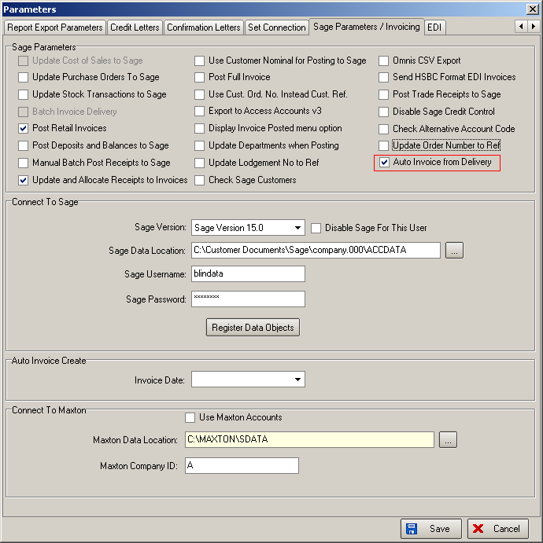

1348. Appointment Costs

It is now possible to hold costs against appointments so that profitability can be better analysed for orders where sales leads and fittings are involved.

The following work has been carried out.

Three fields have been added to the appointments, ‘Actual Start Time’, ‘Actual End Time’ and ‘Actual Cost’.

The sales leads that are related to orders are now displayed in the ‘Appointments’ tab in the Order form.

There is a new button on the ‘Appointments’ tab of the Orders form called ‘Costs’. When this is clicked, a form is opened called ‘Appointment Costs’. This shows ‘Start Time’, ‘End Time’ (both read only), then ‘Actual Start Time’, ‘Actual End Time’, (both editable), and the ‘Actual Cost’. The actual cost field is read only and is calculated as the actual time (actual end time – actual start time) multiplied by the hourly rate held against the employee.

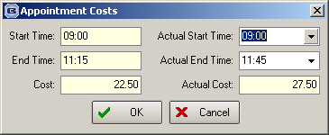

There is also an ‘Appointment Costs’ field in the Order section in ‘Advanced Permissions’ to determine whether the ‘Costs’ button is displayed or not.

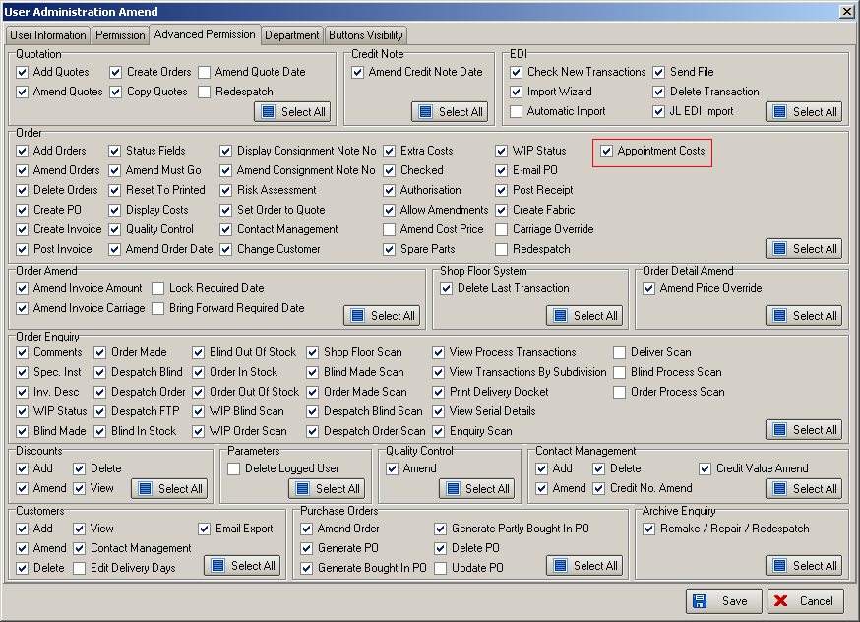

There is a new report called ‘Employee Profit Report’ in Reports > System Reports. This can be selected between ‘Start Order Date’ and ‘End Order Date’, by employee (if ‘All’ then grouped by employee), and is sorted by order number. It shows ‘Order No’, ‘Order Date’, ‘Nett Total’, ‘BOM Cost’, ‘Extra Cost’, ‘Appointment Cost’, ‘Appointment Actual Cost’, ‘Profit’, ‘Actual Profit’. The ‘Profit’ = ‘Nett Total’ – ‘BOM Cost’ – ‘Extra Cost’ – ‘Appointment Cost’. The ‘Actual Profit’ = ‘Nett Total’ – ‘BOM Cost’ – ‘Extra Cost’ – ‘Appointment Actual Cost’.

1349. EDI Import

If the EDI import is done automatically and orders get checked automatically (done in dev 1322), an order history record is now created to say that the order is ‘Order Checked’ – the same as if it is checked manually, except the user name will be the user that is set up as ‘Automatic Import’ in Advanced Permissions’.

1350. Menu Form Title Bar

The company name (from Administration > Company Details) now appears to the right of ‘Blindata’ and before the menu choice eg ‘Order Amend Enquiry’.

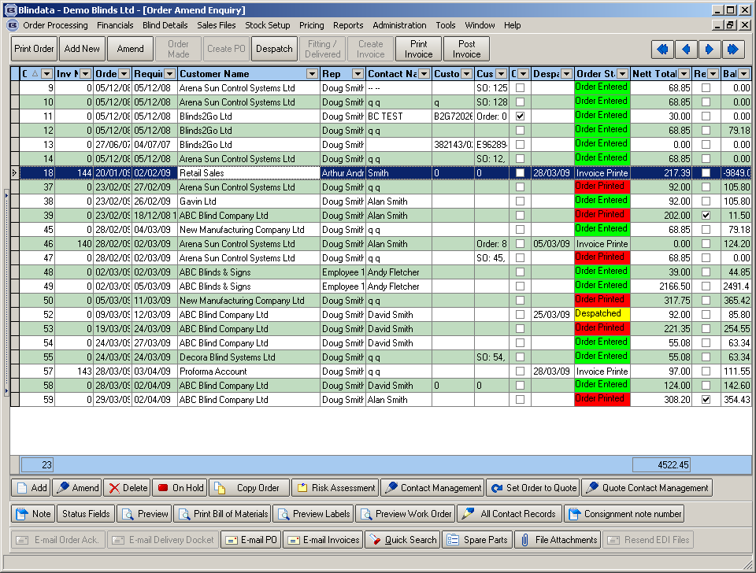

1351. Administration > Import From Excel > Discounts

When importing discount records, fields for ‘Start Date’, ‘End Date’ and ‘Employee’ can now be included in the spreadsheet that is to be imported.

1352. Blind Details > Blind Types

There is a new description field appear in the blind type record called ‘WO Description’. It appears on the top small labels of ‘Works Order Label 1’ in the same place as the blind type and fabric description previously appeared.

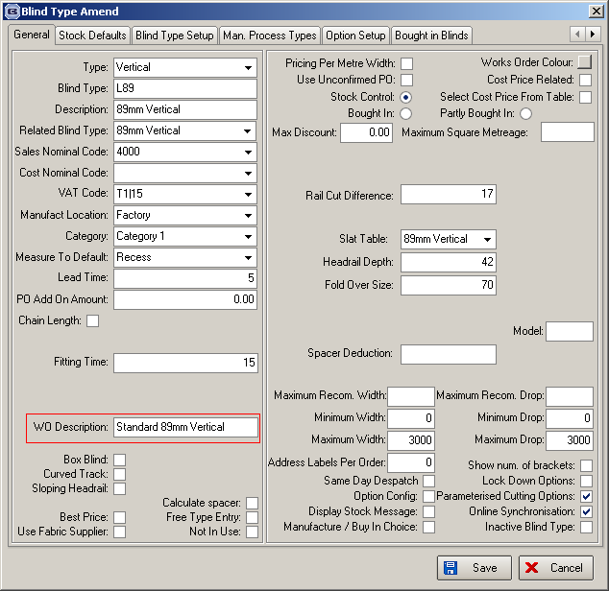

1353. Passwords

It is now possible to alter the expiry date of a user.

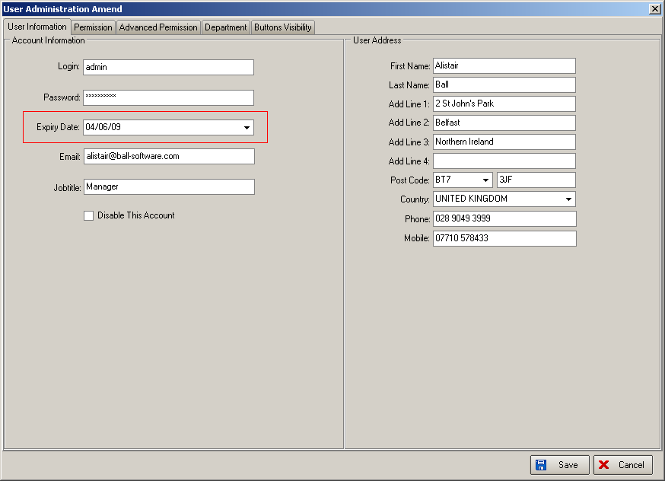

1354. Order Processing > Orders

There is a new field called ‘Delivery Text’ held against orders. This can be filled by using a button called ‘Delivery Notes’ on the Order Amend Enquiry form. There is a permission flag for this in Administration > Users > Buttons Visibility.

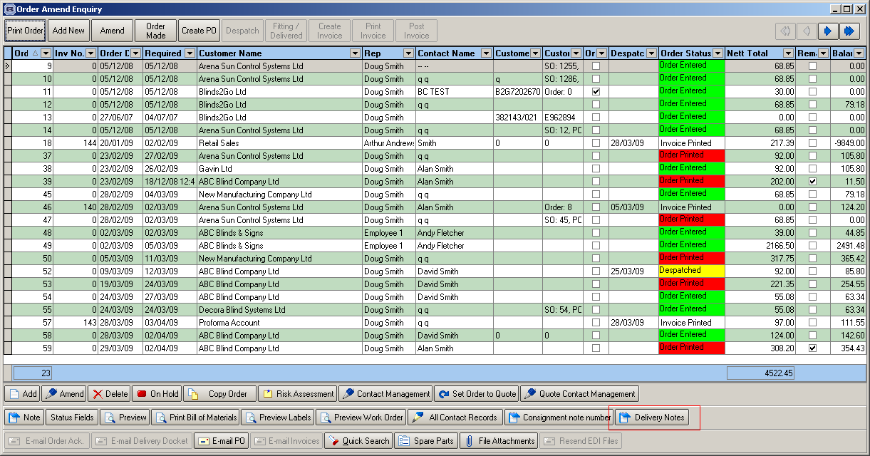

The ‘Delivery Note’ text can also now be printed on delivery dockets.

1355. Order Processing > Archive Enquiry

For operators who have screens with low resolutions, the buttons at the bottom of the form have been moved onto two rows.

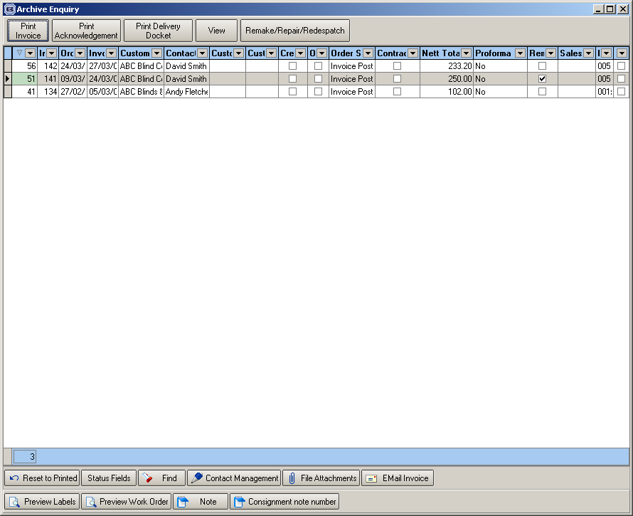

1356. Order Processing > Paid Proformas

There are now two extra columns on this form, one for ‘Order No’ and another for ‘Total’.

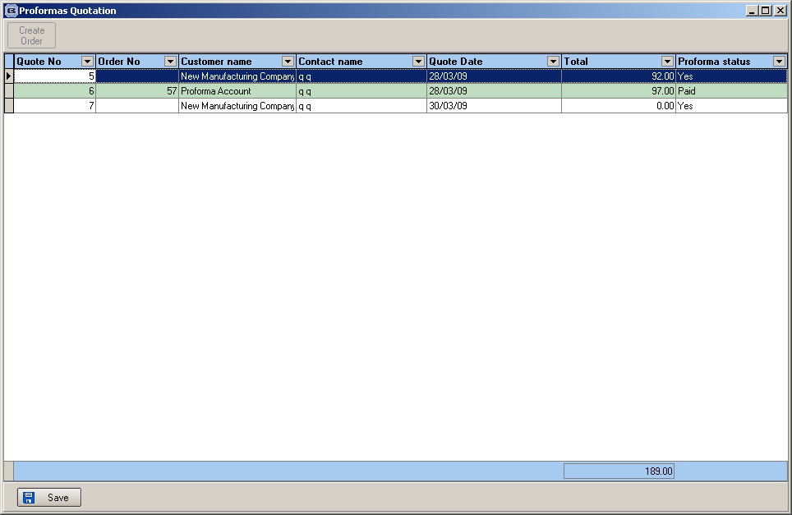

1357. Order Processing > Orders

If ‘Print Venetian Barcode’ is switched on in Administration > Parameters > Report Parameters, then characters 2-3 are selected from the ‘Model’ field in Blind Details > Blind Types. Code has been added to the program so that if ‘01’ is in the Model field, then ‘01’ prints in characters 2-3 on the bar code, and if ‘03’ is in the Model field, then ‘03’ should print in characters 2-3.

