Blindata Release Note 4.4.2 

31 March 2009

Bug Fixes and Enhancements

2667. Invoice – Bespoke 2

- The logo now prints proportionately.
- The VAT figures now print to 2 decimal places.

2668. Works Order A4 Packing Slip

The fabric description is now shortened, and does not print right up to the fabric metreage required.

2671. Fitters Sheet / Sales Lead

When you convert a sales lead to an order, the new parameter ‘Receipt to Delivery Address’ is now set to true if the customer trade type = Retail.

2674. Export Invoice For Customs

The layout of the header section of this report has been changed so it is the same as the ‘Export Order’.

2675. Archive Enquiry > Remake / Repair / Resdespatch

If an order is create using Remake / Repair, it now has a null manufactured date and delivery date in the order detail line. If it is a Redespatch, it has a null delivery date in the order detail line.

New Work and Customer Requests

520. Impala Headrail System

Impala is a headrail system supplied by a company called Eclipse. It has a complicated method of calculating the travellers for the headrail If an Impala headrail is used, we can now print the travellers on the report ‘Works Order Label Blind Size’ and on ‘Works Order Portrait’.

We have also enabled this for another Eclipse headrail system called Vitesse.

This means Blindata can now work with four different headrail systems, Impala 89mm, Impala 127mm, Vitesse 89mm and Vitesse 127mm. We have created a new table in Administration > System Tables to handle these.

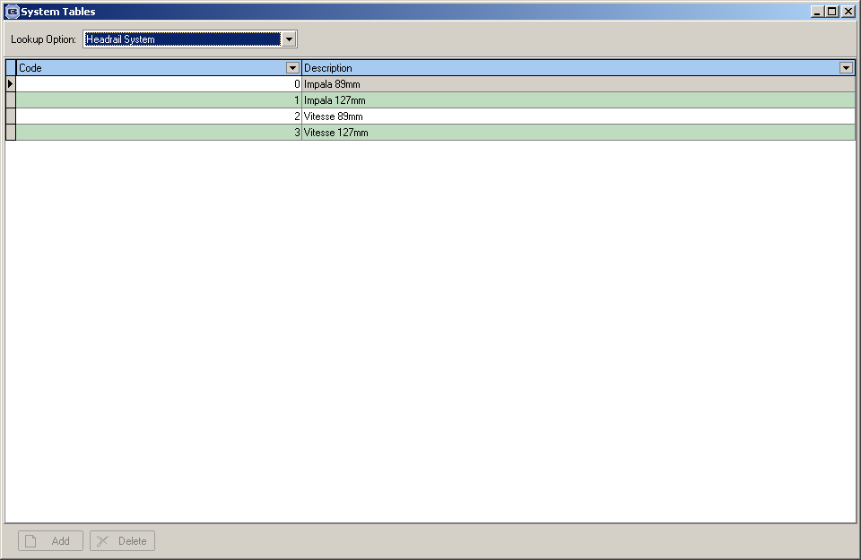

We now hold these headrail systems in the ‘Headrail Slat Table’ in Administration > Parameters.

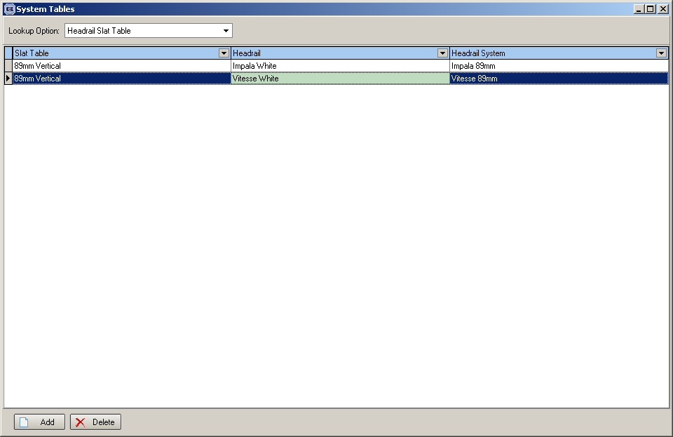

There is one further complication. The pitch figure is based on the following calculation (taken from page 54 in the Impala manual):

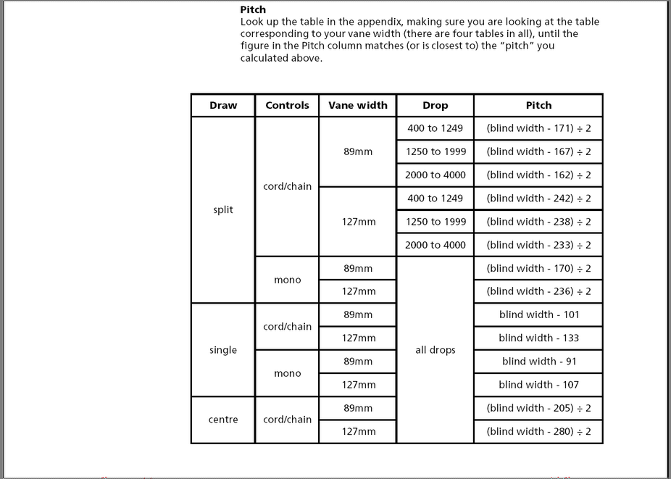

We therefore have another table that will hold the pitch calculation, based on blind type, two options (draw, controls), slat table (vane width), drop and a formula. This table is called ‘Impala Pitch’ and is held in Administration > System Tables. The user can enter the fields in a form (see below). The pitch will be calculated from this, and it is this pitch that is used when looking up the Impala traveller table.

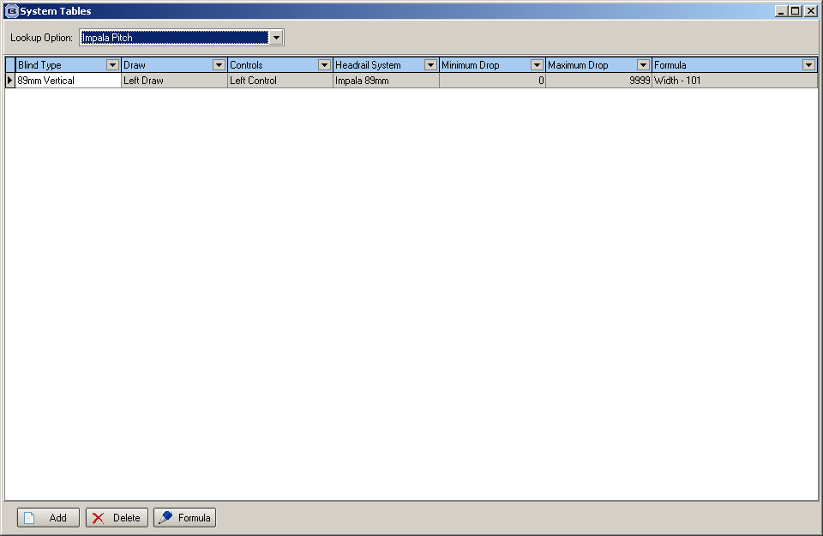

The Impala traveller table is held in a spreadsheet, Impala_trav_look.xls. Column A contains the pitch width, column B-E contain the number of travellers and the traveller code. For example, if the pitch width was 777, this information would be found:

778 | 4 | 3C | 7 | 3D

This means that the number of vanes is 11, 4 of which use traveller code 3C, 7 of which use 3D. We want to display this on the works order label as No. of Vanes: 11 (4 3C, 7 3D).

Once the information is found, it will print on a works order report. To start with, it has been put on ‘Works Order Portrait’ and ‘Works Order Label Blind Size’.

It is now possible to hold the Impala and Vitesse Traveller tables in the system. They can be imported in Administration > Import from Excel in new import options called Impala 89mm, Impala 127mm, Vitesse 89mm and Vitesse 127mm. We can provide you with the relevant spreadsheets.

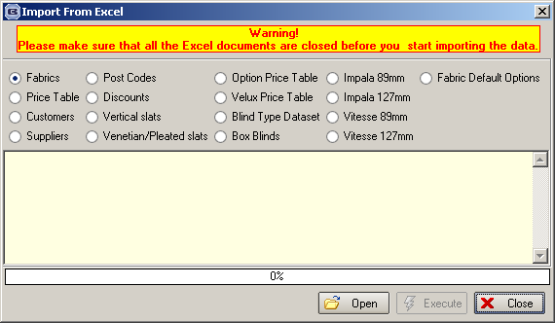

901. Order Processing > Fitters Sheet / Diary

We now keep a history of when fitting appointments were added and when changed in the diary and from the order entry form. This is displayed in the diary in the same way as the sales lead history is ie right click and select ‘History’.

1204. Order Processing > Order Enquiry

Previously we added a column choice for ‘Nett Price’. We have now added a total for this column and the quantity column at the bottom of the grid (in the same way as we do for ‘Nett Total’ in the Order Amend Enquiry form).

1276. Order Processing > Production List > Production List Summary Preview

The ‘Blind Type’ and ‘Total Qty’ descriptions are now column headings in this report and do not appear on each line.

Also, it is now possible to print this report by order date as well as by required date. Previously the ‘Order Date’ choice was greyed out.

1341. Post Proforma Invoice Text

There is a new text field in Administration > Company Details > Parameterised Text tab called ‘Post Proforma Invoice Text’.

There is also a new parameter in Administration > Parameters > Report Parameters called ‘Use Post Proforma Invoice Text’. If this is set to true for an invoice that originated from a quotation where Proforma = true, then the ‘Post Proforma Invoice Text’ is printed on the invoice instead of ‘Invoice Text’. This applies to all invoice layouts.

1342. Receipt Print

There is a new parameter on an order, held in the Totals tab, called ‘Receipt to Delivery Address’. When an order is entered, if trade type = Trade, then ‘Receipt to Delivery Address’ defaults to false. If trade type = Retail, then it defaults to true. The user is then able to switch this off or on as appropriate. This parameter will then affect the company name and address that is printed on the receipt print (in the Receipts tab). The receipt address will be the invoice address of the order if ‘Receipt to Delivery Address’ = false, and the delivery address of the order if ‘Receipt to Delivery Address’ = true.

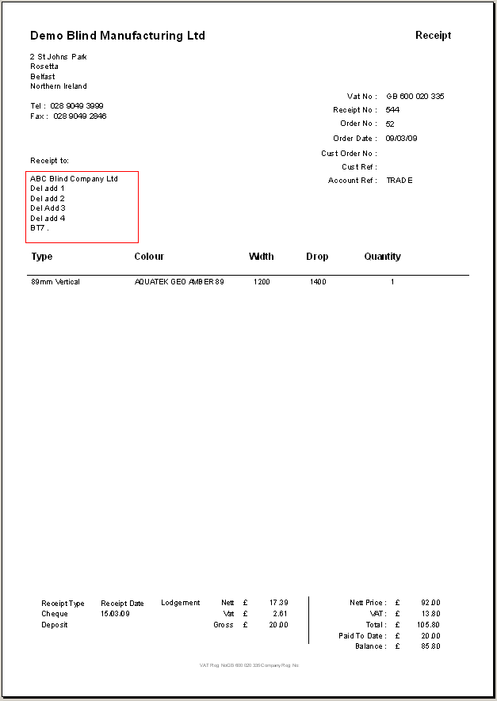

1343. Customer Email Address Export

It is now possible to export all email addresses for customers and extra contacts to a spreadsheet so they can then be used in e-mail shots. The spreadsheet should contain contact name, company name and email address. This can be done using a new button on the Customer form called ‘Export to XLS’. There is an advanced permission for this button in Administration > Users > Advanced Permissions.

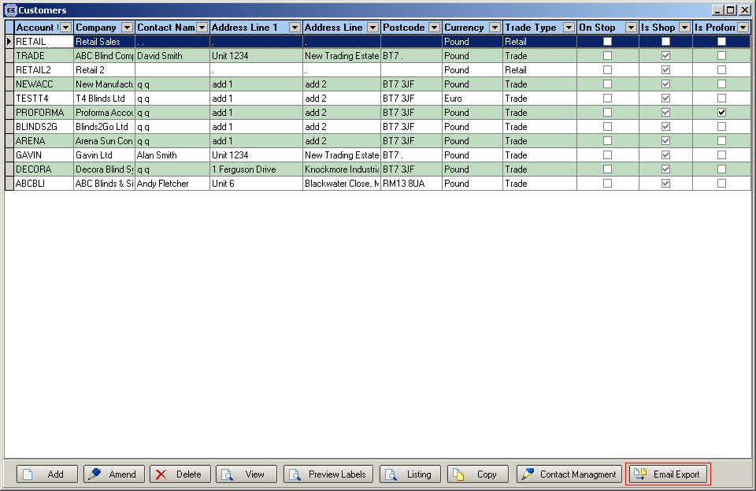

1344. Order Processing > Quotations

There is now a tab for ‘Contact Management’ on the quotation form. This has exactly the same functionality as the ‘Contact Management’ button and the same advanced permissions apply. The new tab only appears if the ‘Quote Contact Management’ visibility button is switched on.

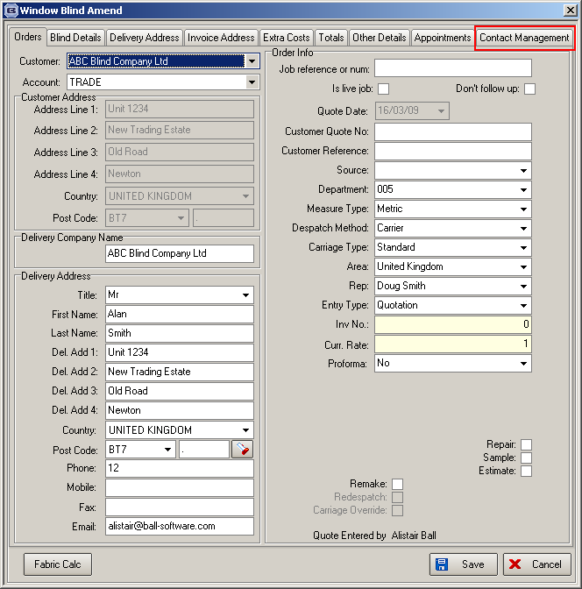

1345. Order Processing > Orders

The ‘Up’ and ‘Down’ arrows we included recently are now only enabled if the order has a status of ‘Order Entered’.

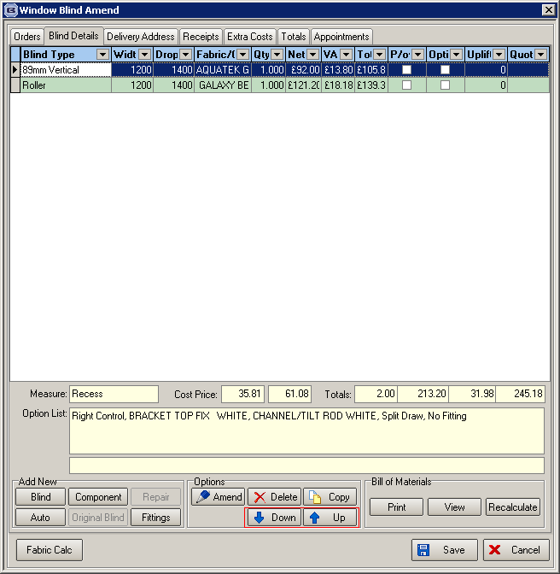

1346. Order Processing > Orders

In development item 1337, the new ‘right click’ functionality was added. A parameter has been created for this in Administration > Parameters. It is called ‘Alternative Option Selection’ and defaults to true.

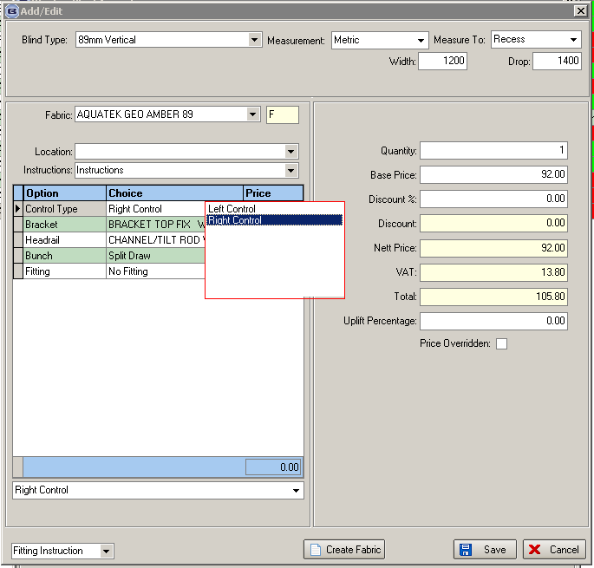

1347. Order Processing > Order Enquiry

When a blind is flagged as in or out of stock or the order is flagged as in or out of stock, a message can be sent to the customer services email address. This is fine, but we have removed the ‘The e-mail has been successfully sent’ message because it was slowing down the operator.

