Blindata Release Note 4.4.0 

13 March 2009

Bug Fixes and Enhancements

2638. Financials > Invoice Print and Post

The logic of these two buttons did not seem sensible. If we clicked ‘Hold Invoice’, then the invoice was put on hold. This is ok but it had no effect on anything else. If you clicked ‘Clear Inv Hold’, then it asked for a new invoice date, gave the order a new invoice number (overwriting the old one) and left the ‘Invoice on Hold’ flag = true. Now it does not create a new invoice number and only makes ‘Invoice On Hold’ = false.

2639. Pricing > Price Table Enquiry

If you click on ‘Export to Excel’, previously you could save an Excel spreadsheet to your own PC but not to a network location. We have changed the functionality slightly so that a new spreadsheet is opened and the user can then save it to any location.

2643. Order Processing > Quotations / Orders

If an option stock code is set up as a ‘Non Discount Item’ in the stock record, and the actual total of an order is changed so the discount is back calculated, the detail lines discount did not get calculated properly in the last line. This has been fixed.

2644. Invoice Laser Print (Letterhead Logo)

- The logo is now printing proportionately.
- These fields have been moved right so they line up with the delivery address fields.
- These field name fields now all have the same font size and in bold. Same size as ‘Invoice To:’.
- ‘Colour’ now lines up with the fabric description underneath it. Also the blind type description ran into the fabric description. We have moved the fabric description 10mm to the right and adjust other fields to the right accordingly.
- The option price is now right justified and lined up with the base price above it.
- There was not enough room to print all the text here. The font has been reduced in size slightly and the text space expanded left a bit so it is in line with the rest of the left hand side of the invoice.

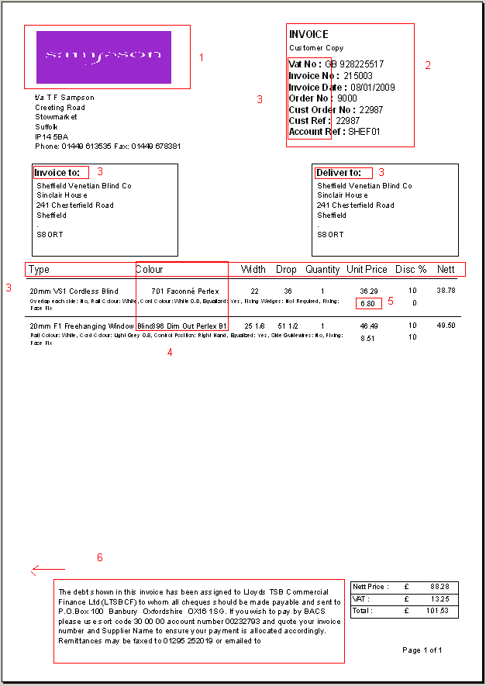

2645. Password Expiry

This text now says ‘have’ instead of ‘has’.

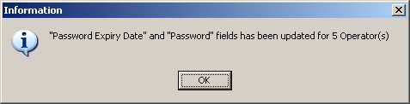

2646. EDI Enquiry > EDI Import

If an order comes in after the cut-off time and it is a ‘Same Day Despatch’ order, it flags correctly as same day despatch and it is now also flagged as a Must-Go.

2647. Bespoke Works Order

The number of vanes now appears if the blind identifier = Vanes Only.
The number of options displayed horizontally on the form has been increased to 12. This is required because of the number of options on a roller blind.

2648. Quotation > Bespoke 21

For large value quotations, the last decimal place was being dropped from the total. Fixed.

2649. Invoice – Bespoke 17a

- Moved left hand alignment 10mm to right side, because it printed on the left hand side lines
- Changed square metre calculation.
- Total now only prints on the last page.
- Page length is now ‘Letter fanfold 8.5 X11inch’.
- We have extended currency symbol to allow 3 characters.
- Page numbers are now on top right.

2650. Delivery Docket – Bespoke 17b

- Room Ref: we have moved this up.
- Decreased the space between line items
- Printed the 4th detail line on the bottom

2651. Label Print – 3 ½ x 1 No Desc

- Renamed the label ‘Room Ref’ to ‘R/Ref:’.
- The entered size on the label in brackets is now like old one. For example, if you enter order in imperial then the label is (1560 (61’) and if the order entered as 1560mm then the label is 1560(1560).

New Work and Customer Requests

1334. Invoice – Sage Tractor Feed Letterhead

We have included ‘Cust Ord No.’ on this invoice.

1335. Order Processing > Order Enquiry

There is now a column for ‘Nett Price’ on the column choice.

1336. Works Orders / Purchase Orders / Labels

We have now implemented the Order Checked box functionality throughout the whole system. This means that if the ‘Display Checked’ parameter is set to true in Administration > Parameters, then works orders, labels and purchase orders will not be created for orders until they have been flagged as ‘Checked’ in the order entry form.

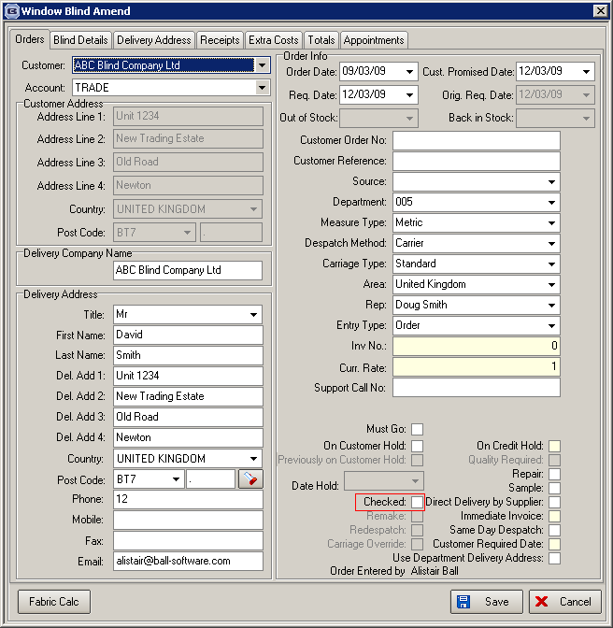

1337. Order Processing > Orders

A number of customers (who all used the old Access system) did not like the way that options were chosen in the order detail entry. They wanted to be able to tab down through the options, selecting options as they go. They say they have to keep going to the option selection at the bottom and then clicking on the next option they want to change.

We have therefore made a change that allows the user to select and change an option without going to the Option field at the bottom of a form. If you right click on an option in the option grid, then all the choices for that option will appear. You can then select the choice by keying the first letter of the choice.

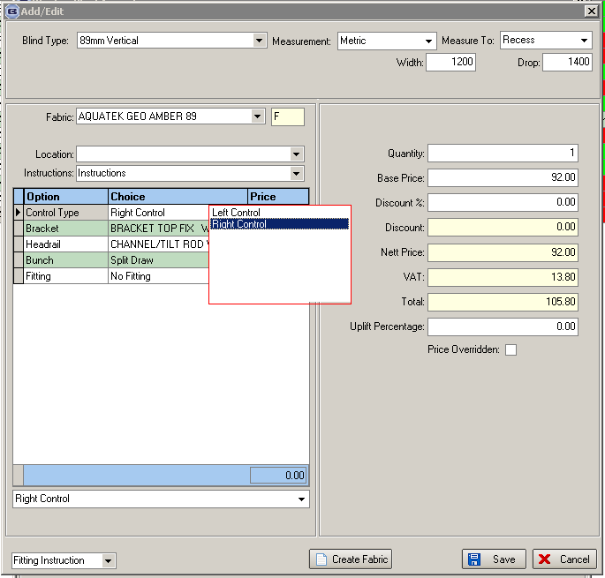

1338. EDI Enquiry > EDI Import

The following modification is only required for customers where Parameters > Display Checked = true.

Previously, if this parameter = true, when an order was imported from an EDI file, it then had to be flagged as checked by an operator. We have changed this to the following: if an order is imported via EDI and there are no special instructions on any of the detail lines (after importing), then it is flagged as checked. If special instructions do exist, then it remains unchecked.

