Blindata Release Note 4.3.9 

9 March 2009

Bug Fixes and Enhancements

2634. Order Processing > Orders

If you entered a detail line that has an option that is priced in Pricing > Option Price Per Metre, the option price was 1000 times greater than it should be. This was because it was multiplying by the drop in millimetres and not the drop in metres. Fixed.

2636. Reports > Sales Analysis > Sales Analysis by Nominal by Blind Type

The text was overlapping if there was more than one nominal code on the report. Fixed.

2637. Order Acknowledgement (Letterhead Logo)

This report was not printing correctly. The ‘Measurement’ line was appearing at the top. Fixed.

2640. Packing List

1. The box contents text now appears at the end.
3. The ‘Further Items..’ text has been removed.

2642. Administration > Users > Button Visibility

If you switched off certain flags in ‘Quotation Amend Enquiry’, saved the form, then went back into it, different flags were switched off. Fixed.

New Work and Customer Requests

1322. EDI Enquiry

When an order is imported via EDI, a check is done to make sure that the customer is not ‘On Stop’. If they are on stop, then the record is not imported and an EDI log record is created. We have improved this so that this ‘On Stop’ status is shown on the EDI Enquiry > Received form. This means that the user will be able to see why the order has not been imported.

1323. Customer Services Email

We now hold a new field called ‘Customer Services Email’ in the same box as Despatch Email Address in Administration > Parameters > Set Connections.

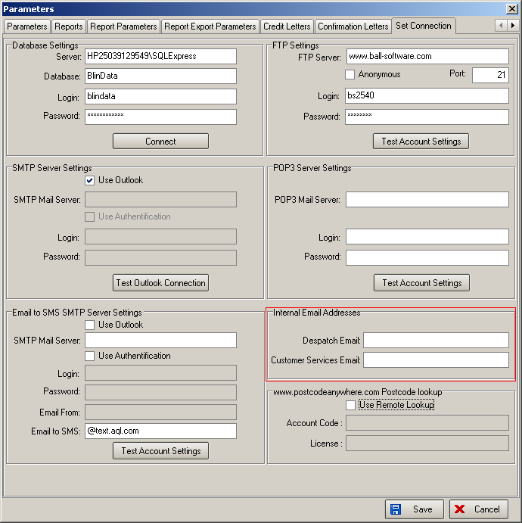

When an order is flagged as ‘Order Out of Stock’, an email is sent to the customer services email saying ‘Order no 999999 for [blind description, fabric description, width = 9999, drop = 9999] for [customer company name] has been flagged as ‘Out of Stock’. Please contact [contact name] on [contact telephone number].’

When an order is flagged as ‘Order in Stock’, an email is sent to the customer services email saying ‘Order no 999999 for [blind description, fabric description, width = 9999, drop = 9999] for [customer company name] has been flagged as ‘In Stock’. Please contact [contact name] on [contact telephone number].’

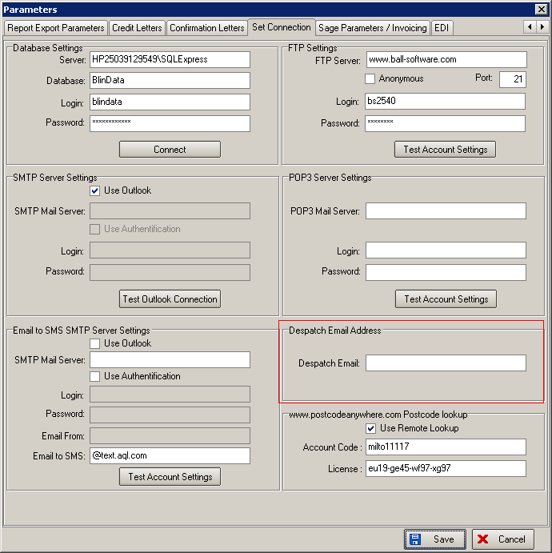

1324. Password Expiry

We have created functionality for expiry dates for username passwords. A lot of customers will not want this so there should be a new parameter called ‘Enable Password Expiry’ in Administration > Parameters, which defaults to false.

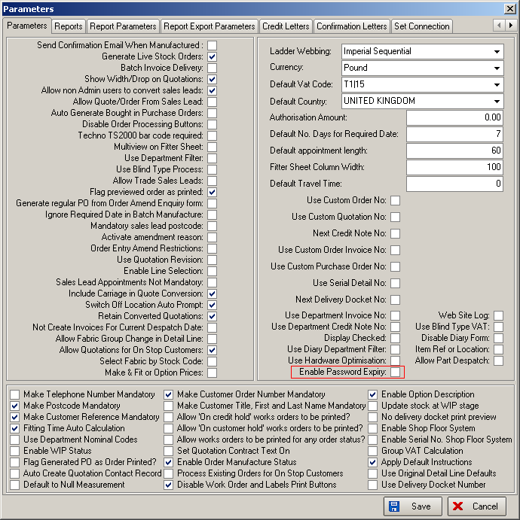

If ‘Enable Password Expiry’ is switched on, then user passwords will expire after 3 months. The first time this is switched on, we fill all the username password expiry dates with a date of current date + 3 months.

When a password expires, the user is prompted with a new password. They should first have to enter their old password. Once this has been done successfully, the user will be able to log in.

The user should be able to change their password when they want. It is possible to do this from the login form.

If ‘Enable Password Expiry’ is true, then passwords are encrypted so they cannot be seen by looking in the database.

1325. Works Order – Label 1

We have removed the blind type and fabric description from the top labels.

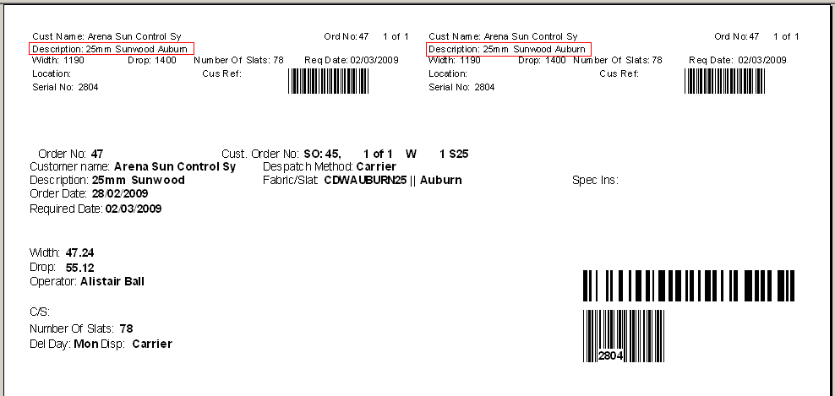

1327. Pricing > EDI / Online Discounts

It is now possible to select the customer by account code as well as by name.

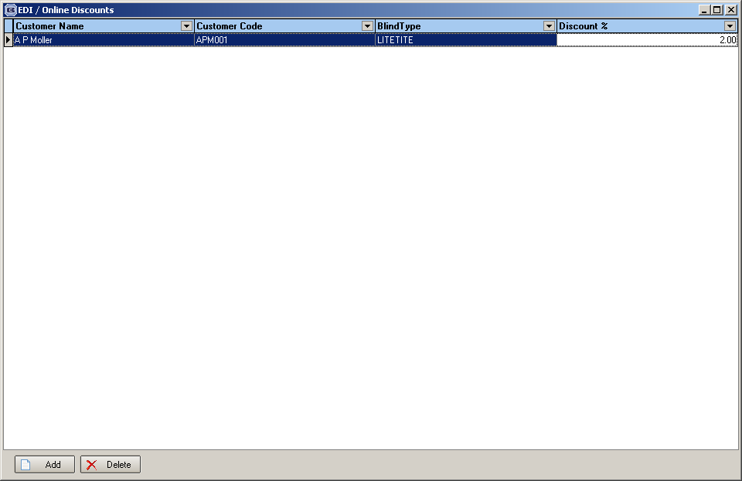

1328. Evening Cut Off Time

We now hold a new field called ‘Evening Cut Off Time’. This is held in Administration > Parameters > Automated Tasks tab.

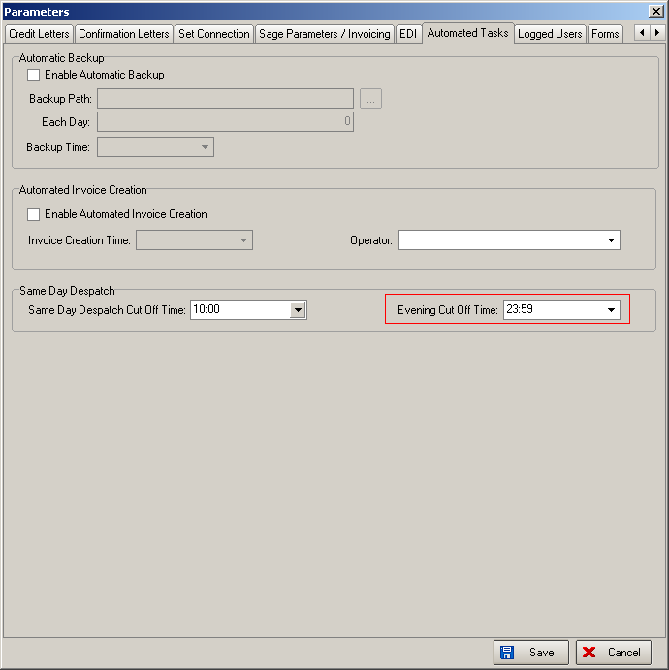

If an EDI order is imported or an online order is synchronised after the ‘Evening Cut Off Time’, the order date becomes the next working day. We also hold the import order date / synchronised date.

1329. Label Print - 2 x 11 A4

Previously, the number of labels printed was related to the number of records in ‘Label Control’. On this label print, we now keep the number of ‘Production Labels’ related not to the number of blinds, but per order, regardless of the number of blinds on the order. We have done this by having a new field in the blind type record called ‘Address Labels Per Order’.

Also, on venetian label, we show number of slats.

1330. Works Order - Three Copies

- Removed page numbers
- Moved works order no to right hand side (where despatch method was)
- Removed Contact Tel No
- Removed Despatch Method
- On works order, now only show entered size (metric or imperial).
- There is now room for 3 cutting size options.
- We now show the number of vanes (if vertical), or slat metreage (if Venetian) after the option list.
- All the footer fields have been removed to be replaced by the same colour bar as is on the top of the report.

1331. Invoice - Bespoke 25

We now show the ‘retail price’ column immediately to the right of quantity. This is exactly the same field as is on ‘Invoice – Bespoke 2’.

1332. Administration > Import From Excel

There is a new option on this form called ‘Fabric Default Options’. We can now import a spreadsheet with only two columns, the first with the fabric code and the second with the option code into the Fabrics Default table. These records will then be seen in this form.

