Blindata Release Note 4.3.8 

3 March 2009

Bug Fixes and Enhancements

2626. Order Processing > Orders

If you enter a ‘Must Go Reason’ and save the order, when you go back into the order, the must go reason no longer defaults to the first ‘Must Go Reason’, but to the one that was entered.

2627. Works Order – Label 1

The word ‘REMAKE’ or ‘REPAIR’ or ‘REDESPATCH’ now appears further to the right. It has been right justified with the right hand side of the packaging barcode.

2629. Order Processing > Orders > Bill of Materials Report

- The column for ‘Product Description’ has been made wider.
- The ‘Price Incl.’ and ‘Scrap %’ heading are now on two separate lines to so this column can be reduced in size.

2631. Order Processing > Orders

If ‘Print Batch Documentation’ is set to true in Administration > Parameters > Report Parameters, and ‘Email Order Ack’ is selected in ‘Order Amend Enquiry’, three reports were emailed. It now emails two reports, and not the order acknowledgement report set up in Report Export Parameters > PDF Acknowledgement.

2632. Financials > Invoice Batch Print

In the customer record, ‘Exclude From Invoice Batch Print’ is switched on, and the invoice print is run, the orders for these customers is now changed to ‘Invoice Printed’ from ‘Invoice Created’.

2633. Pricing > Price Table Enquiry

If you did a ‘Selected Price Uplift’ and chose ‘Round Up to Nearest’, previously it rounded to the nearest. It now rounds up to the next whole number.

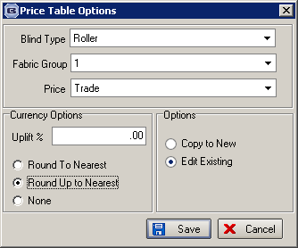

New Work and Customer Requests

1249. Quick Report Components

We have upgraded the Quick Report components to the latest version, Quick Report 5 version.

1286. EDI Enquiry

At the moment one Blindata customer can send a PO to another Blindata customer via EDI. We have expanded this so an order acknowledgement can then be sent back to the first customer via EDI, and then a notice of delivery can also be sent. We also now have a facility for sending an EDI invoice as well.

There are three new flags held against the customer record, one called ‘Send EDI Order Ack’, another called ‘Send EDI Despatch Notice’, and a third called ‘Send EDI Invoice’.

We also need to hold the ftp locations for these new EDI files in the customer record as well. Therefore there are also new fields called ‘FTP EDI Order Ack. Location’, ‘FTP EDI Despatch Location’ and ‘FTP EDI Invoice Location’.

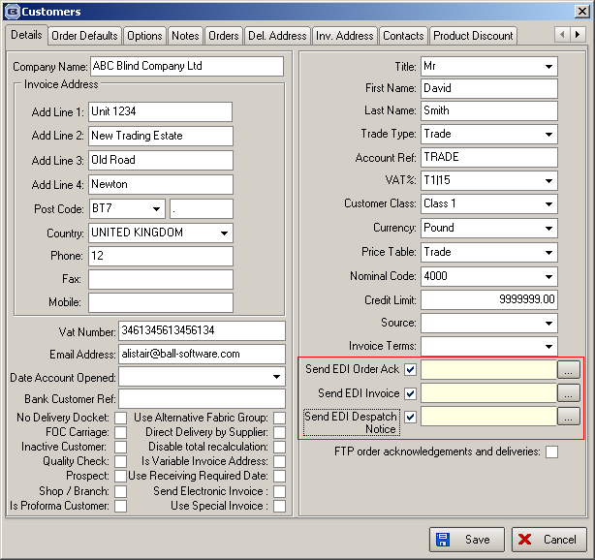

EDI Order Acknowledgement

If an order is entered manually or imported via EDI, when the order is saved and if ‘Send EDI Order Ack’ is set to true in the customer record, an EDI file is created and sent to the relevant location. An order history record is created for this as well. The EDI file layout is in the same format as the EDI import file.

EDI Despatch Notice

When an order is despatched and the customer record ‘Send EDI Despatch Notice’ is set to true, an EDI file is sent to the relevant location. The EDI file is in the same format as the EDI import file but should also contains the consignment note number. An order history record is created for this as well.

EDI Invoice

When an order is invoiced and the customer record ‘Send EDI Invoice’ is set to true, an EDI file is sent to the relevant location. The EDI file is in the same format as the EDI import file but also contains the nett amounts in the detail lines. An order history record is created for this as well.

There is also a facility for resending files via a button on the Order Amend Enquiry form called ‘Resend EDI Files’ is activated.

To hide or display the ‘Resend EDI Files’ button use the User Administration Amend > Buttons Visibility form.

There are also three new columns on the Order Amend Enquiry form for ‘EDI Order Ack Sent’, ‘EDI Despatch Note Sent’ and ‘EDI Invoice Sent’.

1308. Order Processing > Orders > History

An order history record is now created if a purchase order has been emailed or an EDI file has been sent.

1309. PO Email Standard Text

We have added a standard message body to the purchase order emails. There is a new field in Administration > Company Details called ‘Email Purchase Order Text’. This can be used, along with email filling text fields, when a purchase order (bought in) is sent.

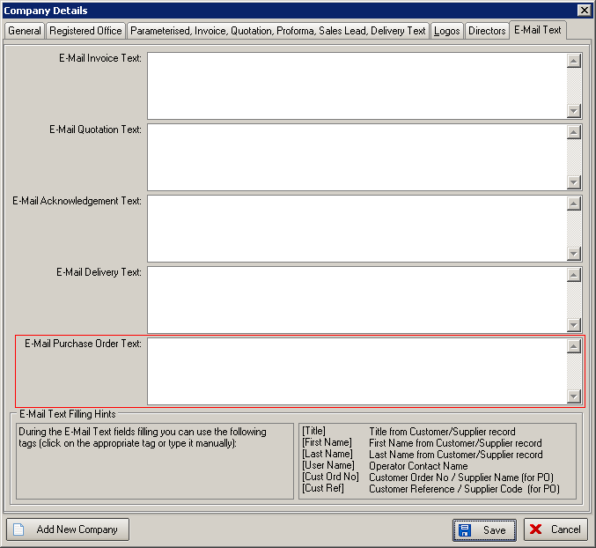

1310. Order Processing > Orders > Order History

If an invoice has been emailed to a customer, an order history record is created for this.

1312. Order Processing > Orders

If you enter an order and you specify a 'Required Date' & ' Promised Date' and then add or amend the blinds/components on the order previously both dates would revert back to the default lead time date. The only way to hold the altered required date was if the required date was entered after all the detail lines had been added. However sometimes users are forgetting about this, and the required date is getting changed back without them realising.

We have made the following change. If this happens and the required date is going to be set back to the ‘lead time’ date, then a message appears saying ‘You have already altered the required date for this order. Do you want to keep the date you entered?’. If the answer is yes, then the required date that was entered manually remains.

1313. Stock Usage Report

We have altered this report so that two more columns are printed. The first is ‘Stock Purchased’ and the second is ‘Stock In Hand’. The ‘Stock Purchased’ figure is calculated as the purchases made between the start and end date entered.

1317. Delivery Docket – Bespoke 17b

- The fabric description now prints to the right of the fabric code.
- The category has been moved to the right to make room for fabric description.
- ‘Sq. Metres’ is now printed to the right of the width and drop. The square metre calculation is (width * drop)/1000000.
- ‘Room Ref:’ now prints on the right hand side of special instructions. ‘Room ref’ is the ‘Location’ field.

1318. Invoice – Bespoke 17a

The following changes have been made to the layout of this invoice.

- ‘Order No’ now prints here.
- ‘Cust Ord No’ prints here, with a ‘/’ between Cust Ref and Cust Ord No
- The detail line now prints:
Fabric Code, fabric description, category description
Sizes (eg 1340 W x 1785 D), Price band = ‘fabric group’.
4. This is now the chargeable square metreage, not the the actual square metreage

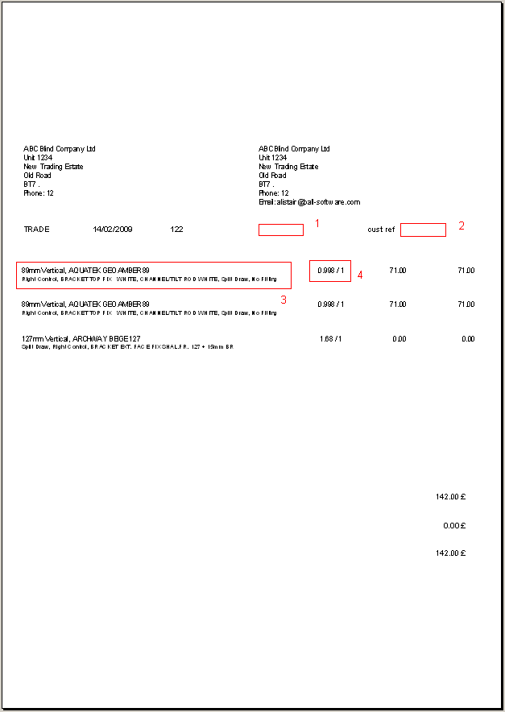

1319. Sales Files > Customers

‘Fax Number’ has now been included as a column choice.

1320. Invoice – Bespoke 20

- We have removed the despatch method.
- There are now 8 detail lines fitted onto a page.

1321. Invoice – Bespoke 15

There was a lot of blank space on this invoice if it was for more than one page. The number of details lines has been increased for all but the final page.

