Blindata Release Note 4.3.7 

23 February 2009

Bug Fixes and Enhancements

2619. Label Print A4 2 x 11

If you set records up for ‘Customer Label’ in Blind Types > Blind Type Setup, then the company name and address lines now print, not the production label.

2620. Label Print A4 2 x 11

The labels now print in order left to right, top to bottom, and not top to bottom, left to right.

2623. Works Order – Bespoke 23

- The job no (order number) is now lined up properly.
- The order date is in the format dd/mm/yy.
- The boxes were too big.
- A lot of the options were not displaying properly – fixed.

2624. Order Processing > Quotations > Contact Management

It is now possible to amend a previously entered contact management record. Previously it was greyed out.

2625. EDI Enquiry > EDI Import (4.3.4 and 4.3.7)

If an EDI order is imported at the weekend or on a holiday, the required date now defaults to the next working day if ‘Same Day Despatch’ = true. The order is still flagged as ‘Same Day Despatch’.

If an EDI order is imported after the cut off time and it is a ‘Same Day Despatch’, the required date is the next working day and the order stays as ‘Same Day Despatch’.

New Work and Customer Requests

1277. Works Order – Label 5

The bar code now prints on one of the top two labels.

1288. Invoice - Laser Print 11 Detail Lines

The stock code is now shown for miscellaneous items, in front of the stock description. For example, in the first line of this invoice, if the stock code was LFTUBE01, it now says:

LFTUBE01 / Lay Flat Tubing 5”/125mm 250 gauge

This has also been done for ‘Invoice (Laser Print) Letterhead Logo.

There is a new parameter for this in Administration > Parameters > Report Parameters, called ‘Print Stock Code on Invoices’. If set to true, then the stock code will be printed. If false, the reports will remain as they are.

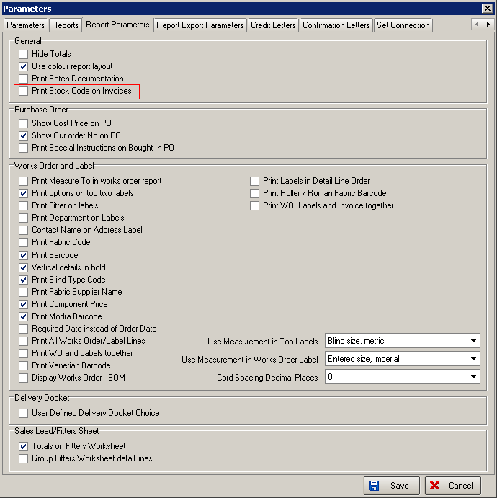

1296. Blind Types > Cutting Options

We have added two new fields to the cutting options form, for ‘Minimum Size’ and also a formula field. We have done this to improve the flexibility of the cutting calculation.

For example, we may need to calculate the length of a chain as (drop * 2) – 656, with a minimum of 1500.

We also need to be able to do the following calculation:

Cutting Size = (width + drop) * 2 – 746.

We can now do this by using the new field called ‘Formula’. This will allow the user to enter a formula eg (Drop * 2) – 656 or ((Width + Drop) * 2) – 746 or (Width / 2) + (Drop * 3) or any other variation of widths, drops, addition, subtraction, multiplication and division.

If the formula field is filled, then it will be used, otherwise the existing calculations will be done.

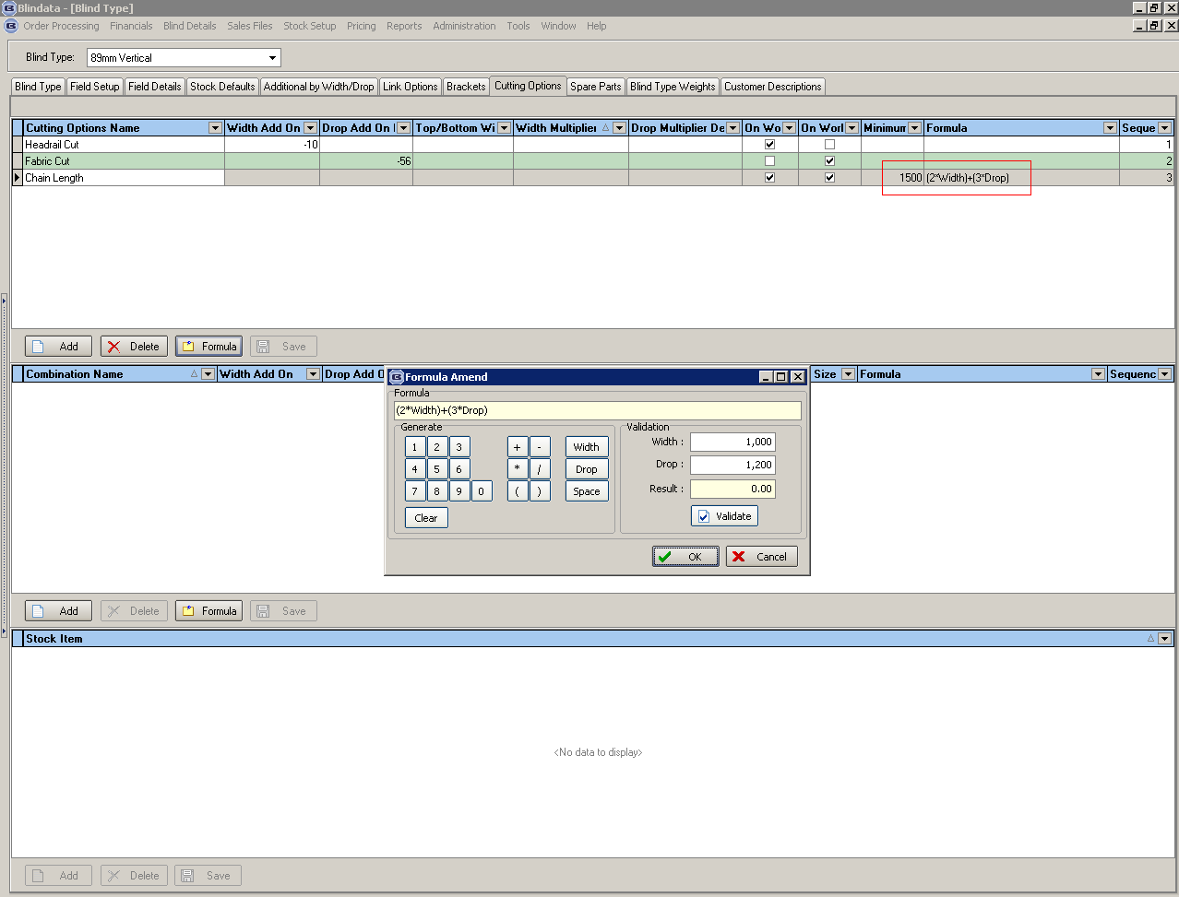

1315. Label Print – 3 ½ x 1 No Desc

- ‘Fabric Description’ has been changed to ‘Fabric Des’ to make more space for ‘Room Ref’.
- ‘Room Ref’ is now on the right hand side of this line. It is the ‘Location’ field.
- The sizes now only show the entered size eg if imperial it would show 39 3/8 W x 39 3/8 D. If metric it would show 999mm W x 999mm D.
- ‘Item No:’ has been moved left by 10mm as it was chopping off the last number.

1316. Invoice – Bespoke 17

- The logo is now printing proportionately.
- This now prints the fabric group that has been used (it could be the alternate fabric group).
- The prices now all display to 2 decimal places.
- We have created a new field in the department record called ‘Invoice Text’ and print it here instead of the invoice text from ‘Company Details’.

