Blindata Release Note 4.3.6 

13 February 2009

Bug Fixes and Enhancements

2614. Order Processing > Receipts

The following error appeared after entering an order number in the Receipts form. Fixed.

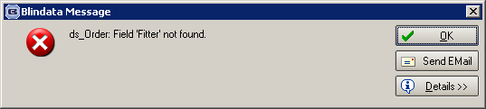

2617. Posting Invoices to Sage

If ‘Use Department Nominal Code’ is switched on and there is a record in the ‘Department Nominal Codes’ table, then the nominal code from this table is now used when posting to Sage, and not the one from the blind type record.

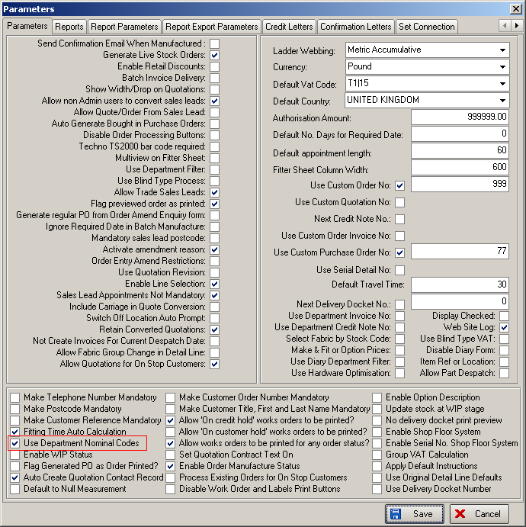

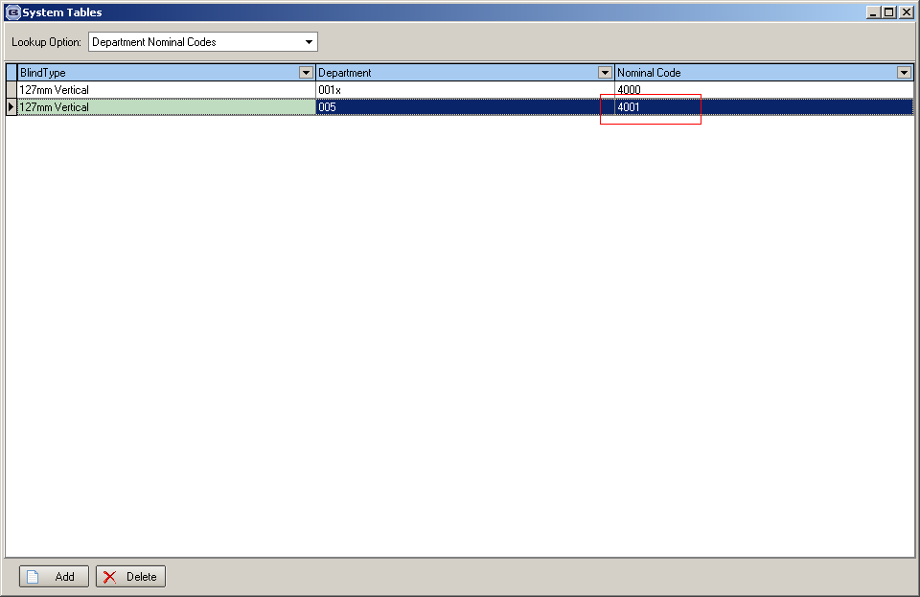

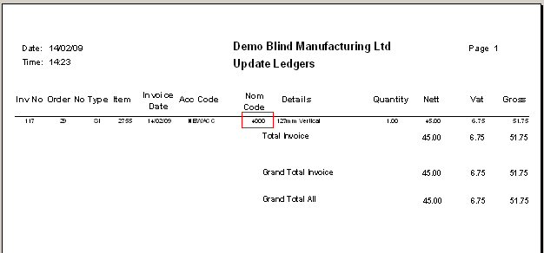

2618. Blind Details > Blind Types > Same Day Despatch

This field now defaults to false when the upgrade to 4.3.6 is done.

New Work and Customer Requests

1294. Order Processing > Orders

We have removed the decimal places if measurement = Metric in the detail entry form.

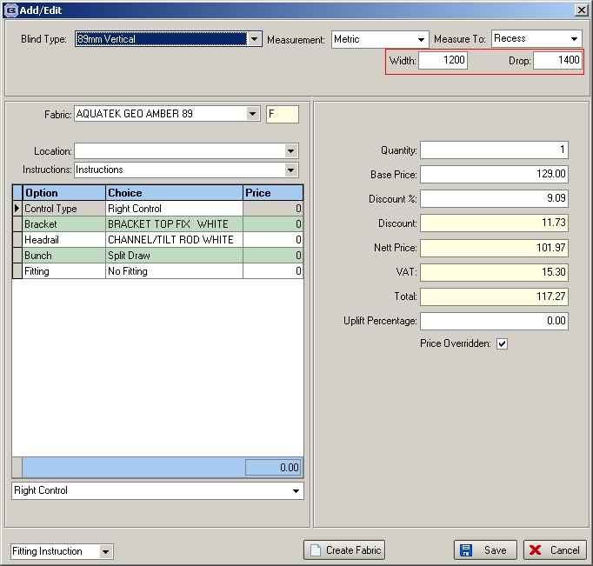

1295. Works Order – Three Copies

There is a new works order report called ‘Works Order – Three Copies’, which is based on ‘Works Order – Delivery 8’. The following changes have been made to it.

- Print both ‘entered size’ and ‘blind size (in metric) on the report. To achieve this, we have created a new option called ‘Entered Size, Blind Size, Metric’ in Use Measurement in Works Order Label’ in Administration > Parameters > Report Parameters.
- Three copies are printed out with different colour borders. White, pink, yellow.

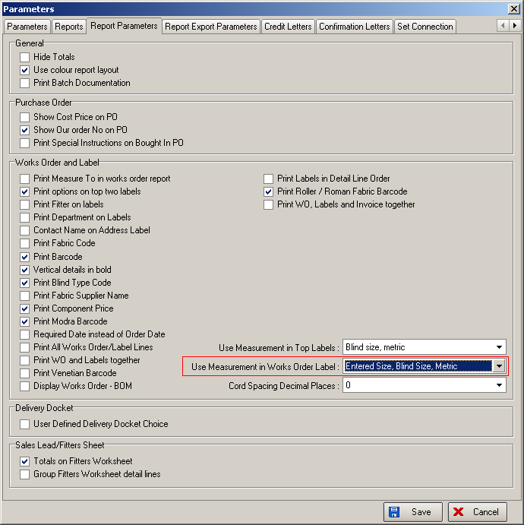

1297. Label Print – A4 2 x 11

There is a new label print that prints onto A4 paper. This paper has 2 labels across and 11 deep. The labels will be 95mm wide and 25.4mm deep. The labels will be set on the page so the A4 sheet is symmetrical, so the paper can be fed into the printer either way round.

The new label print is called ‘Label Print – A4 2 x 11’.

It looks at the label control to see what labels to print eg customer and production labels. The order of the labels printing is left to right, top to bottom.

1298. Invoicing (Specific Customer Request)

There is new functionality to print invoices at the same time as printing works orders and labels. The invoice date is left blank on the invoice print (Invoice – Bespoke 25). We have also added in a carriage amount if it is applicable – it is the same routine as in ‘Create Invoices’.

We have created a new parameter called ‘Print WO, Labels and Invoice together’ in Administration > Parameters > Report Parameters.

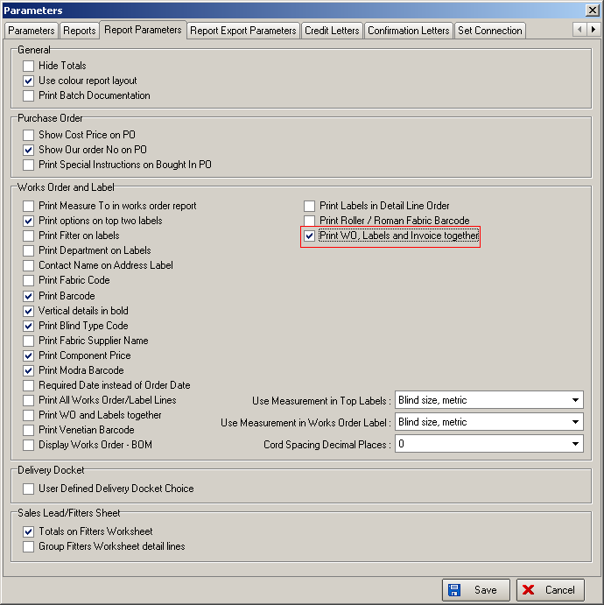

If this is set to true, then when the order is saved as an ‘Immediate Invoice’, we assign an invoice number to it and add a carriage line if necessary.

1299. Invoice – Bespoke 25

There is a new invoice layout based on ‘Invoice – Laser Print 11 Detail Lines’. This includes order date, uses order number as invoice number, and include VAT %.

1300. Order Processing > Orders

Manual orders for same day despatch customers are no longer defaulted to ‘Same Day Despatch’, and have to be flagged as such by the processor. However it will not be possible to set an order as ‘Same Day Despatch’ = true if the customer record is not ‘Same Day Despatch’ = true.

1301. Blind Details > Blind Types > Same Day Despatch

There is a new field in this table called ‘Same Day Despatch’. When an order is entered and ‘Same Day Despatch’ is set to true, the blind type record is now checked to see if it is also set to true for ‘Same Day Despatch’. This check is made when the detail line is saved, and also when the order is saved. If the blind type record is not same day despatch and the order has been flagged as same day despatch, then a message appears saying ‘This order contains blind types that are not set as ‘Same Day Despatch’, so the order cannot be set to ‘Same Day Despatch’. The ‘Same Day Despatch’ in the order will then be switched off.

When an EDI record is imported, this check is also made. If a record is imported and fails the ‘Same Day Despatch’ customer and blind type test, then a record appears in the EDI log. The order is imported, but ‘Same Day Despatch’ will be set to false.

1305. EDI Enquiry > JL EDI Import

When orders are imported using the ‘JL EDI Import’ button, the ‘required date’ is taken from the EDI file for all orders, not just those with code ‘012’.

1306. Sales Files > Customers

There is a new field in the customer table called ‘Allow EDI Own Descriptions’. This is held in the Customers > Options tab.

If this is set to true, then ‘Blind Type Description’ and/or ‘Fabric Description’ will be updated as described in dev 1275.

