Blindata Release Note 4.3.4 

3 February 2009

Bug Fixes and Enhancements

2588. Reports > Fabric Requirement Report

When you print this report, it was printing out 1000’s of blank pages. Fixed.

2593. Administration > Sage Utilities

If you tried to import customers to a second company and a record had a similar account code to a customer in the first company, the customer record company id was overwritten with the company id of the second company. This has been fixed along with similar issues with VAT Rate, Nominal Code and Products.

2595. Order Processing > Archive Enquiry > Remake / Repair / Redespatch

When using the copy order for remake/repair/redispatch option, the notes from the original order and the consignment note number were copied across to the new order. This is no longer the case.

2596. Bespoke Works Order

- If the order is for customer with trade type = Retail, then the customer contact name is printed (Title, First Name and Last Name).
- The font size and type for the headings are now all the same as ‘Label as’.
- ‘Measure To’ has been removed.

2597. Works Order – Label 5

The works order numbers have increased to 6 digits at a customer site. The top two labels of this works order now print all six digits of the order number on the top line.

2598. Order Processing > Orders > Receipts

If you entered a new order and then tried to enter a receipt before the order is saved, the following message appeared. This has been fixed.

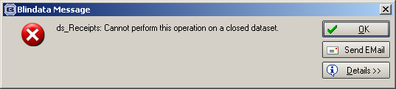

2599. Order Processing > Orders

If you entered an amount in the Actual field in Totals tab that was greater than the original amount a negative discount was created.

If you then went into the detail line and into the discount % field, you then got the following message.

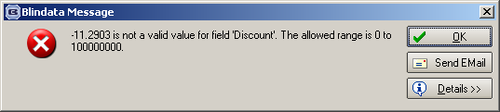

It is now possible to enter negative discount here.

2600. Quotations > Appointments

If you try to add an appointment (a survey) to a quotation, it is now saved properly.

2601. Quotations

If you entered ‘quotation text’ in a quotation, then went to ‘Totals’ and tried to change the ‘Actual Nett’ (or ‘Actual’ if customer trade type = retail), the following message appears. It is now possible to do this if there are quotation text lines in the quotation.

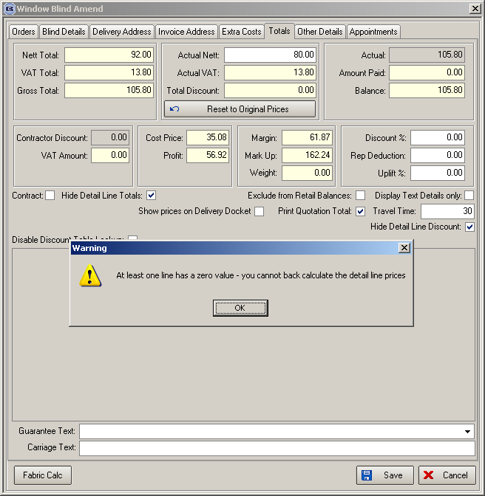

2602. Label Print 3 ½ x 1 - Standard

The Item and Order No fields are now in a slightly larger font.

New Work and Customer Requests

1260. EDI Import

We now hold extra fields in the EDILog table for order id and order detail id. The order id and order detail id are for the imported records.

1274. Sales Files > Mapping

This is a new menu option called Mapping (that has replaced Update Customer Credit).

There is now a form that allows a user to alter an EDI mapping record. Previously if a fabric, for example, has been mapped incorrectly, then it was not possible to amend it unless you amend the order detail line after it has been imported. This then created a problem with EDI orders that were imported automatically.

It is possible to select customer, then show outer code, outer description, inner code and inner description. The user is able to change inner code, so then next time an EDI import is done, the mapping is correct.

1275. EDI Import

One client has a customer that wants to include their own blind type description and fabric description with the EDI record. If this is done, then the ‘Customer Descriptions’ form in ‘Blind Types’ ‘Stock Items’ get updated with that description if it is not already there. This is done at the EDI import stage – the fabric code mapping will remain the same.

1279. Financials > Create Invoices

We have made a slight change to the logic where the ‘Same Day Despatch’ carriage charge is applied. Instead of comparing the order date to the despatch date, we now compare the original required date with the despatch date. If the despatch date is on or before the required date then the same day despatch charge is applied.

This will then catch any same day despatch orders that come in after the cut off as they are still treated as a same day despatch order for the next day.

1280. Works Order – A4 Packing Slip

It is now possible to have cutting sizes on the works order.
The fabric code now prints to the right of the supplier.
Blind type codes now print in ‘Complete Order’ box instead of blind identifiers.
Velux codes now print on works order.

1281. Invoice Print – A4 Batch Print

The font size on the detail lines is slightly smaller.

1285. EDI Enquiry > Import

It is now possible to send the ‘Carriage Type’ in the EDI transfer file. We have created an extra ‘mapping option’ for ‘Carriage Type’. If the field is blank or doesn’t match then it should default to ‘Standard’

1291. EDI Import

If a customer is on stop, orders are no longer imported from the EDI order tables. There is a new flag to say that the EDI record has not been imported because the customer is on stop.

1292. EDI Import

When an order is imported via EDI, the same ‘on credit hold’ check is now made as is currently done in the manual order entry and an order goes ‘on credit hold’ if necessary.

