Blindata Release Note 4.3.5 

6 February 2009

Bug Fixes and Enhancements

2604. Sales Analysis by Customer by Quarterly Comparison

This report was printing by rep and then customer order. It now only prints in customer order.

2606. Reports > Sales Lead Status Report

On the Sales Lead Status Report and Sales Lead Report, if a lead is changed to a quote and subsequently then to an order, the report now shows status as ‘Changed to Order’ instead of remaining as ‘Changed to Quote’.

2609. Order Processing > Orders

The ‘Email Invoice’ button is now enabled if the order status = Part Posted.

2610. Quotation – Laser Print by Option

The special instructions were being cut off on this report. They now wrap round onto the next line.

2613. Blind Box Assembly Instructions

The blind number was not printing on here properly. Fixed.

New Work and Customer Requests

1269. Order Processing > Orders

Previously when you converted a quote to an order, you lost all the contact management notes for the quotation. Now, if a quotation has been converted to an order, there is a button on the order amend enquiry form to view the quotation contact records.

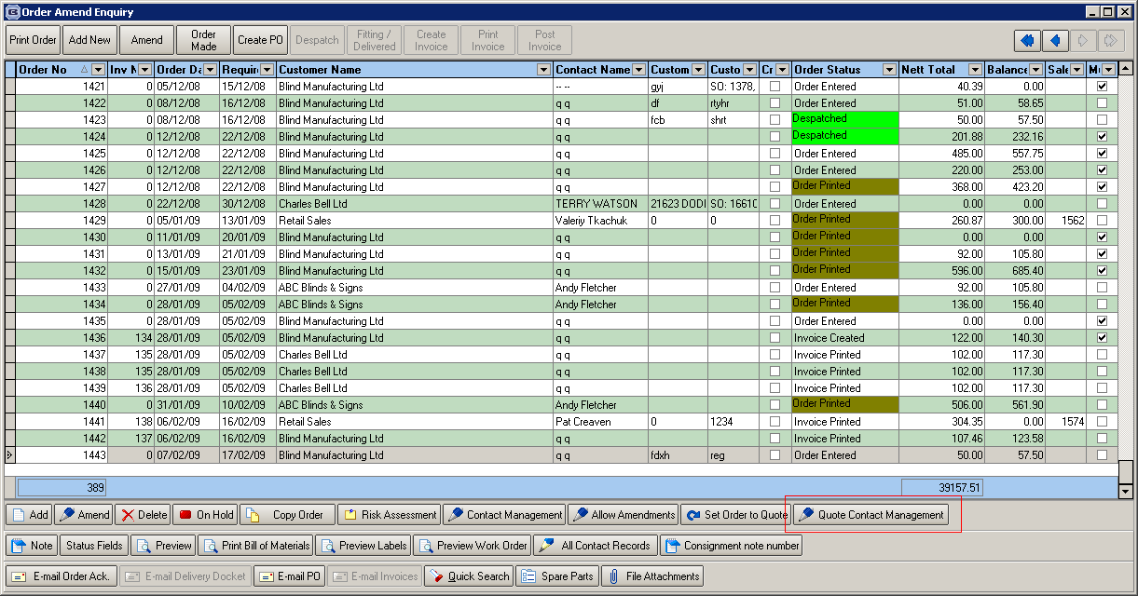

1270. Customer Receipt

- If a blind type has been entered as a free type blind, then the free type entered now prints (for both blind type and fabric free type) instead of the descriptions in the blind type and fabric records.
- It is now possible to print text in the bottom left of the receipt. This is taken from a new field in Administration > Company Details > Parameterised Invoice Etc Text, called ‘Receipt Text’.
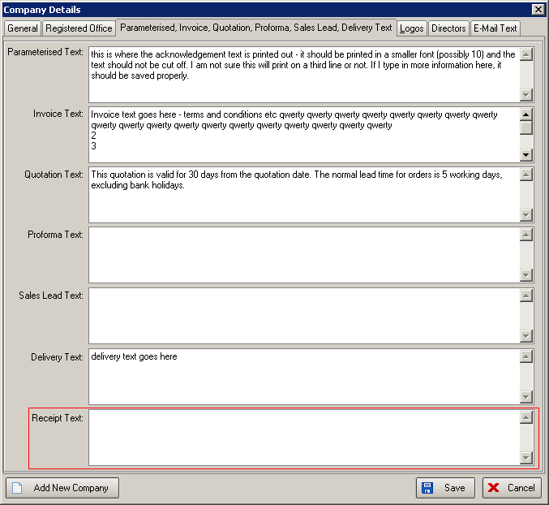

1271. Works Order – Bespoke 15

The despatch method now prints on this report.

1272. Order Processing > Orders > Window Blind Amend

We have added a ‘Copy to Clipboard’ choice to the context menu (right click on the form).

We have also added extra column choices. These are ‘Option List’, ‘Instructions’ and ‘Chain Length’.

1273. Order Processing > Orders > Window Blind Amend

We now have ‘Up’ and ‘Down’ buttons on the order detail form, so it is possible to adjust the order of the detail lines on the form.

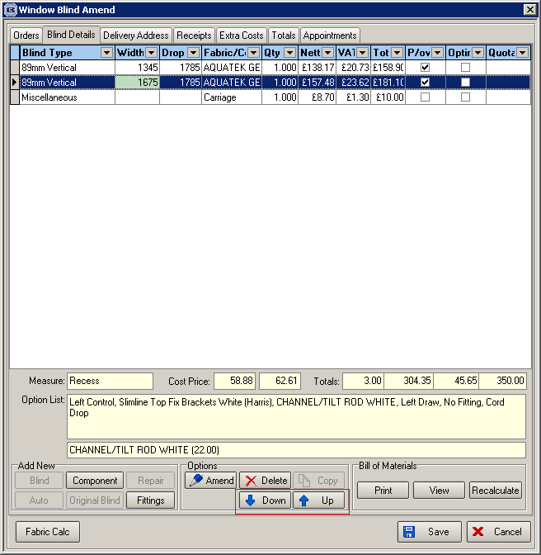

1278. Financials > Invoice Batch Print

It is now possible to print an invoice for each batch of orders that is received by EDI import.
For this new functionality to work, the following parameters must be set:

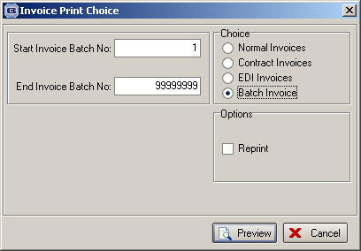

- ‘Parameters > Use Delivery Dockets Number’ is switched off.
- ‘Parameters > EDI > EDI Batch Invoice’ is switched on
- ‘Parameters > EDI > Use EDI Batch Number for Invoicing’ is switched on
- Administration > Parameters > Reports is set to ‘Invoice - Bespoke 8’.
- Sales Files > Customers > ‘Batch Invoice’ is switched on
- Sales Files > Customers > ‘Exclude from Invoice Batch Print’ is switched on

1293. Works Order – Portrait Barcode

We print the barcode for the first order detail id on the top right of the page (this is the same principal as Works Order Delivery 8’).

