Blindata Release Note 4.3.3 

23 January 2009

Bug Fixes and Enhancements

2589. Financials > Invoice Batch Print

This customer uses the ‘Delivery Docket Batch Print’ menu option and has all customers set up with ‘Batch Invoice’ = true. If you look at some orders, they will not print using the Invoice Batch Print.

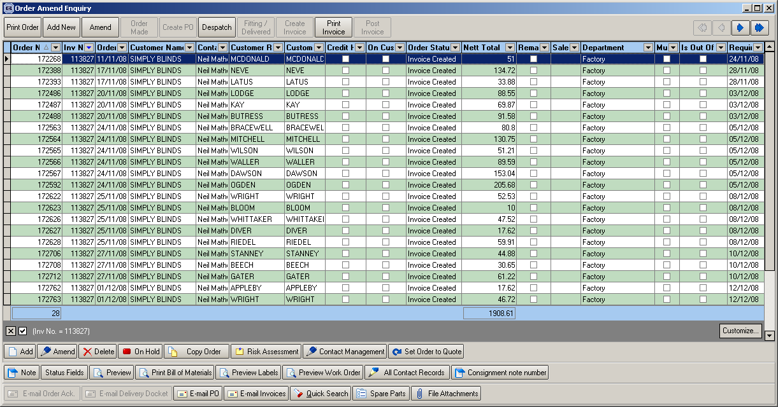

The invoice was not printed for order with invoice no 113827 because field ‘DeliveryBatchNo’ in the Order table was empty. This could have happened if parameter ‘Use Delivery Docket Number’ was switched off during the ‘Delivery Docket Batch Print’ routine. After creating a new order for the same customer with the ‘Use Delivery Docket Number’ flag switched on, the invoice printed out.

2590. Label Print – 3 ½ x 1 Standard

- The fabric calculation was wrong for vertical blinds. This has been fixed.
- The font for the sizes has been changed to ‘Times New Roman’ and increased in size.

2591 Delivery Docket – Batched Orders

- Width and drop no longer print if it is a component order detail line.
- For miscellaneous sales, the Comments are now printed properly on the right hand side.

2592. Works Order – Portrait

The total fabric calculation at the bottom of the report was wrong if the quantity was > 1 on a detail line. Fixed.

2594. Label Print – 3 ½ x 1 Standard

If the blind identifier = Vanes Only, the number of vanes and the fabric metreage now print on the label (like blind identifier = Vertical).

New Work and Customer Requests

