Blindata Release Note 4.3.2 

19 January 2009

Bug Fixes and Enhancements

2583. Label Print – 4 x 1 ½

The number of vanes is no longer overlapping onto ‘No of Vanes’ on the second and subsequent labels.

2584. Quotation – Bespoke 15

The blind type description was overlapping into the fabric description. We have moved the fabric description 10mm to the right but made sure it does not overlap into the width.

2585. Bespoke Works Order

If a pleated blind is entered (where blind type ‘Shaped Blind’ = true), the top rail and small height now print.

2586. Order Processing > Orders

The ‘Actual Total’ column (and all other amount columns) now display to 2 decimal places on the ‘Order Amend Enquiry’ form. This was caused by the Borland Delphi upgrade.

2587. Bespoke Works Order

The ‘Pleats’ field is now lined up (as centred) exactly under the text, which now says ‘Pleats Required’.

New Work and Customer Requests

1215. Customers > Generic Waiver

There is a new flag in the customer record called ‘Generic Waiver’. If it is set to true, then the recommended sizes warnings are ignored in the order entry program.

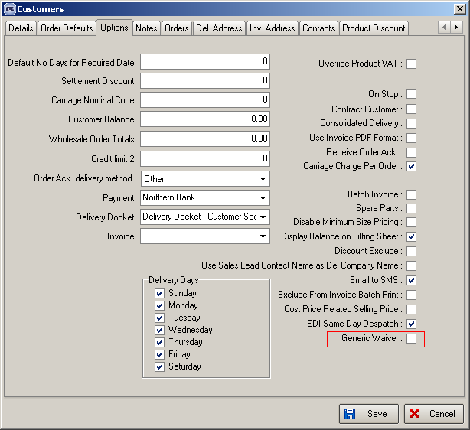

1255. EDI Import

There is a new column on this form that shows the name of the xml file that contained the imported data. This can be shown by choosing the ‘File Name’ column in the Context menu (you can see this by right clicking anywhere on the ‘EDI Enquiry’ form).

1261. EDI Enquiry

There are now start and end filter buttons on EDI Enquiry for both the ‘Sending Data’ and ‘Receive’ form. They both default to being for the last seven days.

In the ‘Sending Data’ form, the records shown default to the last seven days for ‘Transaction Date’.

In the ‘Receiving Data’ form, the records shown default to the last seven days for ‘Create Date’.

1262. Reports > System Reports > Customer Discount Report

Previously the promotion end date was printed. This is now the discount end date.

1265. Order Processing > Quotations

After copying a quotation, the user is now prompted to enter a new contact record (if ‘Auto Create Quotation Contact Record’ is switched on).

1266. Purchase Order Email

After a purchase order has been emailed to the supplier, the ‘Sent’ field is flagged as true.

1267. Order Processing > Quotations / Orders

If you enter a quotation or order with a large number of detail lines on it, and then adjust the price of the order in the Totals tab, all the detail lines are adjusted proportionately. However if the overall price had to be adjusted again, each individual line had to be changed back to the way it was (with the original line price and price overridden = false). This was extremely time consuming for the operator.

We now have a new button in the Totals tab called ‘Reset to Original Prices’. If this is clicked a message appears saying ‘Are you sure you want to reset all detail line prices?’. If the user says yes, then a repricing routine is run for that quotation / order. This is the same routine as the selling price repricing in Administration > Maintenance > Repricing, except that it includes detail lines where Price Overridden = true.

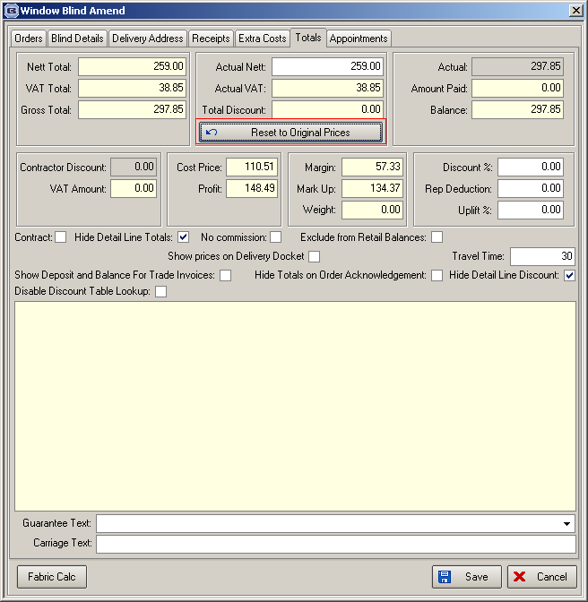

1268. Export Order / Invoice For Customs / Despatch Note

We have removed Title from the Delivery Contact Name on these documents. This means that just the First and Surname will be displayed.

This is for all UK, EU and World forms.

