Blindata Release Note 4.3.0 

19 December 2008

Bug Fixes and Enhancements

2556. Invoice – Bespoke 15

The payment terms is now taken from ‘Invoice Terms’ in the customer record.

2557. Acknowledgement – Laser Print (Letterhead Logo)

If there is a ‘Customer Add Ref’ held against the customer record, then it should be printed instead of ‘Account Ref’.

2559. Credit Note (Letterhead Logo)

‘Registered Office: Registered Office, Registered Office Address, Reg No: Reg No’ now prints along the bottom of the report. The text is centred and is in 8 pitch.

2560. Fitter Sheet 15

- The records were split across different pages by blind type – fixed.
- The quantity (from detail line) now appears between drop and fabric colour.

2561. Order Processing > Quotations

If you enter a quotation that has ‘free type’ blind type and fabric descriptions, it now copies the ‘free type’ properly when converting to an order.

2563. Fitter Sheet / Sales Leads > Sales Lead Enquiry

It is now possible to amend a sales lead if it has a status of ‘Pending’. The button was greyed out previously.

2564. Fitter Sheet 15

If ‘free type’ blind type and fabric description are entered, they now appear instead of the blind type description and fabric description.

2565. Order Processing > Quotations > Create Order

When you create an order or a quotation from a sales lead, the ‘Carriage Type’ record in the order is filled with the default.

New Work and Customer Requests

1256. Order Processing > Orders

Recently we created a column for ‘Fitting Date’ in the column choice. This selected the fitting date from the first fitting appointment for the order. We have now added a column for Fitter.

1257. Order Processing > Archive Enquiry

There are two new column choices for ‘Fitting Date’ and ‘Fitter’. The same rule applies as with ‘Order Amend Enquiry’ – the first fitting appointment for the order is selected.

1258. Label Print – 3 ½ x 1 Standard

A new label print has been created, called ‘Label Print – 3 ½ x 1 Standard’. This has the same layout as ‘Label Print – 3 ½ x 1 Process Barcode’ except there are no labels for barcodes. It only print labels according to how many records there are in the Label Control table ie the same as ‘Label Print – 3 ½ x 1’.

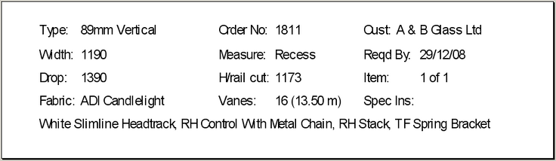

1259. Works Order – Delivery 8

The options now appear immediately underneath the detail lines (if switched on in Blind Details > Field Setup > On Works Order = true).

