Blindata Release Note 4.2.9 

15 December 2008

Bug Fixes and Enhancements

2552. Order Processing > Batch Manufacture

The ‘Batch Manufacture’ routine is now working again.

New Work and Customer Requests

1230. Invoice - Bespoke 17a

A new invoice layout has been created. However this can be specific to the customer so we have created a new field in the customer record to hold the invoice layout required. If this is null, then the standard invoice print is used. If the ‘Invoice’ field is filled in, the ‘Exclude from Invoice Batch print’ will be set automatically to true.

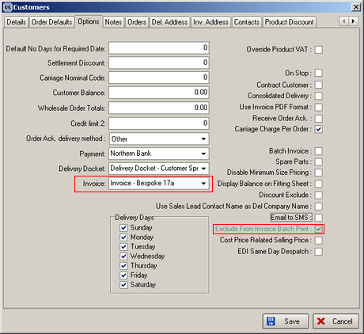

1251. Order Processing > Orders and Administration > Maintenance > Repricing

There is a new flag in the ‘Totals’ tab of the order called ‘Disable Discount Table Lookup’. If this is set to true, then when order detail lines are entered, the pricing will not look up any discounts that are held in the discount tables. The purpose of this is to allow a user to enter an overall discount or a total amount against the order in the Totals tab – because this does not work if any discounts have already been applied to individual detail lines.

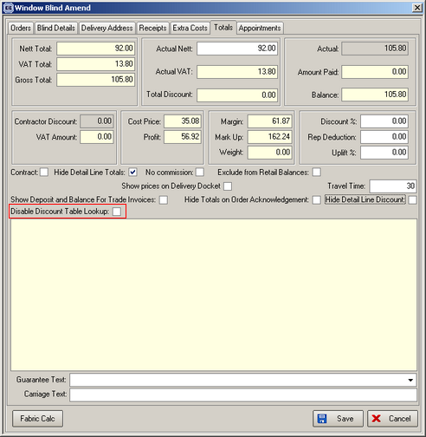

We have also adjusted the Administration > Maintenance > Repricing routine so the repricing takes the ‘Disable Discount Table Lookup’ into account.

1252. Order Processing > Order Enquiry

There are two new buttons on this form, called ‘Blind Process Scan’ and ‘Order Process Scan’. These buttons have advanced permissions in Administration > Users > Advanced Permissions.

The purpose of these buttons is to scan orders so processes for blinds can be updated.

Order Process Scan

The barcode that is scanned is the one printed on ‘Works Order – Delivery 8’ (the blind id).

When the ‘Order Process Scan’ button is selected, a form is displayed, where a scan can be done.

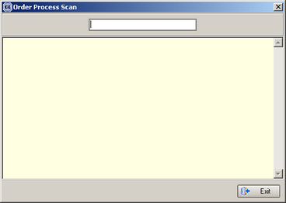

When the scan is done, the manufacturing processes relating to the blinds in that order are displayed. The user is then able to choose which process they want to complete. When this is selected, all the relevant process transactions for the blinds in that order are created. If all the processes for a blind within the order have been completed, then the status of the blind changes to ‘Blind Manufactured’. If all the blinds are manufactured, then the status of the order changes to ‘Fully Manufactured’.

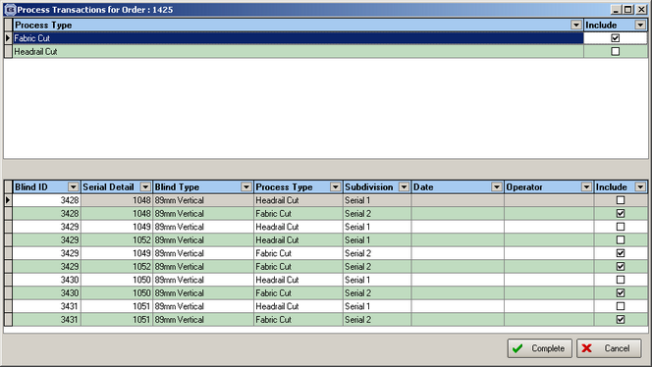

Once this has been done, it is possible to see the process transaction by clicking on the relevant button on the bottom left of the ‘Order Enquiry’ form.

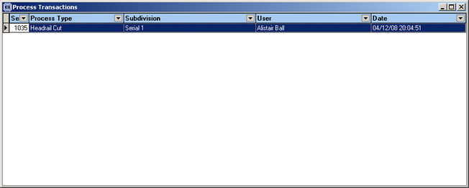

Example

There is a blind type for ‘89mm Vertical’ that has 2 manufacturing processes, ‘Headrail Cut’ and ‘Vanes Cut’. There is also a ‘Roller’ blind type that has 1 manufacturing process, called ‘Roller Made’.

There is an order for three 89mm Vertical blinds and one roller blind. When the ‘Order Process Scan’ is chosen, and the barcode is scanned, the user will be able to choose from three manufacturing processes: ‘Headrail Cut’, ‘Vanes Cut’ and ‘Roller Made’. If the ‘Roller Made’ is selected, then a process transaction is created for this order detail line, and the status of the detail line changes to ‘Blind Manufactured’. Later on the barcode is scanned again, and the ‘Headrail Cut’ process is chosen. Two process transactions are created, one for each 89mm vertical blind. The scan is then done again after the vanes have been completed. This time, two process transactions are created for ‘Vanes Cut’, the vertical blind detail lines get changed to ‘Blind Manufactured’ (because all the processes for the blind have been completed) and the order status is changed to ‘Order Manufactured’ (because all the detail lines have been manufactured).

Blind Process Scan

The barcode that is scanned is the one printed on ‘Works Order – Label Blind Size’.

When the ‘Blind Process Scan’ button is selected, a form is displayed, where a scan can be done.

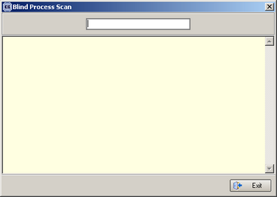

When the scan is done, the manufacturing processes relating to the blind detail line for that barcode should be displayed. The user should then be able to choose which process they want to complete. When this is selected, the relevant process transaction for that blind detail line should be created. If all the processes for a blind within the order have been completed, then the status of the blind should change to ‘Blind Manufactured’. If all the blinds are manufactured, then the status of the order should change to ‘Fully Manufactured’.

1253. Hardware Optimisation

We have introduced functionality that will allow users to calculate the best way to cut lengths of headrail or tube. As an example, white headrail is bought in 5 metre lengths. If we have a number of orders that have detail lines in them with blinds that need white headrail, we need to calculate the best way to cut them from 5 metre lengths.

Example: we have 3 orders

Order 1 has 4 blinds with headrail widths 1340mm, 1560mm, 1675mm and 875 mm
Order 2 has 6 blinds with headrail widths 2113mm, 1650mm, 1650mm, 1332mm, 1458mm, 1602mm
Order 3 has 2 blinds with headrail widths 895mm, 1154mm.

That is a total of 17304mm. We also have to allow for the fact that the saw will use an amount eg 2mm. We know that we will need 3 5 metre lengths of headrail to make these blinds, but we need to work out the most efficient way to cut the headrails from the 5 metre lengths, so that we use as much as possible from each 5 metre length.

Therefore we have created an algorithm that will work out the most efficient way to cut the headrails. Here is how the result might look.

1675 + 1650 + 1650 + 6 = 4981
1340 + 1560 + 895 + 1154 + 8 = 4957
2113 + 1332 + 1458 + 6 = 4909
1602 + 875 + 4 = 2481

This means we will use three 5 metre lengths and 2.481m of a fourth length. This can be kept but the remainder (3 pieces of 19mm, 43mm and 91mm) is scrap. The scrap % on these 3 lengths is therefore (19 + 43 + 91) / (5000 * 3) = 1.02%. The scrap % on 4 lengths is (19 + 43 + 91 + 2519) / (5000 * 4) = 13.36%.

Software Changes Made

There is a new parameter in Administration > Parameters called ‘Use Hardware Optimisation’. This must be switched on for it to work.

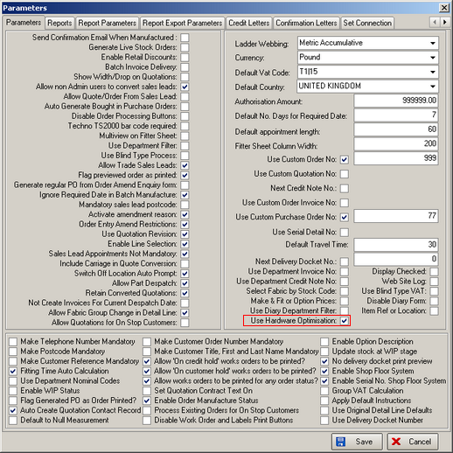

There is a new field in Stock Setup > Stock Details > Regular PO Options called ‘Hardware Optimisation’.

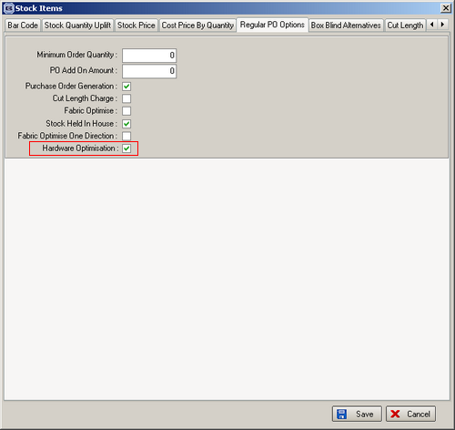

The size of the stock item bought eg headrail can be held in the ‘Roll Width’ field in the stock item.

We also hold an amount for the amount lost when the saw cuts the hardware. This is held in the stock item record in ‘Cutting Wastage’, formerly called ‘Cloth Thickness’.

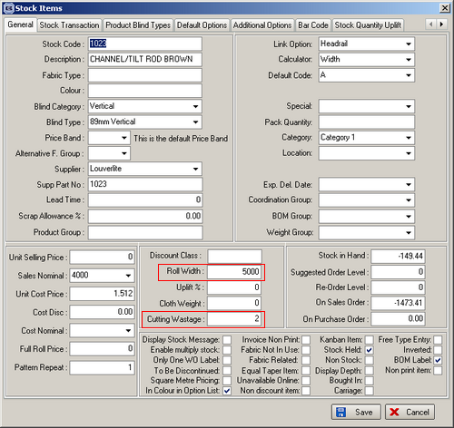

We have changed the title of the menu option ‘Fabric Optimisation’ to say ‘Optimisation’ and made some amendments to the optimisation form.

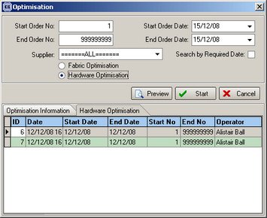

There is now a tick box to choose between ‘Fabric’ and ‘Hardware’. If ‘Hardware’ is chosen, then the optimisation is done according to the criteria. This will check all stock transactions for sales orders where the stock item has ‘Hardware Optimisation’ = true and will use the ‘Roll Width’ field as the size of the hardware item. Each time a cut is made, the ‘Cutting Wastage’ amount will be added to the amount that is being cut from the hardware piece.

The user will then be able to preview a report which will show:

Start Order No:
End Order No:
Start Order Date:
End Order Date:
Stock Code: Stock Description:
1675 + 1650 + 1650 + 6 = 4981
1340 + 1560 + 895 + 1154 + 8 = 4957
2113 + 1332 + 1458 + 6 = 4909
1602 + 875 + 4 = 2481
Scrap % on 3 lengths = 1.02%, Scrap on 4 lengths = 13.36%
The records are grouped by supplier.

Once the orders have been hardware optimised, it is possible to see this in the ‘Bill of Materials’ form.

