Blindata Release Note 4.2.8 

10 December 2008

Bug Fixes and Enhancements

2550. Order Processing > Quotations > Contact Management

If you have ‘Non Live Next Action Days’ set to 21, then when you enter a contact record for a quotation where ‘Live’ = false, it now sets the ‘Next Action Date’ to the current date + 21. Previously it was setting this to current date + 7 days.

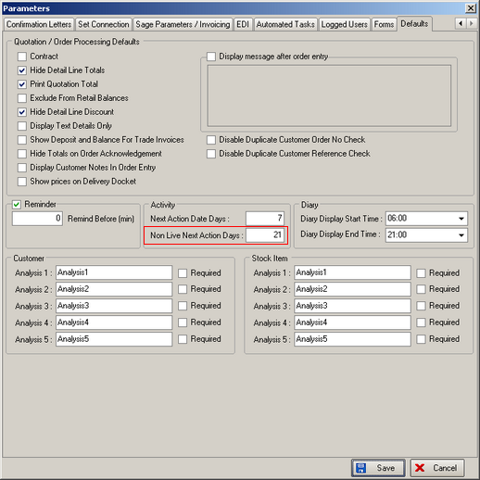

New Work and Customer Requests

1214. Administration > Users > Advanced Permission

There is now an advanced permission button for the ‘Remake/Repair/Resdespatch’ button on the ‘Archive Enquiry’ form.

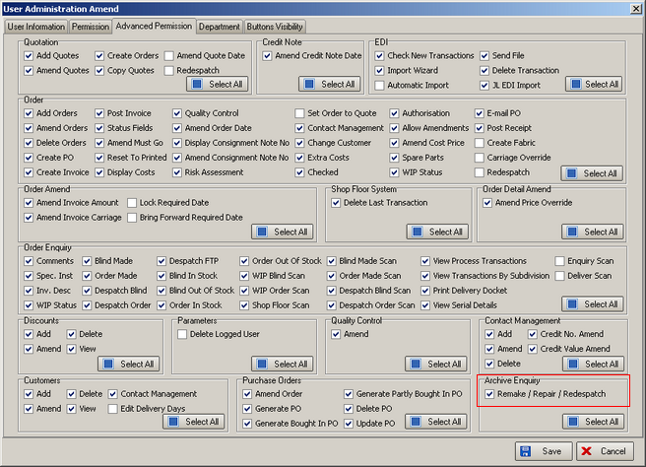

1236. Blindata Upgrade

There is now an option to select what database to upgrade when upgrading to a new version. It defaults to the Blindata database, but there is a check box (which will default to false) that can be ticked so a different database can be upgraded.

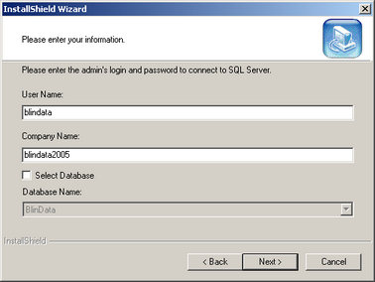

1254. Order Processing > Quotations

We have introduced a new parameter to stop the processing of quotations for customers that have ‘On Stop’ = true. The parameter is in Administration > Parameters > Defaults and is called ‘Allow Quotations for On Stop Customers’. This defaults to true. If set to false, when the customer is entered for a new quotation, a message appears saying ‘This customer is on stop. A quotation cannot be entered’.

