Blindata Release Note 4.2.6 

28 November 2008

Bug Fixes and Enhancements

2258. Order Processing > Orders

W11 and W12 options are now getting selected if W10 is chosen. This now behaves in the same way as W1 works ie if a W1% wood slat is chosen, the options for bottom bar and valance (codes W3% and W5% get selected).

2525. EDI Transmission

The ftp method now being used in Blindata is an passive ftp, when previously it was active ftp.

2526. Fitters Sheet / Sales Lead

If a sales lead had been entered and had already been assigned to a customer account before it was turned into an order, when it was turned into an order, the required date = sales lead date. This was incorrect. The required date is now calculated according to the normal rule when manually entering an order for that customer account.

2527. Reports > System Reports > Stock Transaction Totals

The quantity figure no longer picks up stock transactions that are for quotations.

2528. Purchase Order Enquiry > Generate PO

Purchase order records are now only generated for stock transactions that are sales orders, and not for those stock transactions that are tied to quotations.

2529. Order Processing > Orders

The display of the option list was determined by the settings in Blind Details > Blind Types > Field Setup > On Invoice. If the option was not set to true here, it did not display in the Blind Details tab in the order. The options now always appear in the option list display in this form.

2530. Blind Details > Blind Types > Cutting Options

These fields display properly if you entered them to 2 decimal places, but if you entered only one decimal place, multiple decimal places display. This has been fixed.

2531. Quotation – Bespoke 21

There is now a blank line in here to separate the text into paragraphs.
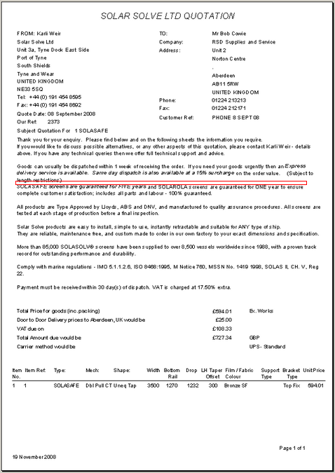

2532. Archive Enquiry > Redespatch / Remake

If you created a ‘Redespatch’ or ‘Remake’ order from an archived order, it sets the status to ‘Order Entered’, which was correct, but if you then amended that order, it changed the status to ‘Order Manufactured’. The status now stays as ‘Order Entered’.

2532. EDI Import

When an order with a ‘box blind’ is imported via EDI, the imported detail line did not take min/max width/drop deductions into consideration. It did not apply the ‘Measure To’ recess etc before checking the sizes. This is now being done.

2533. EDI > Same Day Despatch and EDI > Customer > Must Go

The Must Go flag is not analyzed at the SDD Carriage line adding stage. The routine only looks for orders with ‘Same Day Despatch’ = true.

2534. EDI Import

If an order is imported via EDI and has ‘Same Day Despatch’ = true and the customer has ‘Same Day Despatch’ = true and it misses the cut off date and it is a Friday, the required date is calculated as the next day, a Saturday. It is now the next working day, so it looks up the Weekend/Holiday table.

New Work and Customer Requests

1226. Reports > System Reports > Stock Take Report

1. We now have a supplier choice as well.
2. Records can now be in stock code order or stock code description order.

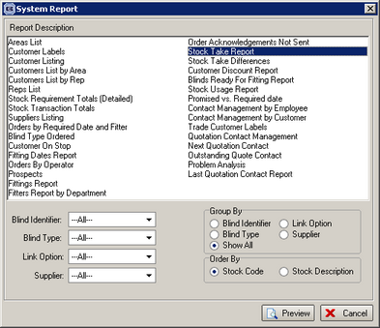

1229. Order Processing > Orders

We have a flag called ‘In Colour In Option List’ in Stock Setup > Stock Items. If this is set to true, the options in the blind detail entry are also shown in colour (if they are not the default options).

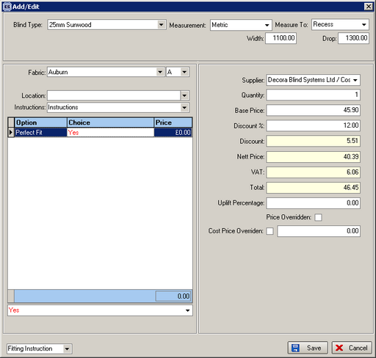

1231. New Delivery Docket

A new delivery docket layout has been created, called ‘Delivery Docket – Bespoke 17c’.

This will be used to print delivery dockets for a specific customer.

1232. Order Processing > Delivery Docket Batch Print

If one of the van despatch manifests has been selected and is held in Administration > parameters, it is now possible to choose by customer in this form.

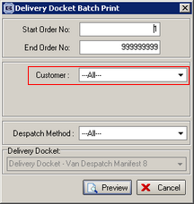

1233. Order Processing > Orders

There are new parameters to switch off the duplicate cust ord no and customer ref check in order entry. They are held in ‘Administration > Parameters > Defaults.

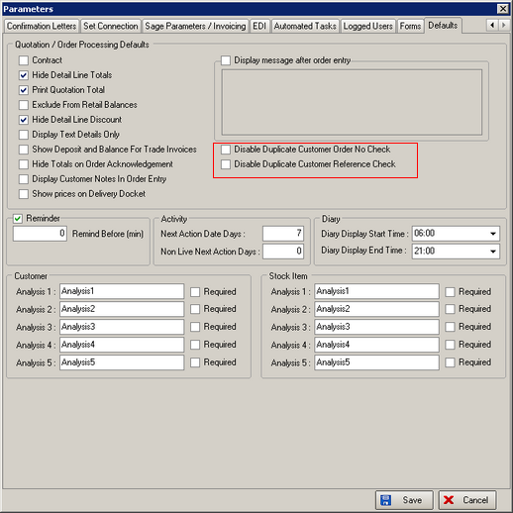

1234. Label Print 3.5 x 1 Process Barcode

A new 3.5” label print called ‘Label Print 3.5 x 1 Process Barcode’ is required has been created.
This is required because one client is going to implement the shop floor and ‘blind type process’ parameters so that the barcodes can be generated with serial numbers and processes on them We now have a similar barcode on these labels, identifying blind id and process id.
If the barcodes for each process are printed on labels, then the ‘Shop Floor Scan’ in Order Processing > Orders can be used to update the status of blinds and orders. This functionality is already working.
The idea is that we print out on 3.5” x 1” labels, with 2 different types, ‘Production Label’ and ‘Barcode Process’ labels.

There will be a different number of labels depending on the way the blind type ‘Label Control’ and ‘Man Process Types’ have been set up.

For example, for rollers, we need two roller labels and then one barcode process label, for verticals we need two vertical labels and two barcode process labels. But if there is more than one process set up for a blind type, the barcode labels need to be printed out after each production label. But we only need to print one process label after each production label and we need to work out which one to print.

So they would print out in this order.

Roller label 1
Roller label 2
Roller barcode
Vertical label 1
Vertical barcode 1
Vertical label 2
Vertical barcode 2

The following setup needs to be done. First we need to set up records in the ‘Free Type’ field for ‘Label Control’.

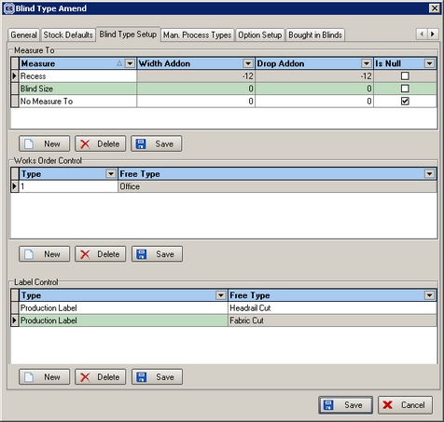

Then we need to set the order of the labels by going to the ‘Man Process Types’ field. There is a new field here called ‘Print After Label Control’.
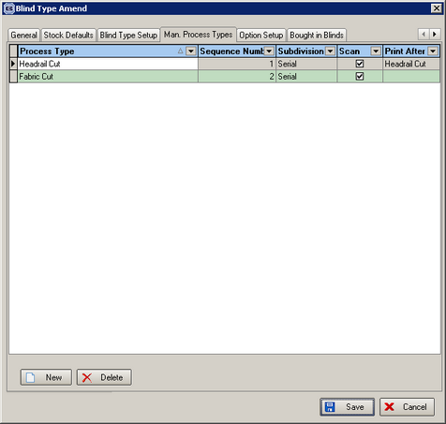

1235. Purchase Order Regular – Standard

The total value for the purchase order now prints.

1250. Administration > Maintenance (Urgent)

We have introduced new criteria in this form so that we can adjust the selling price of only quotations and all orders with status before ‘Invoice Created’ ie orders with status = ‘Order Entered’, ‘Order Printed’, ‘Work in Progress’, ‘Order Manufactured’, ‘Despatched’, ‘Part Delivered’ and ‘Delivered’.

There is also the possibility to change quotations as well.

This is required because VAT will change to 15% from December 1 and we have to adjust all existing orders and quotations in Blindata.

There is also a new tick box called ‘VAT Only’. If this is ticked, then ‘Selling Price’ will be unticked automatically.

If ‘VAT Only’ is ticked, the following differences to the existing logic now take place:

- The detail lines (base price and options) will not get repriced
- ‘Price Overridden’ records will be included

The new VAT rate will be found and the detail lines and order totals recalculated.

We also have a criteria for choosing Orders or Quotations.

So when you want to change the VAT amount for existing sales orders, you should set the form with the following criteria. It is extremely important that the criteria are set properly before running this routine. A backup should be taken. This must be run after you have changed the VAT rate to 15% in Administration > System Tables > VAT Rates.

