Blindata Release Note 4.2.4 

7 November 2008

Bug Fixes and Enhancements

2499. Order Processing > Orders

If ‘Allow Horizontal Join’ = true, then if blind drop > roll width, for no fabric stock items where calculator = ‘Width’, the quantity was being multiplied by 2 or more depending on the blind drop size. It now calculates as just the width.

2506. Order Processing > Orders

If you filtered orders, it was possible to delete the wrong order because the record pointer was not pointing at the first filtered record. If you look at this form, we have filtered the records by customer = ‘ABC Blinds and Signs Ltd’, then clicked on the arrows (1) to go to the last record, but the record pointer (3) is not showing on the form now. The arrows do not seem to work properly if the filter is on.

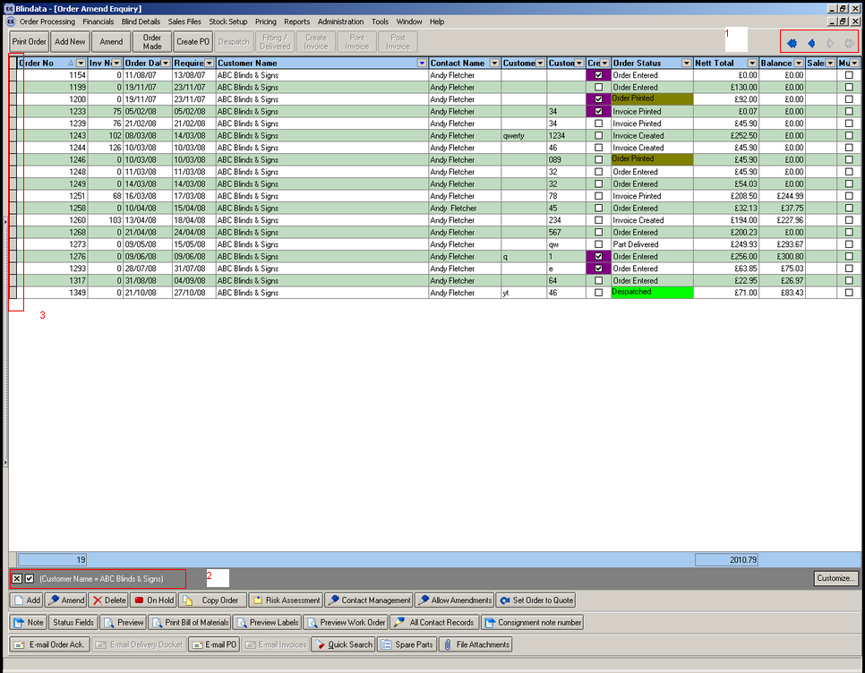

2507. Despatch Docket – Customer Special

If there is a ‘Blind Type Description’ set up in the Blind Type record, then it is now used in this print.

2508. Order Processing > Delivery Docket Batch Print

It is now possible to select the ‘Despatch Method’ if the delivery docket is a ‘manifest’ type docket.

2509. Order Processing > Quotations

The quotation enquiry form was very slow after the introduction of the cost price field as a column choice, so it has been removed.

2510. Order Processing > Archive Enquiry

When doing a Redespatch or Repair to create a new order from the archived order, the balance was being brought across. This is no longer happening.

2511. Reports > Lead Times

If you chose ‘By Blind Type’ or ‘By Customer’, a message says there were no records to print. Fixed.

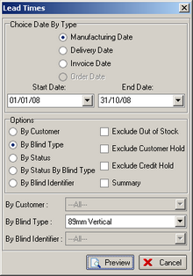

2512. Order Processing > Orders

If ‘allow Fabric Group Change in Detail Line’ is switched on, then if you enter one detail line and then change the fabric, the fabric group did not get updated. Fixed.

2513. Fitters Sheet / Diary

When you converted a sales lead to an order, and a fitting appointment is created at this point, the appointment was being assigned to the rep instead of the fitter. Fixed.

2514. Delivery Docket – Customer Special

The layout of this report has been changed.

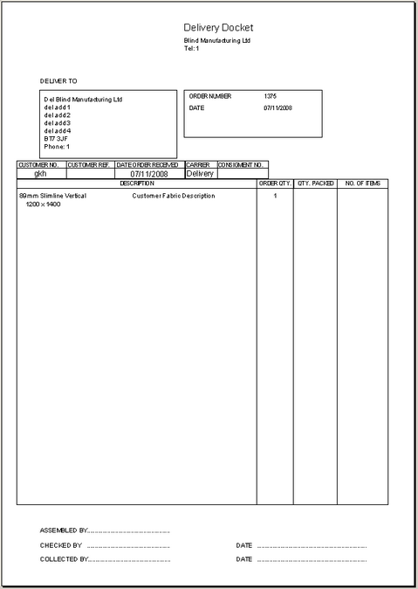

2515. Delivery SMS Message

Previously the SMS message said: Delivery notification for order 1372 from: Demo Blinds LtdThe blinds are on the way. We have made the following change:

The company name (in the example above ‘Demo Blinds’) is now the company name from the order record, not the company record).

2517. EDI Import

When you import an order with a customer specific required date via EDI, the ‘Customer Required Date’ flag is now set to true.

2518. Despatch Label 4 x 2

If the blind type description uses the ‘customer description’, it was being cut off. Fixed.

2519. Works Order Label 1

For blinds with a lot of options, they overran the label. Fixed.

New Work and Customer Requests

1217. Additional Options by Width/Drop and Blind Type

There was an omission in the current functionality for Blind Types > Additional by Width/Drop. The field ‘Group’ was looking up the ‘Fabric Group’, but it is now a free text field. We have also specified the order of choice, so another field has been added called ‘Order’.

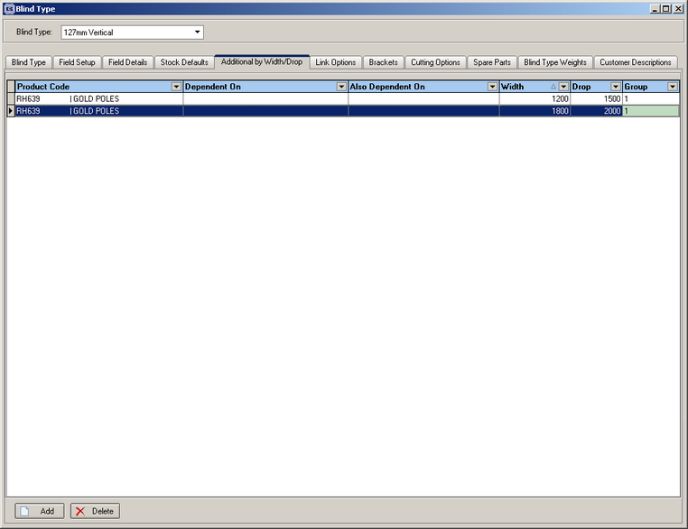

The field group is a free type text field and is used to prevent multiple stock items in the same group from being added to the bill of materials. The first stock item in each group that matches the criteria for the detail line being entered is added to the bill of materials using the stock item calculator, default code and quantity. All other stock items in the same group are ignored. The system then moves down the list until it reaches a new group and then continues to match stock items to add to the bill of materials.

For example:

A blind is entered with a width of 1200 and a drop of 1800. The first stock item in the Additional Options that matches these criteria is added to the Bill of Materials. In this case it is the first record down the list. All other stock items in the same group are ignored. The procedure then moves down the list until it finds the next group, which is “Motor”, and then adds the next stock item that matches the same criteria. This process is continued until the end of the record set is reached.

Dependent On / Also Dependent On

If either of these fields are filled in then the stock item entered into this field must match an option that has been selected in the detail line.

1218. Order Processing > Order Enquiry

There is now an ‘Advanced permission’ for the ‘Deliver Scan’ button.

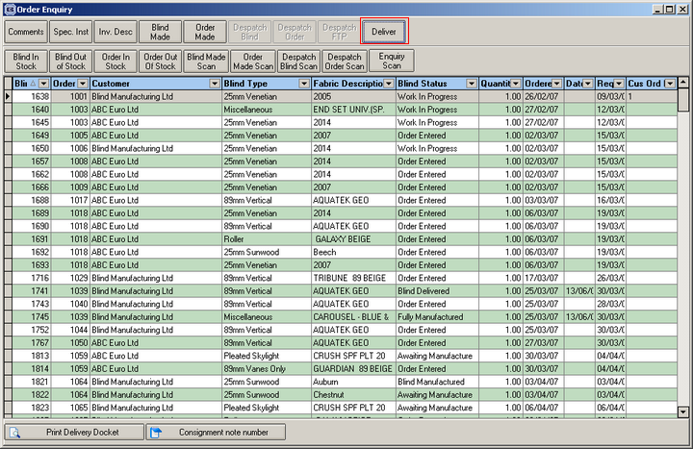

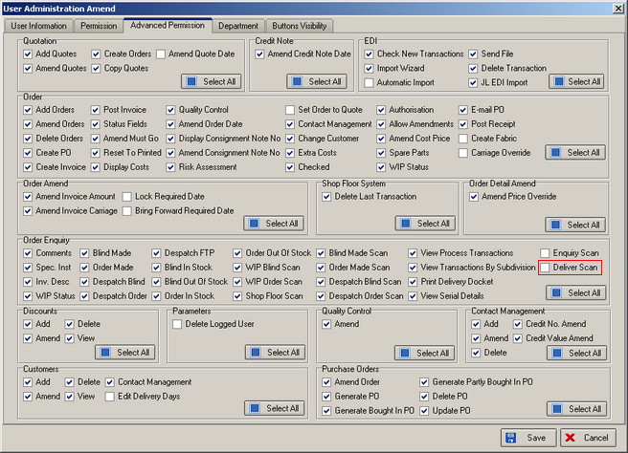

1219. Works Order – Label 1

If there are records for customer description for the blind type and fabric description for the customer, they now appear here instead of the standard blind type and fabric description.

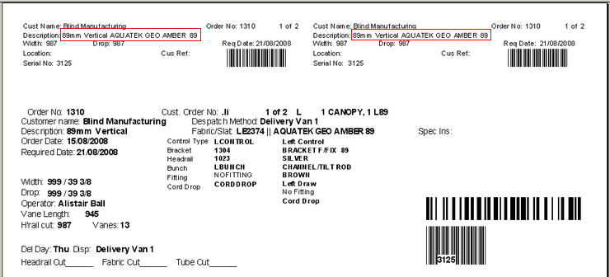

1220. Order Processing > Orders

When an order is created, or has been imported via EDI, and if there is a required date different from the generated one, a flag is now updated to indicate this. The flag is called ‘Customer Required Date’ and is displayed as a read only field in the order entry form in the bottom right area below ‘Same Day Despatch’. It is also a column choice in ‘Order Amend Enquiry’.

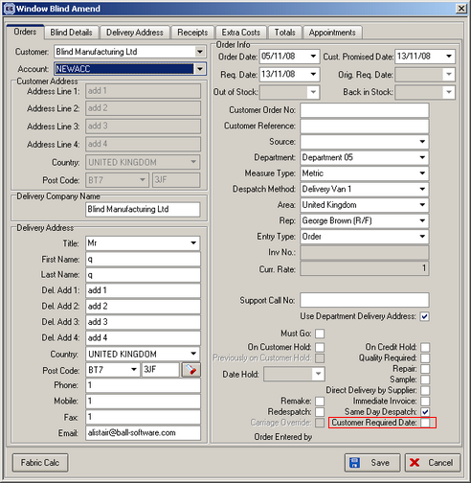

1221. Despatch Label 4 x 2 / Despatch Label 4 x 3

The blind type now prints the blind type description, not the blind identifier description. Also, if there is a customer blind type description, it prints instead of the standard description.

1222. Order Processing > Archive Enquiry > Redespatch

For Redespatch, we have changed the order status to ‘Order Entered’, not ‘Order Manufactured’.

Also, when selecting lines, it was easy not to pick the last one. A message now appears saying ‘Do you want to save this record?’ to stop this happening.

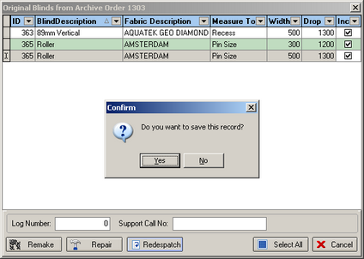

1223. Works Order – Label 1

For roller blinds, a letter is now printed for the roller calculator next to width and drop. If calculator = Width, letter = W, for Drop = D, for ‘Width or Drop’ = T.

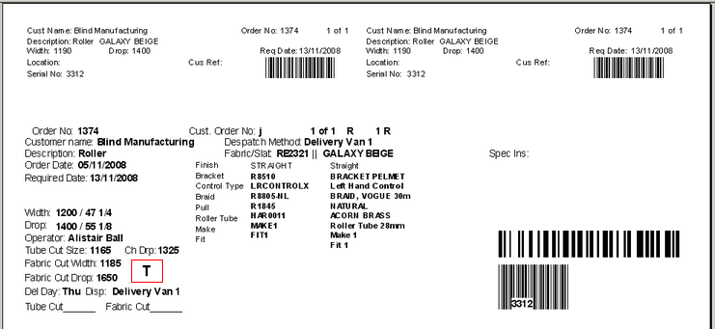

1224. Works Order Label Blind Size

This field now say ‘Print Roller / Roman Fabric Barcode’. If ticked, the barcode will now print on labels where blind identifier = Roller and blind identifier = ‘Austrian/Roman’.

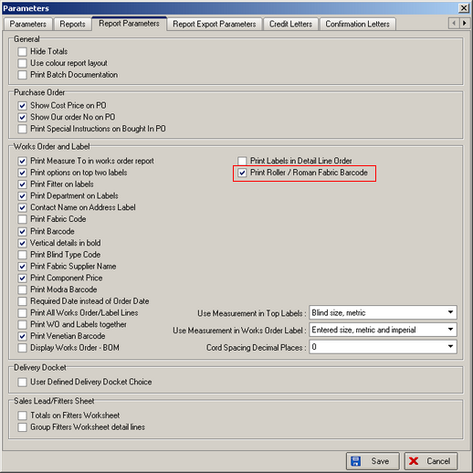

1225. Sales Files > Customers

We have included the ‘prospect’ and ‘Inactive Customer’ fields on the column choice.

