Blindata Release Note 4.2.5 

14 November 2008

Bug Fixes and Enhancements

2520. Label Print – Bespoke 18

Previously the quantities in the bill of materials were being multiplied by the quantity in the detail line. Now they only show the quantities for the BOM for one blind.

2521. Label Print 3 ½ x 1 – No Desc

- The order number space has been expanded so it goes closer to ‘Date’.
- ‘Ord.’ has been removed to make room for the order number.

2522. Works Order – Label 8

The invoice comment second and subsequent lines are now printing when a component line is entered.

2523. Order Processing > Orders

It is no longer possible to delete an order with an order status = Despatch.

New Work and Customer Requests

1227. Quotation – Bespoke 21

- The text in the rectangle has been replaced by the text below.
- ‘LH Taper O/S’ now says ‘LH Taper Offset’.

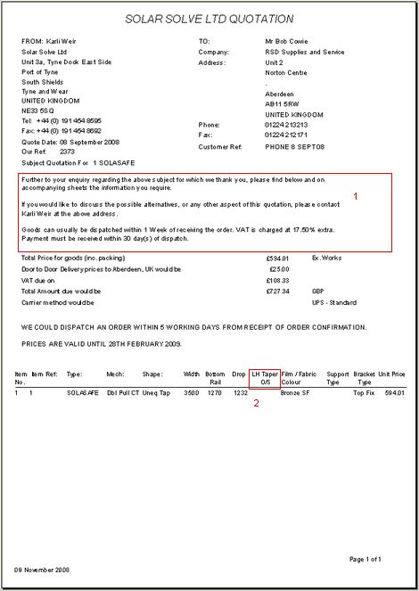

Thank you for your enquiry. Please find below and on the following sheets the information you require.
If you would like to discuss possible alternatives, or any other aspects of this quotation, please contact ??? ????? – details above. If you have any technical queries then we offer full technical support and advice.

Goods can usually be dispatched within 1 week of receiving the order. If you need your goods urgently then an Express delivery service is available. Same day dispatch is also available at a 15% surcharge on the order value. (Subject to length restrictions)
SOLASAFE screens are guaranteed for FIVE years and SOLAROLA screens are guaranteed for ONE year to ensure complete customer satisfaction; includes all parts and labour - 100% guaranteed.

All products are Type Approved by Lloyds, ABS and DNV, and manufactured to quality assurance procedures. All screens are tested at each stage of production before a final inspection.

Solar Solve products are easy to install, simple to use, instantly retractable and suitable for ANY type of ship.
They are reliable, maintenance free, and custom made to order in our own factory to your exact dimensions and specification.

More than 85,000 SOLASOLV® screens have been supplied to over 8,500 vessels worldwide since 1988, with a proven track record for outstanding performance and durability.

Comply with marine regulations - IMO 5.1.1.2.6, ISO 8468:1995, M Notice 760, MSSN No. 1419 1998, SOLAS II, CH. V, Reg 22.

Payment must be received within ??? of dispatch. VAT is charged at ??? extra.

1228. Order Processing > Orders > Email Order Ack

We have attached ‘Invoice for Payment’ and ‘Item Listing’ in ‘PDF Acknowledgement’ ‘Email Order Ack’ button if ‘Print Batch documentation’ is set to true in Administration > Parameters > Report Parameters.

