Blindata Release Note 4.2.3 

27 October 2008

Bug Fixes and Enhancements

2496. Same Day Despatch Service

The ‘Same Day Despatch Cut Off Time’ is now working.

2497. EDI Import > Required Date

If the ‘Use Receiving Required Date -2’ flag is set to true on the customer record, the required date from the EDI import is used in the order. If the receiving required date field is not checked, the order will be assigned a standard required date.

2498. EDI Import

If an EDI file is imported without all options included, the default options are now selected correctly in the import procedure.

2500. Fitters / Reps Sheet 10

The details for a general appointment were overwriting the comments. Fixed.

2501. Sales Lead / Fitters Sheet Full

- Only 2 lines of the ‘Detail’ field printed on this report for a general appointment record. It now prints them all.
- If the record is a sales lead, then ‘Order Source’ now prints on the report.

2504. System Reports > Contact Management by Employee

An error occurred when you ran this report. Fixed.

2505. System Reports > Contact Management by Customer

An error occurred when you ran this report. Fixed.

New Work and Customer Requests

1164. Delivery Docket – Customer Special

A new delivery docket has been created, called ‘Delivery Docket – Customer Special’. This has the same layout as ‘Delivery Docket (A4 Preprinted)’ except that the logo and the address in the top right are taken from the customer record.

If there is a fabric description held for the customer in Stock Setup > Stock Items > Customer Description tab, then this is used instead of the fabric description in the General tab. If there is no matching customer in the Customer Description tab, then the fabric description in the General tab is used.

1208. Multi Blind Pricing

There is a new parameter in Administration > Parameters called ‘Allow Fabric Group Change in Detail Line’.

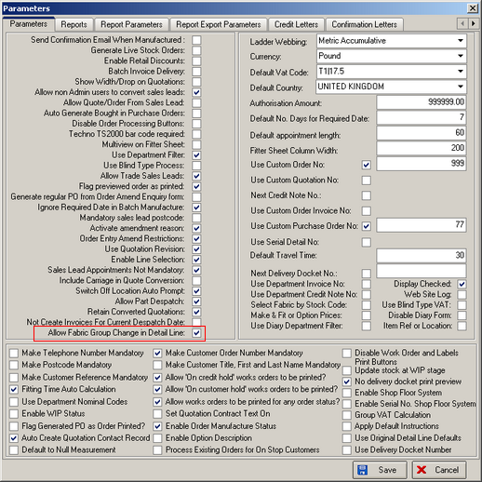

If this is set to true, then the user is able to amend the fabric group when an order is being entered.

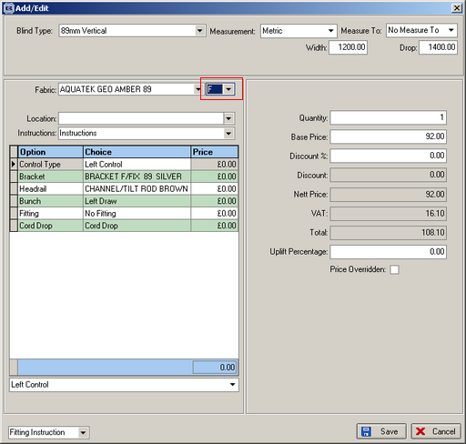

1209. Delivery SMS Messages

Previously we created the functionality to send a SMS message when ‘Deliver’ was clicked on the ‘Order Amend Enquiry’ form. We have now created this functionality in the ‘Despatch Order’ and ‘Despatch Order Scan’ in Order Processing > Order Enquiry.

1210. Order Processing > Archive Enquiry

‘Support Call No’ is now a column choice in this form.

1211. EDI Enquiry > Import

If an EDI order is imported and it has a required date, the imported order is now flagged as a ‘Must Go’.

1212. Delivery Docket Batch Print

There is a new print option called ‘Delivery Docket Batch Print’ in Administration > Parameters > Reports. Once this is set up, the user is unable to change the delivery docket choice in Order Processing > Delivery Docket Batch Print form.

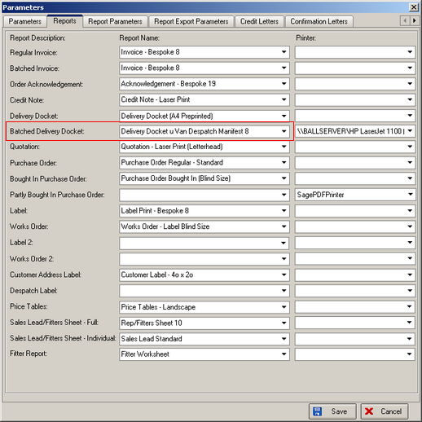

1213. Order Processing > Orders / Archive Enquiry

We have added ‘Title’ as a column choice in both the ‘Order Amend Enquiry’ form and also the ‘Archive Enquiry’ form.

