Blindata Release Note 4.2.2 

21 October 2008

Bug Fixes and Enhancements

2489. Reports > Receipts by Type

If the sub totals go above a certain amount they no longer overlap.

2490. Rep / Fitters Sheet 10

The Telephone number is no longer overlapping the label ‘Mobile:’.

2491. Invoice - Bespoke 12

The field Delivery Company Name now prints at the top of the delivery address.

2492. Administration > Employees

An error occurred if you tried to delete an employee. Fixed.

New Work and Customer Requests

162. Purchase Order Overhaul (Major)

We have conducted a full overhaul of the way the purchase order system works. It is now possible to create purchase orders, print them, deliver them, create purchase invoices and update them directly to Sage 50.

This now means that purchase invoicing can be done directly as a result of sales orders being entered in Blindata. Potentially this will save customers that use Sage an enormous amount of time.

The following procedures can now be followed.

The workflow for a bought in purchase order is as follows:

- A sales order is entered with detail lines for at least one bought in blind
- A bought in purchase order is created (either individually using ‘Create PO’ in Order Amend Enquiry or collectively in Purchase Order Enquiry
- A bought in purchase order is printed and sent to the supplier (possibly an EDI file is sent)
- The blinds are manufactured by the supplier and sent to our client
- The blinds are delivered in Purchase Order Enquiry, and this has the effect of changing the status to ‘Blind Manufactured’ in the sales order. This could be done in several stages because the blinds may not get delivered at the same time.
- An invoice is sent from the supplier
- The invoice details are checked against the delivered purchase order. If necessary, cost prices are changed.
- A purchase invoice is created from the purchase order. It should be possible to create more than one purchase invoice per purchase order.
- Carriage can be entered against the purchase invoice.
- The purchase invoice can be validated with Sage, an audit trail printed, and then the invoice posted to Sage.

The workflow for a regular purchase order is as follows:

- A sales order is entered with detail lines for at least one blind that is to be manufactured in house (i.e. where stock control = true in the blind type record) and a bill of materials is created.
- The user checks to see if the stock items required are currently in stock. This is done by printing the report ‘Stock Transaction Totals’ from Reports > System Reports, and checking actual stock against what the system has calculated. The user will do this in the factory or warehouse, whilst looking at the actual stock.
- A purchase order is then generated, by supplier and between start and end dates. This will calculate amount of each item that is required. The user can amend quantities and remove lines until they are happy with what they want to order. This is actually a complicated process as there may be minimum amounts that can be ordered and also cut length charges.
- Most suppliers have limits set where, if the purchase order is over a certain value, there is no carriage charge. The user may therefore generate a regular purchase order, check its total value, and decide not to save it because it is not high enough. But they may also add items to the purchase order to take its value over the ‘carriage free’ amount.
- A regular purchase order is printed and then sent to the supplier.
- The stock is sent to our client by the supplier.
- The stock is delivered in Purchase Order Enquiry – this has the effect of adjusting on purchase order and stock in hand figures against the relevant stock records. It is possible that not all the stock will be delivered, and so we need to indicate whether the remainder will arrive or not.
- An invoice is sent from the supplier
- The invoice details are checked against the delivered purchase order. If necessary, cost prices are changed.
- A purchase invoice is created from the purchase order. It should be possible to create more than one purchase invoice per purchase order.
- Carriage can be entered against the purchase invoice.
- The purchase invoice can be validated with Sage, an audit trail printed, and then the invoice posted to Sage.
- It should be possible to print a list of outstanding purchase orders, choosing by supplier
- It should be possible to print a list of purchase orders where cost prices have been changed.

Specific Changes Made

The main purchase order enquiry form now has extra buttons at the bottom. These are for ‘Amend Order’ and ‘Update’.

‘Amend order’ is used for making amendments to a purchase order, and also for delivering goods into stock.

‘Update’ is used for creating purchase invoices and updating them to Sage 50.

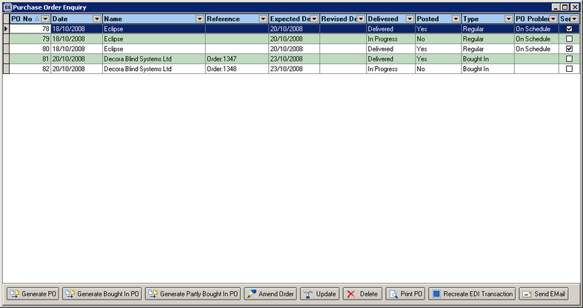

Amend Order

As well as delivering purchase orders in here, it is also possible to amend the cost prices. This screenshot is for a bought in order, but the form for the regular purchase order is similar.

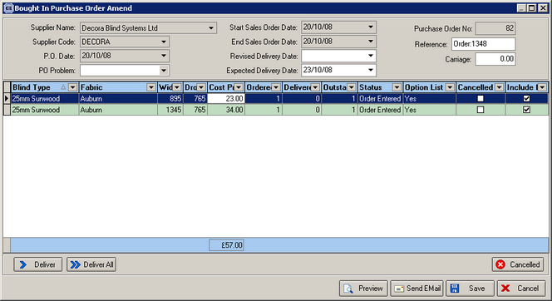

Once all the detail lines for a bought in purchase order have been delivered, and all detail lines on the sales order are manufactured, the following message will appear.

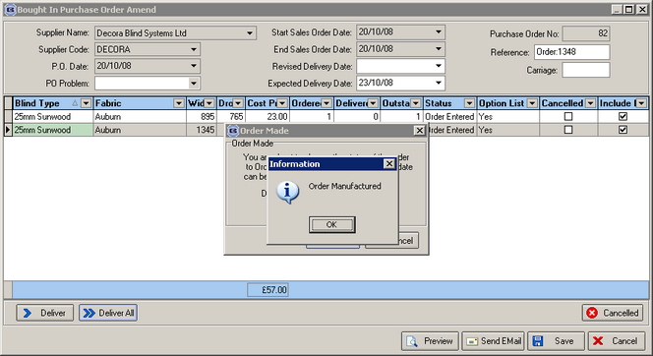

It is now possible to update the purchase order.

Update

When you click on ‘Update’, the following form will be displayed.

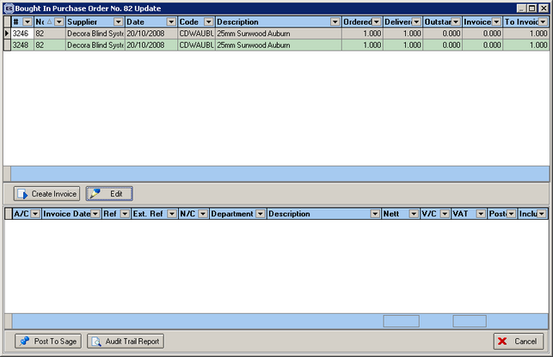

if you want to edit an details before creating invoice records, click on ‘Edit’. The following form will then be displayed.

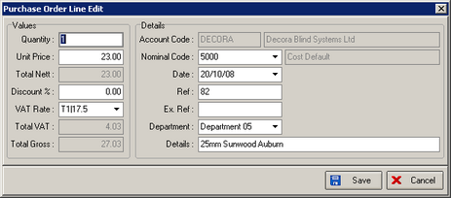

Once you click on ‘Create Invoice’, the following form will be displayed. If there is carriage to be added to the purchase order, click ‘Yes’, if not click ‘No’. The carriage added will be taken from the carriage amount held in the supplier record.

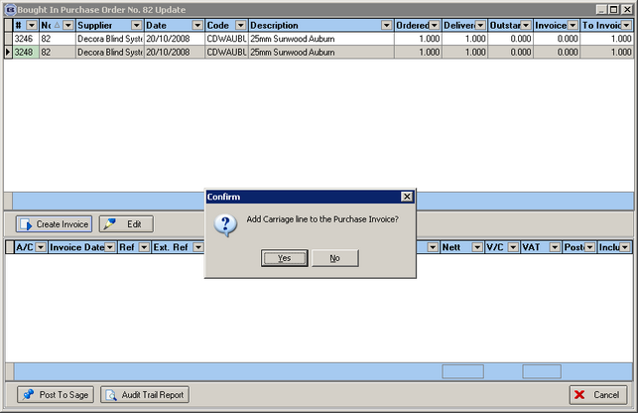

The following form will then be created.

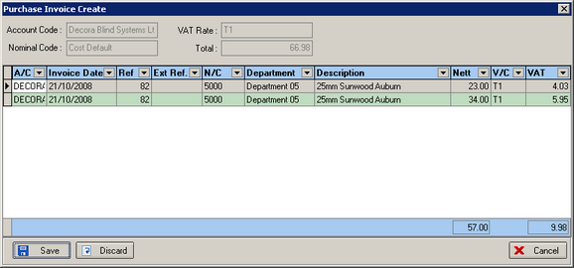

The purchase order form will now look like this.

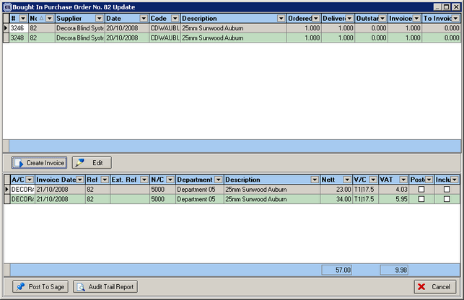

There are now two buttons displayed at the bottom of the form, one for ‘Post to Sage’ and the other for ‘Audit Trail Report’. If you want to post the detail lines to Sage, you must flag the field in the ‘Include’ column as true.

If you print an audit trail, it will look like this.

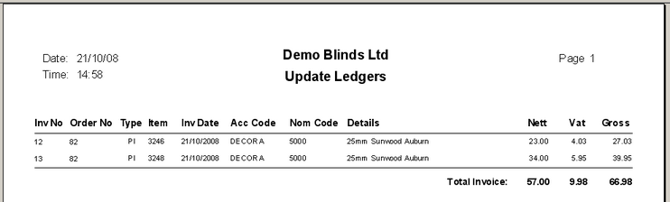

Once the purchase invoice has been posted to Sage, it will be flagged as posted. In Sage, in the supplier record, the invoice will look like this.

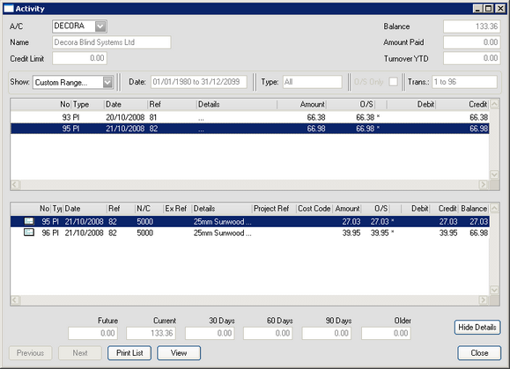

Regular Purchase Order Rules

If ‘Purchase Order Generation’ is false (in Stock Setup > Stock Items), then purchase order detail lines should not be generated for a stock item.

After you update the quantity, the value is now being recalculated and is printed on the purchase order.

We now print the purchase order in the same detail line order as they are displayed on the form.

There is a new status called ‘Sent to Supplier’ – once this is set, it is not be possible to amend the quantity or cost price on the PO.

When the stock item is delivered for a regular PO, a stock transaction is displayed on the stock item (stock trans tab) which shows how much was delivered and the date it was delivered.

Blind Details > Blind Types

We have created a new field in the blind type record called ‘Cost Nominal Code’. This is used when a purchase invoice for a bought in purchase order is created and then updated to Sage.

