Blindata Release Note 4.2.1 

10 October 2008

Bug Fixes and Enhancements

2474. Archive Enquiry > Remake / Repair / Redespatch

If an order has a new order generated from here and the ‘Display Checked’ flag is switched on in Administration > Parameters, the order is now flagged as unchecked.

2476. Purchase Order Regular

This now prints the order amount, not the outstanding amount.

2479. Stock Setup > Stock Transaction Entry

It is now possible to enter a figure up t 3 decimal places in the quantity.

2480. Bespoke Works Order

- The logo should be in proportion.
- There is only one detail line printed for a miscellaneous, regardless of the quantity entered in the quantity field.
- Width, drop and fabric do not appear for blind identifier = miscellaneous.

2481. Works Order – Delivery

The ‘Invoice Comment’ line in a miscellaneous entry now prints onto a second or third line.

2482. Label Print – Bespoke 8

The blind type description, fabric description, width and drop now print in bold.

2483. Label Print 3 x 1 ½ (No Desc)

C/Ref2 was being cut off on the right hand side. Fixed.

2484. JL EDI Import

The specification has changed for the JL-EDI Import file. The new code for the Blind Type can range from 9 - 11 Characters in size and have non-numeric characters in them (See images A (new) and B(old)). The new codes are now 11 characters and include non-numeric characters; these Imports cause an error when parsing. The EDI file may now contain either a 9 or an 11 digit code. Both files shown below should import.

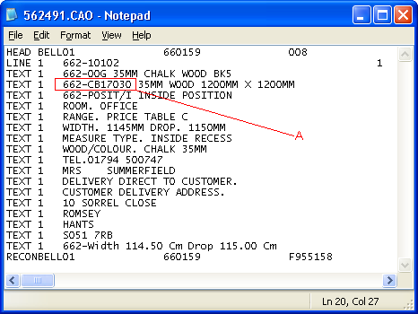

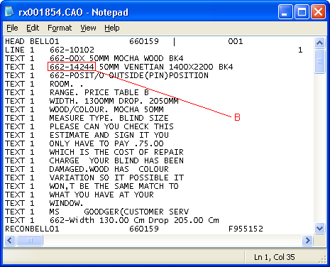

2485. Order Processing > Orders

The ‘Price Inc Scrap’ was not being calculated or displayed in the bill of materials form if the BOM record was generated as an ‘Additional’ item. Fixed.

2487. Works Order Portrait

If a repair detail line is entered, the comment now appears on the report.

New Work and Customer Requests

1191. Order Processing > Orders > Appointments

After entering an appointment, if the user saves the order record without saving the appointment, a message now appears saying ‘You have not saved your appointment’.

1192. Fitters Sheet / Sales Lead

It is now possible to enter the email address on this form, below ‘Mobile’. At the moment it can only be added after assigning the appointment.

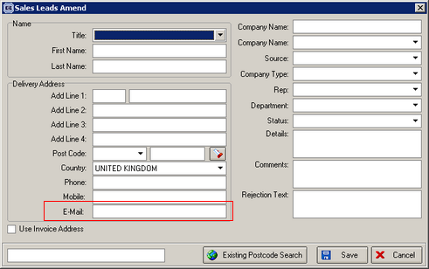

1193. Reports > Fabric Requirement Report

There is now a criteria for ‘Supplier’ in this form. It is possible to select ‘All’ suppliers or an individual one.

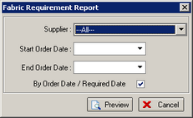

1194. Works Order – Label 1

- Original order number to appear on the labels. It should say ‘Orig No:’.
- Bold should only be switched onfor non default options.
- ‘Redespatch’ should appear on the label, in the same place as ‘Repair’.

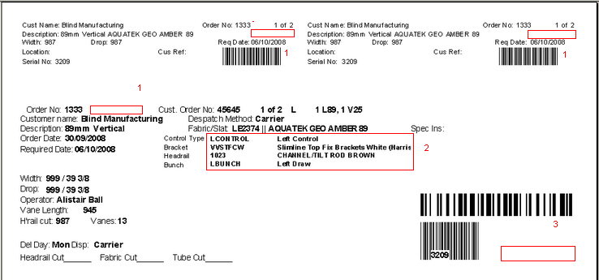

1195. Administration > System Tables > Amendment Reason

There is now a flag for ‘Remake reason’ in this table. If an order has been entered (or generated from Archive Order) for a remake, then only amendment reasons where ‘Remake Reason’ = true will be displayed. If the order is not a remake, and the order has been amended, then only amendment reason records where ‘Remake Reason’ = false will be shown.

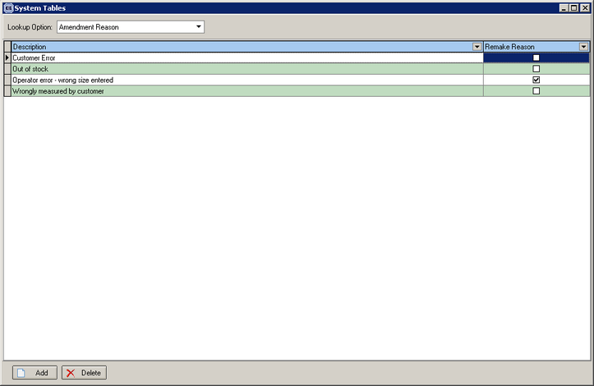

1196. Order Processing > Orders

There is now a ‘Carriage Override’ flag on the order entry form. If this is flagged as true, then there carriage charge is applied to the order at the ‘Create Invoices’ stage.

If a customer has a default setting of ‘FOC Carriage’ = true, then the ‘Carriage Override’ is set to true when an order is created, otherwise it defaults to false.

There is a new ‘Advanced Permission’ in Administration > Users > Advanced Permissions > Order to give a user permission to amend this field.

1197. Order Processing > Orders

Department and Area fields are now mandatory fields at the order save stage.

1199. Order Processing > Orders

There are extra column choices for ‘Delivery Address 1 – 4’.

1200. Order Processing > Archive Enquiry

There are extra column choices for ‘Delivery Address 1 – 4’ and also ‘Delivery Postcode’.

1202. Order Processing > Delivery Docket Batch Print

If you are printing a ‘despatch manifest’ type report here, there is now an option in this form to choose the ‘Despatch Method’ as well. It is possible to choose ‘All’ (the default) or an individual dispatch method.

