Blindata Release Note 4.2.0 

3 October 2008

Bug Fixes and Enhancements

2465. Login Screen

If you left the login screen visible without logging in for a couple of minutes an error occurred. Fixed.

2466. Order Processing > Orders

If a roller blind is entered, and a join is required (when calculator = ‘Width or Drop’ only), when quantity of blinds entered is > 1, the BOM was only calculating as quantity = 1. Fixed.

2467. Invoice – Bespoke 8

If a miscellaneous line is entered, the quantity now print to 2 decimal places on the invoice. This was only happening if the invoice was printed from ‘Invoice Batch Print’. It was ok for the individual print.

2469. Sales Lead Standard

The ‘Company Name’ from the sales lead now prints (if there is one) if it is entered in the ‘Company Name’ field (it worked for the company name lookup).

2471. Rep / Fitters Sheet 10

- Thebox header now says ‘Cash’, not ‘Either cash’.
- The boxes and text are not required if it is a service call.
- The company name only appeared if it has come from the company name lookup. It now also appears if it has been typed into the ‘Company Name’ field.

2473. Fitters Sheet / Sales Leads

The ‘Recalc Blind Number’ did not work after going to Week and Month view. In fact the row in yellow (in the red rectangle below) disappeared. You had to go out and back into the form. Fixed.

2475. Purchase Order Enquiry > Regular PO

The free stock figure now only display to 3 decimal places.

2477. Purchase Order Enquiry > Update

When trying to save the purchase order after printing the purchase order report, an error message appeared. Fixed.

New Work and Customer Requests

1180. Works Order – Bespoke 17

‘Bank Reference’ is now displayed on this works order header.

1182. Works Order Portrait

The number of slats now appears for venetian blinds.

1183. Delivery Docket - Fitter

This is a new delivery docket print that has been based on ‘Delivery Docket - Laser Print (Letterhead Logo)’ and is called ‘Delivery Docket – Fitter’.

1184. Sales Lead Standard

- Company Name now appear on this report.
- The background colour for the totals is now white
- Text and boxes have been added to the header.

1185. Rep / Fitters Sheet 10

- The time has been moved to the right a bit, so there will then be room for the company name (Company Name entered in sales lead, or ‘Delivery Company name’ in order, if fitting).
- If it is a sales lead, the boxes now say ‘Order’, ‘Quote’, ‘Not In’, ‘No Sale’.

1186. Order Processing > Orders

It is now possible to enter a ‘Service Call’ type record in here as well as a ‘Fitter Sheet’ or ‘Survey’ appointment.

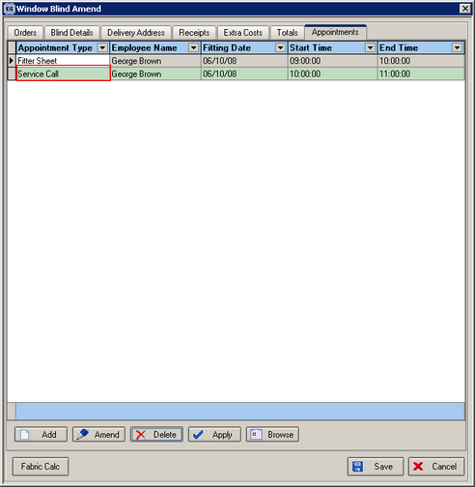

1187. Reports > Outstanding Orders by Product

There is now an ‘Outstanding Orders Report by Product’ with a condensed version similar to Outstanding Orders Report by Customer.

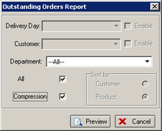

1188. Works Order – Label 5

With ‘Print Venetian Barcode’ switched on, the barcode has been made a bit bigger.

1189. Order Processing > Orders

There is now a flag on the order entry for ‘Same Day Despatch’? It defaults to false unless the customer is set up as a ‘Same Day Despatch’ customer.

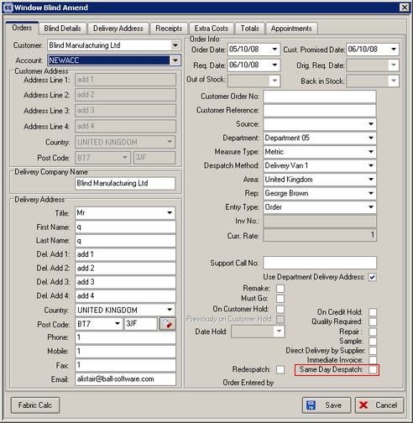

1190. Order Processing > Quotations

When you are entering a next contact date record, the ‘Next Contact Date’ defaults to the current date + number held in ‘Next Action Date Days’.

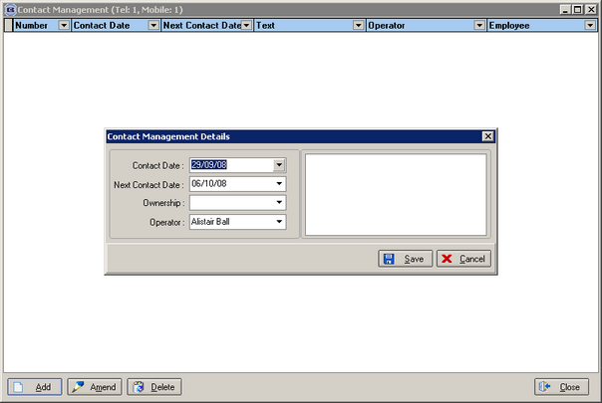

We now hold another number for the number of days if the quotation is non live. This field is called ‘Non Live Next Action Days’. If the quotation is flagged as non live, then it will pick up this number and add it to the current date to get the next action date.

