Blindata Release Note 4.1.9 

26 September 2008

Bug Fixes and Enhancements

2455. Production Documentation > Works Order – Delivery 8

The report did not print properly if it was printed from the Production Documentation form. Fixed.

2456. Reports > Receipts by Type

When you tried to print this report, an error message appeared. Fixed.

2457. Reports > System Reports > Fitters Report by Department.

When you tried to print this report, an error message appeared. Fixed.

2458. Works Order – Delivery 8

- ‘Required Date’ now appears here.
- ‘Contact Tel No’ now appears here (Phone number from order).
- The report now adheres to the metric/imperial entered/blind size parameter in Report Parameters.
- ‘Miscellaneous’ no longer prints and ‘Comment’ has been moved left and made wider.

2459. Label Print – Bespoke 8

- Width and Drop no longer appear if blind identifier = Miscellaneous.
- If blind identifier = Miscellaneous, this now only show the Comment field, and not ‘Fabric/Slat’ and then description. Also, it has been moved down a line so the customer name can be a bit wider.
- Option descriptions are now in bold.
- Process types now appear here.

2462. Order Processing > Orders > Blind Box Assembly Instructions

The ‘Batch Num’ on the report is now the same as the one on the order detail line.

New Work and Customer Requests

776. Order Processing > Orders

It is now possible to select multiple orders for changing to ‘Order Made’. First, make sure the ‘Enable Line Selection’ flag in Administration > Parameters is switched on. Then, when selecting orders to be flagged as manufactured, more than one order can be selected by using the CTRL-click combination.

1169. Reports > Sales Analysis

We have added new criteria to this form. There are options to exclude Remakes, Repairs and Redespatchs. It is now possible to exclude any combination of these orders/invoices from the sales analysis reports.

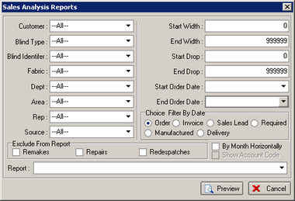

1170. Reports > Sales Analysis > Sales Analysis by Remake by Blind Type

A new sales analysis report has been created, called ‘Sales Analysis by Remake by Blind Type’.

1171. Reports > Sales Analysis > Sales Analysis by Remake by Customer

A new sales analysis report has been created, called ‘Sales Analysis by Remake by Customer’.

1172. Fitters Sheet / Sales Lead

If you enter a new sales lead, and try to put 1a into the first part of address line 1, it moved the ‘a’ into the second part of the address line. It now stays in the first part. We have therefore made the first line of the address a bit more flexible.

1174. Order Processing > Orders

There is now a button on the ‘Order Amend Enquiry’ form for copying orders. This works in the same way as the ‘Copy Quotation’ works except the user is not asked about ‘the same contract’ or ‘issue number’.

1175. Order Processing > Orders

There is a new flag in the Stock Items form called ‘In Colour in Option List’.

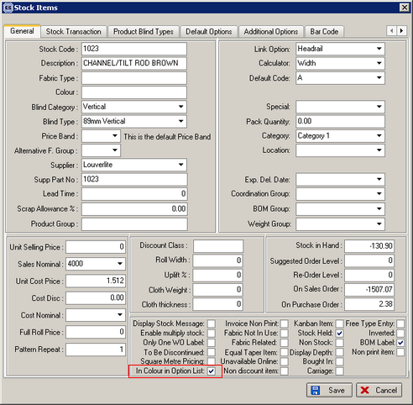

If this is switched on, then if this option is selected in an order, it is printed it in red in the option list.

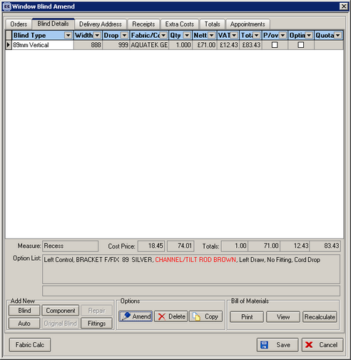

1176. Invoice – Bespoke 24

A new invoice layout has been created, called ‘Invoice – Bespoke 24’.

1177. Analysis Fields

We have created 5 new fields each on the Customer and Fabric table/forms. In each form they should have default names of ‘Analysis 1’, ‘Analysis 2’, ‘Analysis 3’, ‘Analysis 4’ and ‘Analysis 5’. There is a new tab in the Customers form called ‘Analysis’.

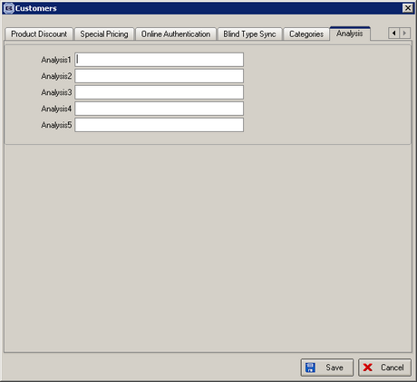

There is also a new tab in the Stock Item form called ‘Analysis’.

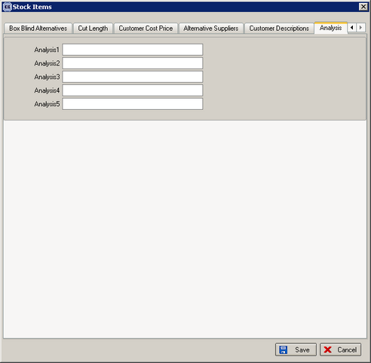

Also, in the Parameters table, it is possible to specify the names of these fields in the form. It is also possible to define these fields as being mandatory or not.

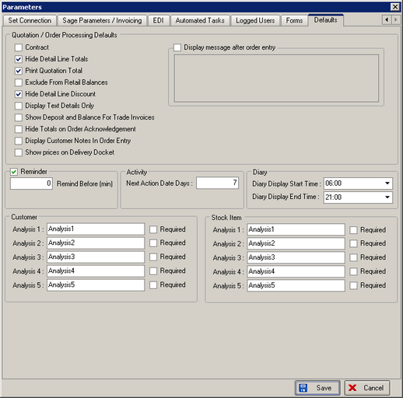

1178. Fabric Optimisation

There is a new field in Stock Setup > Stock Items > Regular PO Options, called ‘Fabric Optimise One Direction’. In Fabric Optimisation, this will work the same way as ‘Width or Drop’ except that within an order for the same fabric, all calculations will be based on ‘Width’ or ‘Drop’ ie all the detail lines in the order will be based on one or the other. The reason for doing this is so that the fabric will be cut the same way for all the blinds in an order.
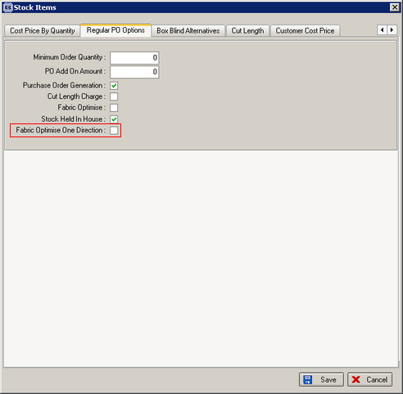

Example: there are four blinds in an order. The roll width is 2000mm and fabric usage is worked out as

Blind 1: width 1200mm, drop 1600mm
Blind 2: width 1200mm, drop 700mm
Blind 3: width 1000mm, drop 1200mm
Blind 4: width 1100mm, drop 1200mm

If the calculator was ‘Width or Drop’, the fabric could be optimised so blind 2 could be turned and cut from the same width of fabric as blind 1. If the fabric has ‘Fabric Optimise One Direction’ = true, then it has to be ‘Width’ for all 4 blinds or ‘Drop’ for all 4.

1179. Order Processing > Orders

The order entry now checks for duplication on field "Customer Order No", It is already done for ‘Customer Reference’ when entering an order and has the same functionality.

1181. Order Processing > Orders

We have adjusted the display of buttons on the bottom of this form. There are now three banks of buttons instead of two. This enables them all to be seen on screens with lower screen resolutions.

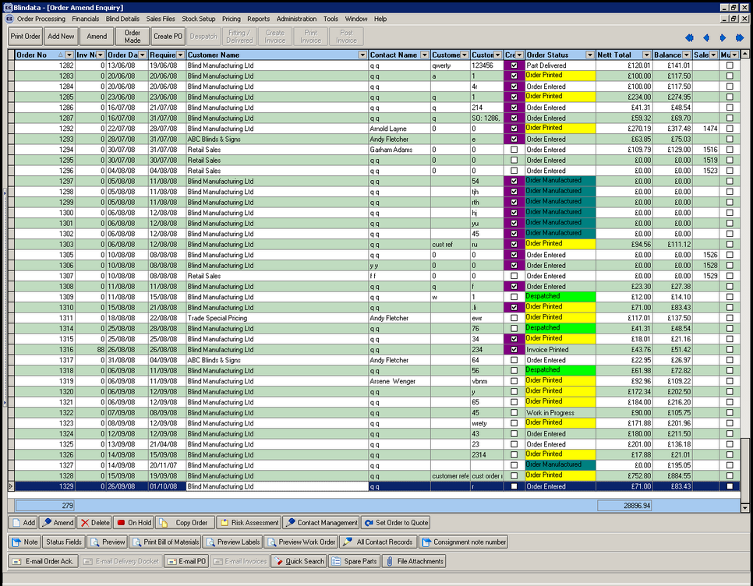

We have also introduced a new level of permissions against users in Administration > Users > Buttons Visibility, so the buttons on this form, and on the quotation form, can be made visible or not.

