Blindata Release Note 4.1.7 

12 September 2008

Bug Fixes and Enhancements

2434. Purchase Order Enquiry > Generate PO

When generating regular purchase orders, Blindata was sometimes giving timeout errors. This routine has been optimised.

2442. Order Processing > Orders

If ‘Use Delivery Address’ is set to true in the department record, then ‘Use Department Delivery Address’ is now set to true when an order is entered.

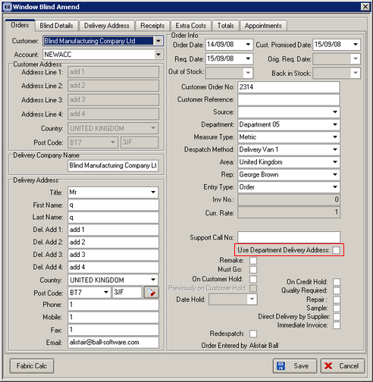

New Work and Customer Requests

1135. SMS Messages

It is now possible to send delivery notification for orders. This can be done by sending an email to a website which is then converted to an SMS message. The website is www.aql.com.

Once you have registered on this site, the connection settings have to be established in Administration > Parameters > Set Connections.

We have used the despatch email address (in Administration > Parameters > Set Connection) to act as the email sender. We also now hold the ‘@text.aql.com’ as part of the email address in the same form. We have called the field ‘Email to SMS Address’.

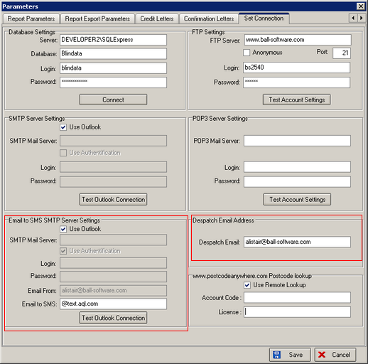

The text for the email is taken from ‘Email Delivery Text’ in Administration > Company Details > Email Text.

Only certain customers will want to receive SMS delivery confirmations, so we have created a new field in the Customer form called ‘Email to SMS’.

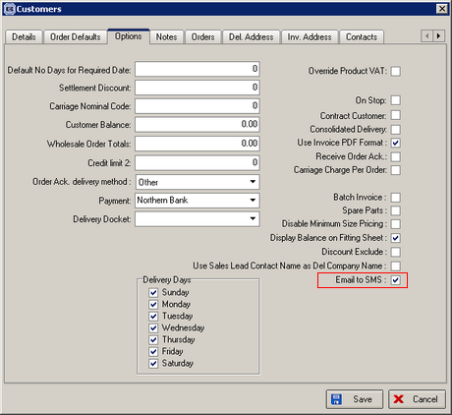

The Email to SMS is generated when the order is despatched. Currently this can only be done using the ‘Despatch’ button in the Order Amend Enquiry form, but this will be extended to all delivery functionality.

1150. Order Processing > Quotations > Create Order

At one site there are still issues when quotations are being converted to orders.

- Not all bill of materials are being created in orders
- Not all detail lines are being converted to orders.

Previously we added in functionality to populate a new table if bill of materials are not being created, but this made no difference. The table is empty but BOMs are still not being created. We have now created new code to check each detail line are it is converted. If it is not converted and/or the BOM is not created for the order, a message appears saying it has not been created. The message says ‘Detail line 99999 has not been converted / BOM has not been created for the order. Retrying…’. The program retries 3 times.

1152. Order Processing > Orders

The ‘Support Call No’ column now defaults to being switched off in the Columns choice.

1153. Sales Files > Delivery Days

There is now an advanced permission for editing the delivery days in this form. It is called ‘Edit Delivery Days’. If it is set to false, the user will only be able to view the delivery days.

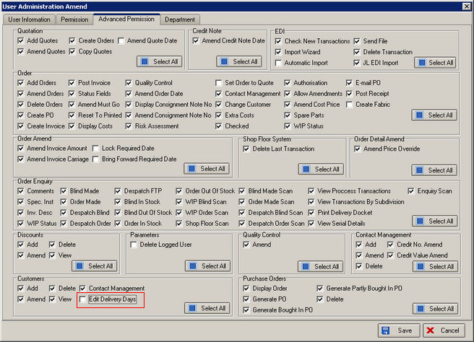

1154. Administration > Company Details > Email Text

We have added ‘Customer Order No’ and ‘Customer Reference’ as tags that can be added here.

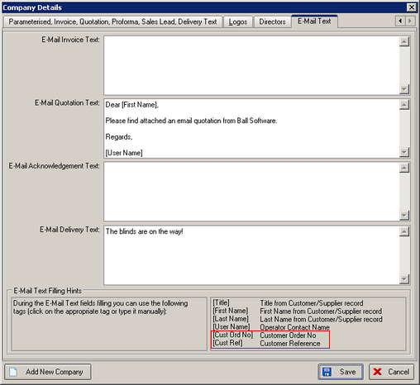

1155. Delivery Docket – Van Despatch Manifest 8

A new report is now available in Order Processing > Delivery Docket Batch Print, called ‘Delivery Docket - Van Despatch Manifest.xls’.

1156. Works Order - Delivery 8

There is a new works order report called ‘Works Order - Delivery 8’.

1160. Order Processing > Orders > Repairs

We have made some changes to the way that repairs can be entered. Previously, once the repair flag was ticked, the ‘Repair’ button on the ‘Blind Details’ tab was enabled. However, whilst keeping this facility, we have make the repair entry more sophisticated.

It is now possible to enter an order, tick it as a repair and then enter the full blind details for the blind using the normal blind detail entry program. We could do this previously but we have made the following changes:

- If the order has been flagged as a repair, then the price lookup is not done – the base price and option prices are zero and the user can enter a price.
- A different set of default options will appear in the detail line entry
- BOM will not be calculated for a repair detail line and stock will be ignored
- The user is also able to enter the original blind that is being repaired – we therefore need a lookup for the original blind in the detail line entry. We can already choose the original order number in the Totals tab. Once this has been chosen, we can then filter the original blind details by order id. This can be done by clicking on the ‘Original Blind’ button in the order detail entry form.

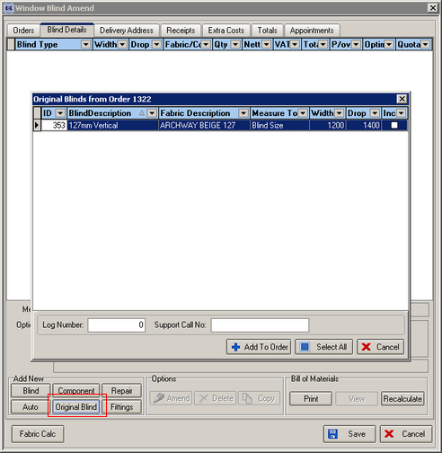

Therefore we have also made the following changes.

Blind Details > Blind Types > Field Details

There is a new field in here called ‘Repair Default’. If this is set to true, then in the detail entry this option choice is the default if repair = true for the order.

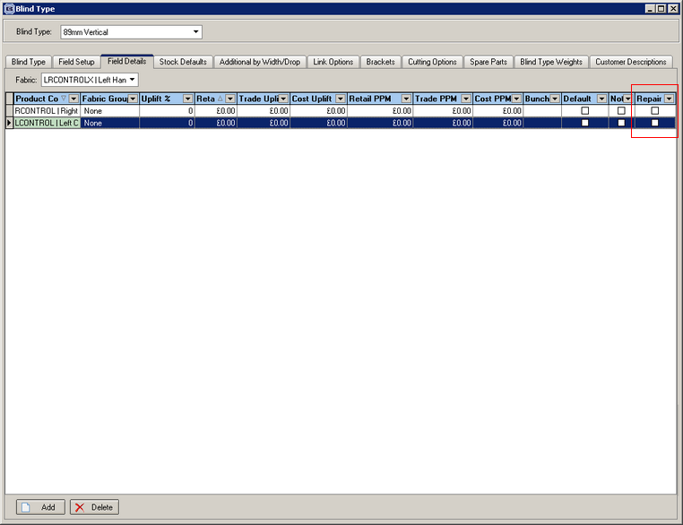

Archive Enquiry

It is also possible to create a repair order record from the ‘Archive Enquiry’ form.
There is a new button on the ‘Archive Enquiry’ form called ‘Remake / Repair / Redespatch’.

When this is selected, a new form appears and the user has the choice of Remake, Repair or Redespatch. It is also be possible to enter a log number and here. These will be copied to the new order record.

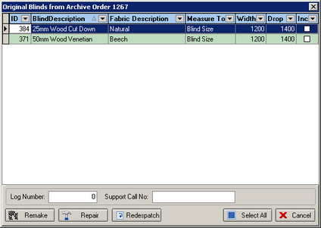

The user can then select which blinds are to be remade, redespatched or repaired. There is an option to ‘Select All’ or to select individual blinds.

The following functionality works depending on selection.

Remake

A new order will be created. This will be flagged as a ‘Remake’. The new order record will be cross referenced with the old order number (and be shown in the Totals tab in ‘Original Order). The blind detail lines will also be cross referenced with their original numbers. These original numbers will then be displayed in the blind detail entry form. The status of the order will be = Order Entered and bill of material records will be created.

Repair

A new order will be created. This will be flagged as a ‘Repair’. The new order record will be cross referenced with the old order number (and be shown in the Totals tab in ‘Original Order). The blind detail lines will also be cross referenced with their original numbers. These original numbers will then be displayed in the blind detail entry form. The status of the order will be = Order Entered, the selling price will be zero and bill of material records will not be created. The option defaults in the detail line will be taken from the ‘repair defaults’ that are held against the options.

Redespatch

A new order will be created. This will be flagged as a ‘Redespatch’. (this will update a new flag field in the order entry form – beside the repair flag, so it is also possible to add a new order manually and flag it as a ‘redespatch’). The new order record will be cross referenced with the old order number (and be shown in the Totals tab in ‘Original Order). The blind detail lines will also be cross referenced with their original numbers. These original numbers will then be displayed in the blind detail entry form. The status of the order will be = Order Manufactured and BOM records will not be created.

1174. Works Order – Label Blind Size

We have added a new bar code to appear on this report. This is only be for blind identifiers = roller. The bar code will be made up of the actual fabric cutting size width and drop, which are taken from cutting options ‘Fabric Cut’ and ‘Fabric Drop’. There is a new report parameter in Administration > Parameters > Report Parameters called ‘Print Roller Fabric Barcode’. The barcode will only print if this is set to true.

