Blindata Release Note 4.1.6 

5 September 2008

Bug Fixes and Enhancements

2431. Order Processing > Orders

If you click ‘must go’ on an order before you add any blinds, when you do add blinds, the required date and original required date are now calculated normally.

2432. Order Processing > Orders

If you tried to enter an order for a customer that is ‘on stop’, then changed to a different customer, then go to ‘Blind Details’ tab to add a blind, the following message appeared. Fixed.

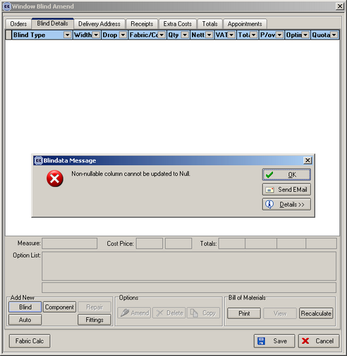

2435. Reports > Receipts Report By Description

The start and end dates were being ignored in the report. It printed out all the records. Fixed.

2436. Administration > Company Detail > Email Text

- ‘You’ now says ‘you’.
- ‘Fist’ is now ‘First’.

2437. Financials > Invoice Batch Print > Invoice - Batch Print A4

If you tried to reprint an invoice that had been archived, it would not print. Fixed.

2438. Invoice – Batch Print A4

The nett price now prints to 2 decimal places.

2440. Order Processing > Orders

There was a bug when the shop floor system was switched on. If the order detail line record was deleted, the ‘ProcessTransaction’ record was left in the table. It is now deleted.

New Work and Customer Requests

1080. Works Order - BOM

We have created a new works order called ‘Works Order – BOM’. This is required because we have customers that make ‘Perfect Fit’ blinds. The reason for doing this is to avoid duplication of data entry – you will no longer need to use the ‘Perfect Fit’ software provided by Louvolite.

Normally these blinds are setup as a separate blind type, but sometimes users have ‘Perfect Fit’ options set up. It is therefore difficult for us to decide which blinds need this report to be printed out. Therefore we have given the user the option of which works order to print in the ‘Works Order’ button in ‘Order Amend Enquiry’. At the moment, the following form appears:

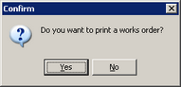

We have created a new report parameter called ‘Display Works Order - BOM’ in Administration > Parameters > Report Parameters. If it is set to true, then a second works order – ‘Works Order – BOM’ will print as well as the normal works order that is printed out.

Perfect Fit can be applied to all blind types, so there will be different information on each according to the blind identifier.

1087. Stock Setup > Purchase Order Enquiry

It is now possible to hold a delivered date on the purchase order enquiry form. If you right click on the relevant purchase order in the ‘Purchase Order Enquiry Form’, a new choice has been added to the context menu.

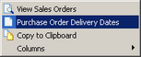

If you then choose ‘Purchase Order Delivery Dates’, the following form will be displayed.
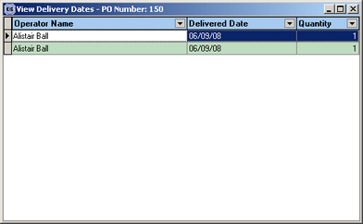

1138. Purchase Order Bought In (All Reports)

If a sales order has been flagged as ‘Direct Delivery by Supplier’, then we now print the delivery address on the purchase order.

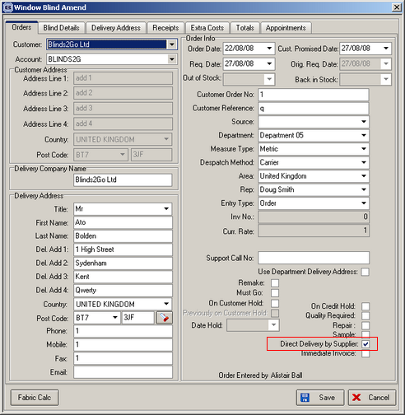

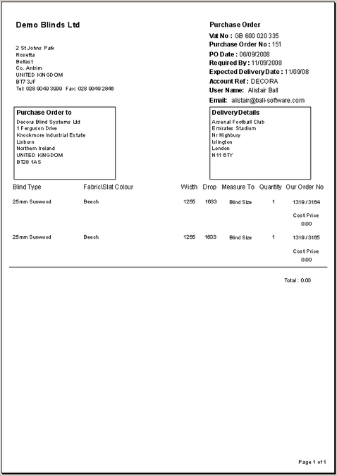

1141. Label Print

Previously, when printing out labels, if there was more than one record in ‘Label Control’, the records printed out in the order

1 of 3
1 of 3
2 of 3
2 of 3
3 of 3
3 of 3

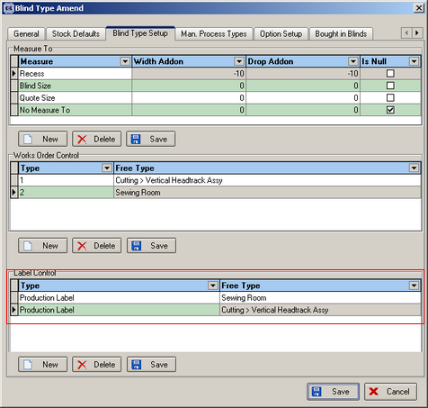

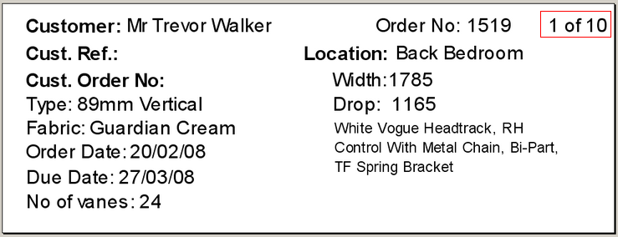

There is a new parameter in Administration > Parameters > Report Parameters so there is now a choice to print labels in this order:

1 of 3
2 of 3
3 of 3
1 of 3
2 of 3
3 of 3

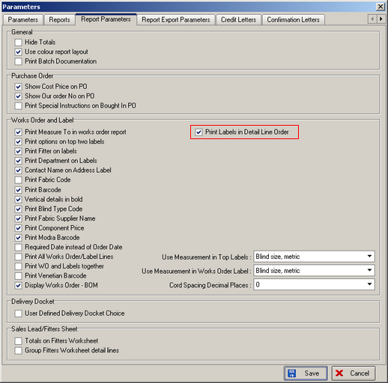

The parameter is called ‘Print Labels in Detail Line Order’. This defaults to false (the existing order). If set to true, the labels will print in the requested way above.

1143. Export Order

We have extended the delivery Contact name, Company name and address details fields. This was because some of the address details are wrapping onto the next line.

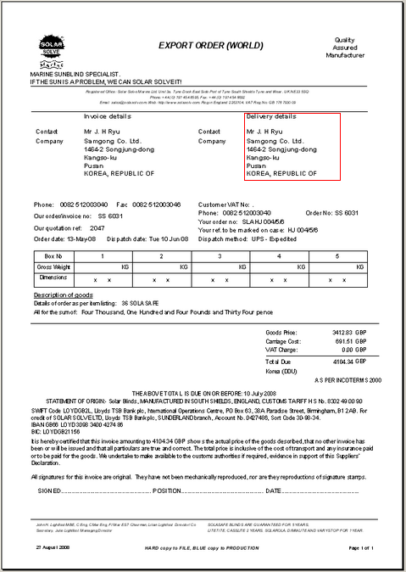

1144. Order Processing > Quotations

Previously when you converted a quotation into an order the quotation vanished from the quotation list. We could get it back by setting the filter but you could not save the configuration. It is now possible to save the configuration or restore the default setting by clicking on the ‘Order Status’ filter and selecting the required configuration.

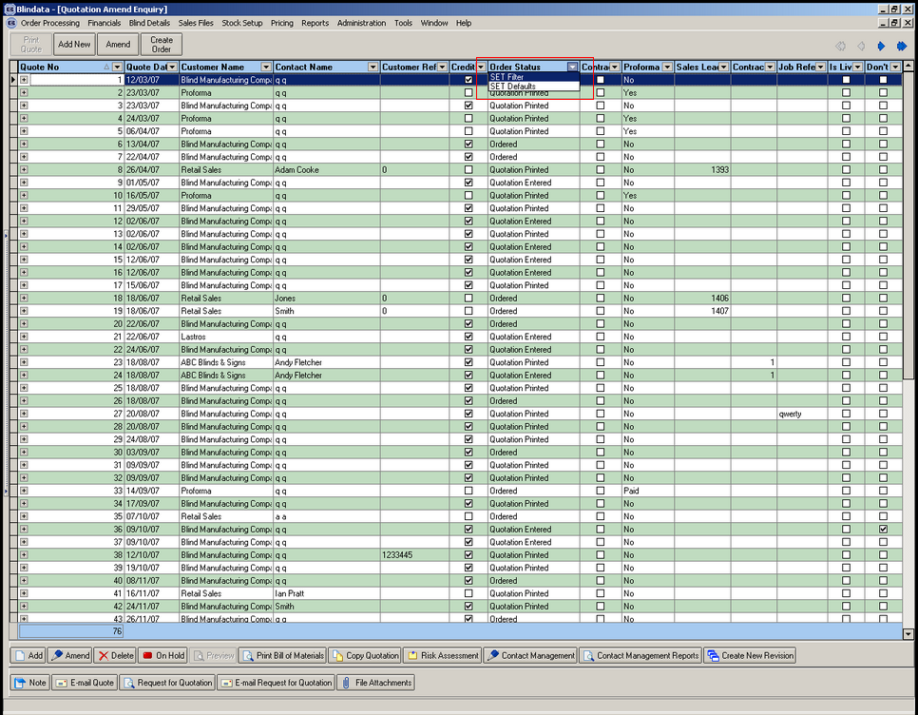

1145. Balance Invoice Report (Totals)

There is a new report in Reports > Financial Reports called ‘Balance Invoice Report (Totals). Previously there was only a report called 'Balance Invoices Report' that showed all the invoices (balance element only) between a specified date range. However it split each order according to nominal codes. The new report contains the same basic data (therefore the 2 reports would show the same totals for the same date range) but lists the invoices in numerical order and does not split them by nominal code i.e. there is 1 record per invoice.

1146. Stock Items > Suppliers

There is now a File Attachment button on the Supplier enquiry form.

1147. Sales Lead / Fitter Sheet Full

This report now contains details of the type of blinds as well as quantity on the report.

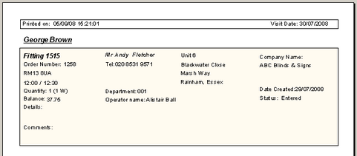

1148. Sage 50 2009

Blindata is now able to integrate with Sage 50 2009.

1149. Delivery Docket – Bespoke 4

There is a new parameter in the order entry program. We have a customer that wants to show prices on their delivery docket (Delivery Docket – Bespoke 4), but only on certain delivery dockets. We therefore have created a new parameter in the Totals tab called ‘Show prices on Delivery Docket’.

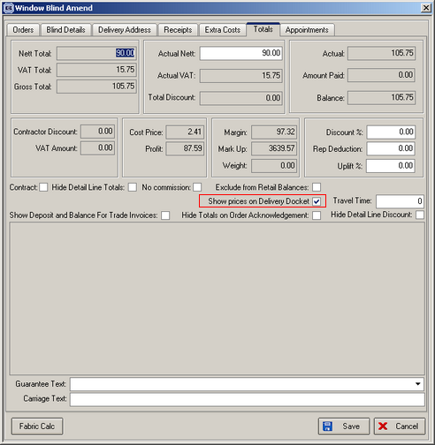

We have also created a default for this in Administration > Parameters > Defaults.

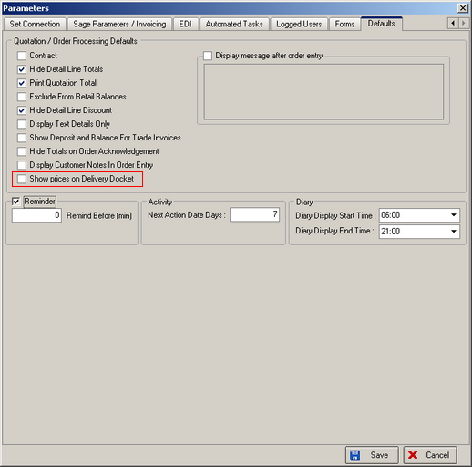

If this parameter is switched on, the unit price (base price + option price), discount percentage and nett price will appear on Delivery Docket – Bespoke 4.

1157. Works Order – BOM

This works order report is now a choice in Administration > Parameters > Reports > Works Orders.

