Blindata Release Note 4.1.5 

29 August 2008

Bug Fixes and Enhancements

2412. Delivery Docket – Batched Orders

Carriage no longer prints out on this delivery docket.

2413. Sales Analysis by Customer by Blind Type

At a particular customer site, the ‘Retail Customer’ account was not being grouped properly. Fixed.

2414. Sales Analysis by Customer

The report now prints in alphabetical order by customer company name.

2415. Order Processing > Orders

If you try to delete an order with status = ‘Order Manufactured’, the message now says:

‘You cannot delete an order with status “Order Manufactured” ‘.

2416. Order Processing > Orders

If you enter an order for a ‘partly bought in’ blind and the click on ‘Create PO’, the following message appeared.

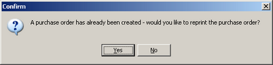

At the moment, a partly bought in purchase order can only be generated in ‘Purchase Order Enquiry’, so the message now says ‘Please create partly bought in purchase orders in the ‘Purchase Order Enquiry’ form’.

2417. Stock Setup > Purchase Order Enquiry > Display Order

After a ‘partly bought in’ purchase order is created, there were two things wrong.

- The ‘Create Invoice’ button should not have been enabled. Fixed.
- The ‘Preview’ button is now enabled enabled.

2419. Works Order – Landscape Metric

If ‘Parameterised Cutting options’ = true in the blind type record, then:

- ‘Tube Cut’ does not print.
- We have moved the cutting sizes to a column to the left of the options.

2421. Fitter Worksheet

- Carriage detail lines no longer appear on this report.

2422. Works Order Bespoke 15

The address box title now says Customer Address rather than Delivery Address.

2423. Invoice – Bespoke 15

Width and drop of 0 no longer print if the detail line is a component or carriage line.

2424. Audit Trail

If a customer is set up with an alternative account code (in Customers > Order Defaults tab > Customer Add Ref), then this account code now appears on the audit trail.

2425. Receipt Print

- If ‘Use Department Filter’ was true, when printing a cash receipt for a customer the branch details were correct but the phone number was always the same regardless of branch printing the receipt. Fixed.
- Width and drop no longer appear for a component or carriage line.

2426. Invoice – Batch Print A4

- For component lines, only the Comment field is printed.
- If the invoice contains only component lines, the totals now print to 2 decimal places.

2427. Order Processing > Orders

When you entered a new blind, filled in the location field and then saved it, then added another blind to the order and then deleted the location field, when tab was pressed the deleted text came back. This no longer happens.

2428. Administration > System Tables > Department Nominal Codes For Stock Items

The nominal code drop down list was not being populated when you try to add a record. Fixed.

2429. Delivery Docket – Bespoke 4

Carriage lines no longer appear on this report.

New Work and Customer Requests

1129. Reports > Sales Analysis > SA by Customer by Quarterly Comparison

There is a new sales analysis report called ‘Sales Analysis by Quarterly Comparison’ that has columns with Q1 Current Year, Q1 Last Year, Q2 to Q4 with comparison columns.

This will allow you to compare year on year figures by calendar quarter.

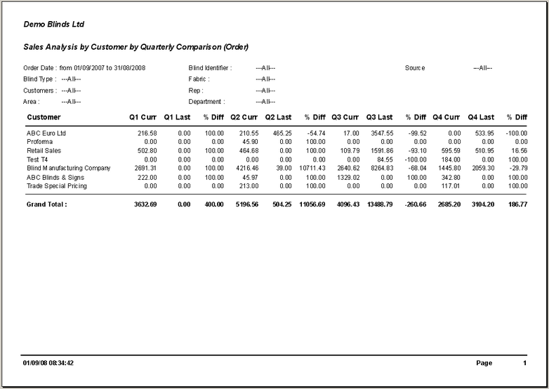

1133. Works Order - Delivery

There is a new works order report layout called ‘Works Order – Delivery’.

1139. Fitters Sheet / Sales Lead

Previously the displaying of orders in ‘Order Amend Enquiry’ and appointments in the diary was controlled by one parameter, ‘Use Department Filter’, and then setting departments against users. We are now able to restrict orders by department but allow the user to see appointments for all departments. We have introduced another parameter called ‘Use Diary Department Filter’. If this is switched off then the user can see all diary appointments, but if ‘Use Department Filter’ = true, then viewing orders is still be restricted by department.

1140. Order Processing > Orders

A pop up warning can now appear when entering a order/quote for a customer if Customer Notes exist. We have created a new parameter called ‘Display Customer Notes in Order Entry’. If this is set to true, then a form with customer notes appears after entry of the customer or account code in the quotation / order entry.

1142. Quotation – Bespoke 21

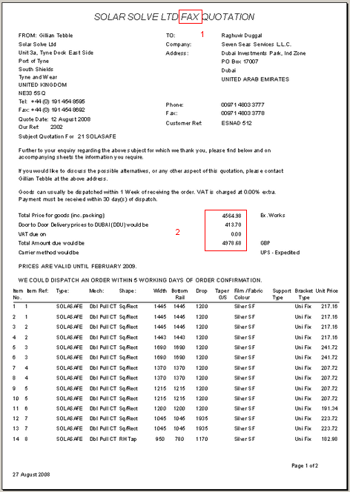

- The word ‘FAX’ has been removed. It has also been removed from the top of the ‘Technical Datasheet’.
- We have put the £, $ or € (when relevant currency selected) in front of monetary values. Also, the amounts now have the thousands separated by a comma eg £12,000.00.

