Blindata Release Note 4.1.4 

22 August 2008

Bug Fixes and Enhancements

2401. Export Order

- ‘Fourty’ is now spelt ‘Forty’.
- ‘Good’ is now spelt ‘Goods’.
- The country now appear below the delivery address.

2402. Packing List

- There is now only one space between ‘items’ and ‘have’.
- There is now only one space between ‘everything’ and ‘to’.

2403. Sales Files > Customers

If you created a new customer with a country <> UNITED KINGDOM, when you entered the ‘trade type’, the country reverted to UNITED KINGDOM. Fixed.

2404. Export Invoice

‘Eightteen’ is now spelt ‘Eighteen’.

2405. Quotation

If the customer is set up as a proforma customer, then the text that appears on the proforma now prints on the quotation.

2407. Order Processing > Orders

It is now possible to browse the diary from the Appointments tab before an appointment has been entered. This button has been enabled even if there are no appointments.

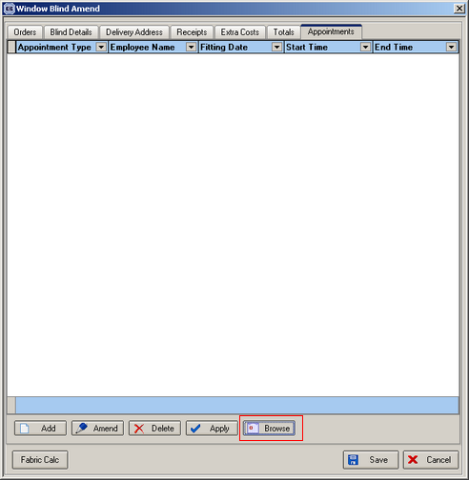

2409. Invoice - Batch Print A4

This report is now grouped properly by invoice number.

Also, the page numbers were incorrect on the invoice. The page number now resets to 1 for the start of each invoice.

Finally, the header now prints on the second and subsequent pages of an invoice.

2410. Delivery Docket – Batched Orders

If you tried to print out a delivery docket that only had a miscellaneous line in it, it did not print anything. Fixed.

2411. Works Order – A4 Packing Slip

If you entered two blinds, the fabric on the second detail line printed the same fabric as the first line, even if the second fabric was different. Fixed.

New Work and Customer Requests

1128. Reports > System Reports > Customer Labels

There is now a label print option that prints the customer address labels in descending customer turnover order (between a start and end date).
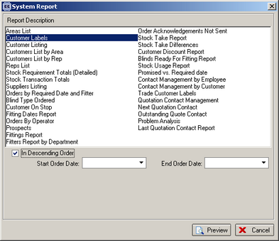

1131. Sales Files > Customers

‘Email Address’ is now a column choice on the customer enquiry form.

1132. Label Print – Bespoke 8

The order number now prints in bold on the top labels.

The Department has been replaced by Manufacturing Location on the right hand label.

1134. Order Processing > Archive Enquiry

There is now an ‘Email Invoice’ button on the Archive Enquiry form.

1137. Fitter Sheet / Sales Lead > Sales Lead Enquiry

The sales lead ‘mobile phone number’ and ‘Email Address’ are now column choices on the ‘Sales Lead Enquiry’ form.

