Blindata Release Note 4.1.2 

8 August 2008

Bug Fixes and Enhancements

2377. Works Order Label 1

If a chain drop is entered in imperial, it printed in imperial – it now prints in metric.

2378. Order Processing > Quotations > Create Order

When converting a repair quote to order, the repair description details on the detail line disappeared. This has been fixed.

2381. Acknowledgement – Bespoke 19

If you entered an order for a trade customer and in the Totals tab in the order ticked “Show Deposit and Balance for Trade Invoices”, when the Order Acknowledgement is printed the balance did not show on the bottom right. The balance now prints.

2382. Export Order

The total due on the Export Order now displays to 2 decimal places.

2383. Order Processing > Orders

If you go into an order and the survey for the order has not yet been completed, the message has been changed to ‘The survey for this order on dd/mm/yy has not been completed. Please go to the diary and complete the survey before continuing’.

2384. Fitters Sheet / Sales Lead

If you tried to change the status of a survey to ‘Completed’ from ‘Entered’ and it was at the same time as another appointment for a different employee, a conflict message appeared. This has been fixed.

2385. Fabric Optimisation

The optimization routine was changed recently when we added ‘Scrap Width Add On’ and ‘Scrap Drop Add On’ to the blind type record and then included these figures in the fabric optimization. The calculation is done correctly but on the optimization print the width and drop should have been the actual amount of fabric required, not the amount including the scrap add on amounts. This has been fixed.

Also, it is now possible to make the fabric shapes on the report smaller. This can be done by using the ‘Zoom’ button.

2386. Blind Details > Blind Types

‘Horisontal’ is now spelt ‘Horizontal’.

2387. Label Print – Bespoke 8

- This no longer prints if ‘Parameterised Cutting Options’ = true in Blind Type record.
- This no longer prints if ‘Parameterised Cutting Options’ = true in Blind Type record.
- This has been moved left if ‘Parameterised Cutting Options’ = true in Blind Type record.
- This no longer prints.
- The whole label has been moved 3mm to the left.

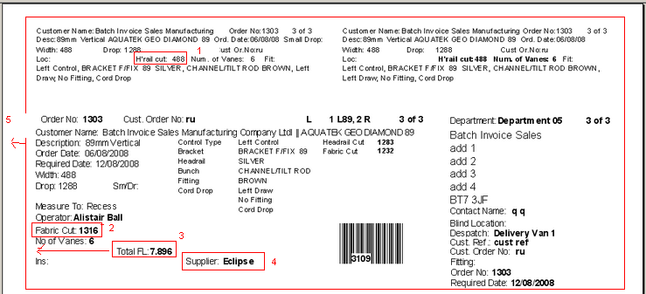

2389. Site Survey Sheet 15

- The branch address now prints.
- The address was wrong if there is more than one survey sheet being printed – the addresses were all the same. Fixed.
- The employee name is now printing beside ‘Surveyor’.
- The tick boxes and descriptions now quite line up when the sheet is printed (looks ok on screen).
- ‘FM Venetian’ now says ‘FH Venetian’.
- Operator name now appears.

2390. Fitters Sheet 15

- Carriage Items no longer print on the report
- The blinds are now listed by blind type and by blind size (descending order);

New Work and Customer Requests

70. Serial Number / Activation Key / Number of Users

We have introduced a new security feature in Blindata. From this version on, you will need an activation key to operate the software.

This activation key is used to check on whether you have an evaluation copy or a full version of the software, how many user licenses the software can run concurrently, and how long the software license is valid for.

When you try to log in after installing v4.1.2 or above, the following message will appear.

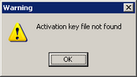

After you click OK, the following form will appear.

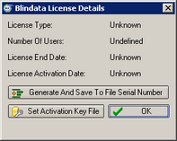

You must then click on ‘Generate And Save To File Serial Number’. Once you do this you will be asked to save the file. Once the file has been saved, it should be emailed to support@ball-software.com.

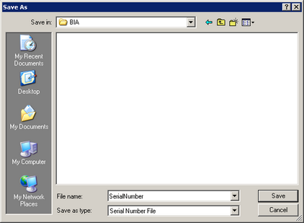

We will receive the file and then send another file back to you. You should then install this in a shared network folder.

You should then click on ‘Set Activation Key File’. When you do this you must select the folder that you stored the file in (the one we sent back to you).

When you click ok, the form should then look like this.

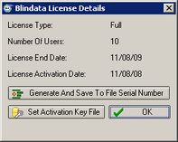

1088. Order Processing > Orders

We can now record what field was changed in the order header and display it in the order history. If you right click on an order, and the click ‘History’ on the context menu, the history will display. The order header changes can be viewed on the left hand side of the form.

1096. Order Processing > Archive Enquiry

There is now a ‘File Attachments’ button on the archive enquiry form.

1097. Order Processing > Orders

There is now a column for delivery postcode and fitting date on the order amend enquiry form. The fitting date displayed is the the first fitting date that is held against the order.

1098. Order Processing > Orders

If a sales lead is converted to an order and there is a fitting date, the required date is now equal to the fitting date in the order.

In the sales lead history, we now record the sales order number that was created.

If a sales order is entered directly and a fitting date is entered, the required date is calculated when the order is saved. If the required date is greater than the fitting date, a warning message now appears saying ‘The fitting date for this order is earlier than the required date’. The system also records an order history record saying ’Fitting Date < Required Date’.

This also needs to be checked when the fitting date is changed.

1099. Stock Setup > Dimension Calculations

It is now possible to calculate the bill of materials based on the number of louvres on a blind multiplied by a factor. There is now a multiplier against the ‘Louvres’ code letter in ‘Dimension Calculations’. When stock is being calculated, the number of louvers is multiplied by the multiplier to get the stock usage amount.

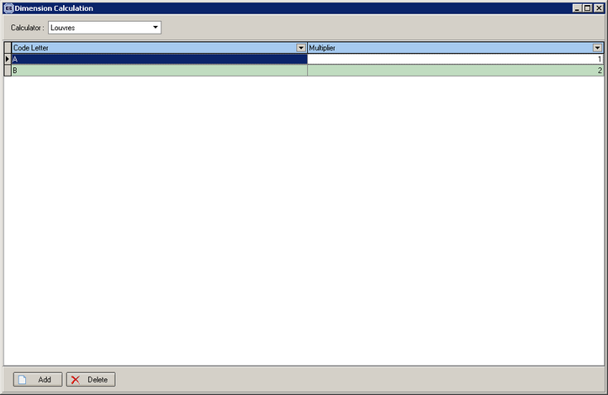

1106. Order Processing > Quotations

It is now possible to enter quotations for on-stop customers. Previously if you tried to enter a quotation for an on stop customer, you got the following message.

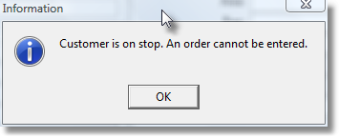
It is now possible to enter a quotation for an on stop customer, but if you try to convert the quotation to an order, a message will appear. This functionality is already in the system.

It is also possible to see that a quotation has been entered for a customer on stop. The customer on stop column is now available to display as a column on the quotation enquiry form.

1108. Automated Create Invoice Routine

The username used by the automated invoice create routine can now be set up in Administration > Parameters > Automated Tasks.

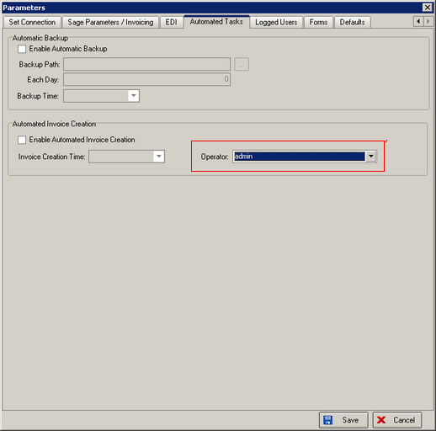

1109. Order Processing > Orders

Previously we created an option to store the location of file attachments on the system. There is now a default storage location which can be defined by the user. This is held in the ‘Company Details’ record (eg c:\my documents\scanned documents). Each order will then have its own folder within here. For example, attachments for order 123456 would then be held in c:\my documents\scanned documents\123456.

1111. Order Processing > Quotations

If you are entering a quotation for a remake, it is now possible to record ‘Log No’ in the same way as we do with an order. When the quotation is converted to an order, this log number is brought across.

1112. Order Processing > Orders

When a repair detail line is being entered, it is now possible to enter a discount percentage.

1113. Order Processing > Orders

It is now possible to display a pop-up with customisable text each time an order is saved. There is a new parameter in Administration > Parameters > Defaults called’ Display message after order entry?’ If true, then a message appears after ‘Save’ has been clicked on the order.

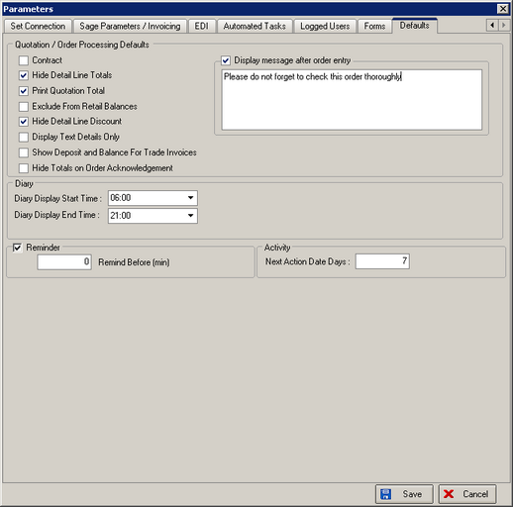

1117. Credit Note – Bespoke 4

There is a new credit note report that has the same layout as ‘Invoice – Bespoke 4’. It is called ‘Credit Note – Bespoke 4’.

1118. New Calculator – PVC Slat

There is a new calculator to work out stock usage for PVC vertical slats. These are plastic slats that are used to make vertical blinds (instead of fabric). They are bought in lengths (approx 5 metres long). The stock will be held in lengths and not metric units. The unit cost price will be for one length. We therefore calculate the number of lengths that are to be used and not the number of metres that are used.

The following functionality has been introduced. First of all, we hold the length of the slat in the roll width field in the ‘Stock Items’ form. When a blind is entered, and the fabric chosen has a calculator = PVC Slat, then the stock usage is calculated as follows:

Stock usage = (number of vanes / ((roll width / vane length) rounded down to whole number)) rounded up

Example: 15 vanes are being used, the vane length for the blind is 1200 and the full length is 5000, then:

Stock usage = (15 / ((5000 / 1200) rounded down)) rounded up = (15 / 4) rounded up = 4 full lengths.

