Blindata Release Note 4.1.0 

25 July 2008

Bug Fixes and Enhancements

2363. Works Order – Landscape Metric

- If quantity is > 1, then only 1 line now appears for that detail line.
- These fields have been replaced by ‘cutting size’ fields if the parameterised cutting option is switched on in the blind type record.
- ‘Order No’ has been moved to the right as it was overlapping the customer company name.

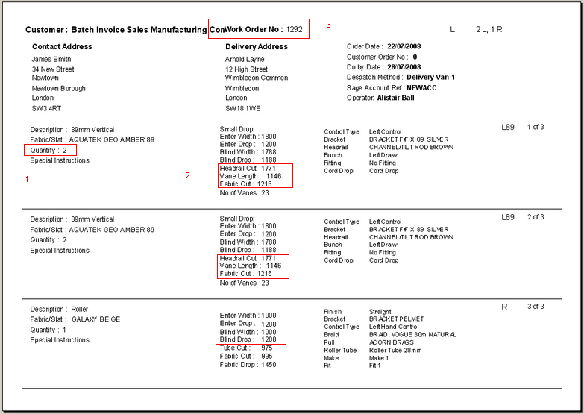

2366. Order Processing > Orders > Bill of Materials Report

The cost disc is now being applied when the cost of a component is printed in BOM report.

2367. Order Processing > Orders

The Location field entry disappeared (is not saved) in order detail entry if auto complete is off. Fixed.
New Work and Customer Requests

1058. Hardware Cutting Sheet

We have added a ‘support’ column onto the hardware sheet to display ‘Cable’ if it is selected on the blind entry screen.

1074. Export Order Report

On the Export order form if the Delivery address was different to the invoice address it changed the Contact Name to the Contact that had been entered into the delivery details. The Invoice Contact Name is now taken from the customer details (customers/details tab) and the delivery contact (order entry) only overwrites info on the delivery address contact name.

1075. Order Processing > Orders

If a blind is entered but its position needs to be changed so it is in sequence, the batch number has been changed to reflect its new position. Previously it showed its original number (e.g. 10) even if it has moved up to position 2. Also if a blind has been deleted, the batch number is now alter accordingly so they are in sequence.

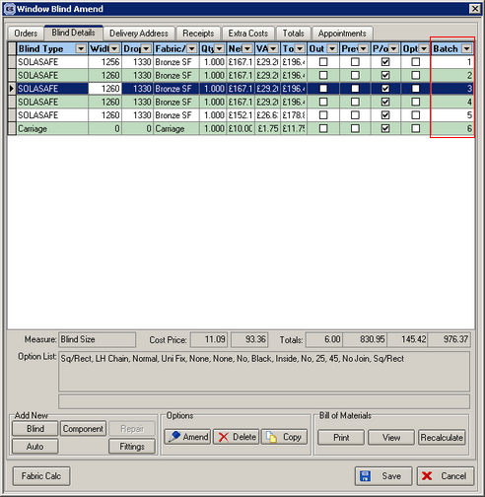

1076. Order Documentation

On this form we have made a slight change to the text. Instead of having ‘Paperwork checked and reviewed by ---------- on ---------- it now says:

CONTRACT REVIEWED BY _____________________ DATE __________________

PAPERWORK CHECKED BY ____________________ DATE __________________

1077. Packing List

The text centralised so it looks like:

All the wood we use in the factory is
ISPM15 compliant

1078. Administration > Parameters > Report Parameters > Fitter Sheet

We have created a new fitter sheet called ‘Fitter Sheet 15‘.

1079. Administration > Parameters > Report Parameters > Sale Lead / Fitter Sheet Individual

We have created a new fitter sheet called ‘Site Survey Sheet 15‘.

