Blindata Release Note 4.0.9 

18 July 2008

Bug Fixes and Enhancements

2356. Order Processing > Fitters Sheet / Sales Lead

In the ‘Sales Lead Enquiry’ form it is now possible to amend the status of the lead.

2358. Export Invoice

The amount printed in words is now the same as the amount printed in numbers ie if not in sterling, the words should be in the correct currency.

2359. Stock Setup > Purchase Order Enquiry > Generate PO

The quantity now only display to 3 decimal places.

New Work and Customer Requests

920. Order Processing > Orders

We can now see on the order amend enquiry form if there are contact management records held against an order. We have created a new field in the Orders form called ‘Contact Record’. This can be selected in Columns in the subtext menu. There is also a parameter in Administration > Parameters > Forms called ‘Contact Record’ so the user can pick the colour.

1072. Order Processing > Fitters Sheet / Sales Lead > Sales Lead

We have tidied up this form and it now looks like this.

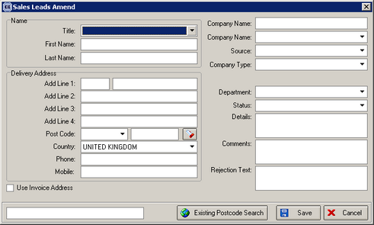

1073. Discounts

Previously we could set a discount to be accumulative or not. If you had two discounts set up for the same customer you could have the following:

1. Customer discount 10%
2. Customer blind type discount 20%

Price of blind 100.00

If accumulative = false, then the discount will be 20% and the nett price will be 80.00. If accumulative = true, then the discount will be 28% and the nett price will be 72.00.

We have introduced a third option, where the discounts will be added together. Therefore in the example above, the discount will be 30% and the nett price will be 70.00.

There is a new flag in the discount form called ‘Accumulative from full price’. If this is set to true, then the third method will be used. It is not possible to have the ‘Accumulative’ and the ‘Accumulative from full price’ switched on at the same time.

