Blindata Release Note 4.0.8 

14 July 2008

Bug Fixes and Enhancements

2347. Order Processing > Quotations

If you entered a quotation detail line for a component, and adjusted the ‘number of labels’ field, when it is converted to an order, the ‘number of labels’ field reverted to 0. It now copies across the number entered.

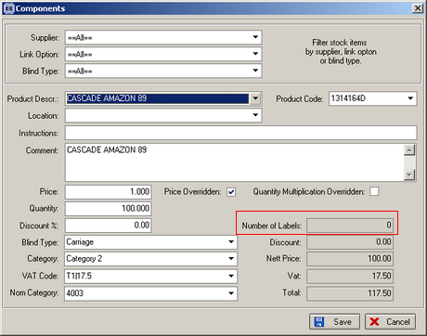

2351. Quotation - Laserprint (Letterhead)

The ‘Print Quotation Total’ flag in the Quotations > Totals Tab was not working when the email quotation was being sent. This has been fixed.

2355. Order Processing > Fitters Sheet / Sales Lead

In the ‘Find Sales Lead‘ form, tabbing through the fields is now in the correct order.

2358. Order Processing > Order Enquiry

If you despatched an individual blind in an order and then tried to scan ‘Blind In Stock’ or ‘Blind Out of Stock’ for another blind in the order, the following message appeared. It no longer appears.

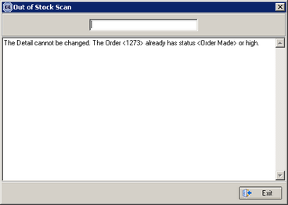

2359. Vanes Only Cost Price Setup

Cost prices are now selected from the Vanes price Table if ‘Select Cost Price From Table’ and ‘Calc width from vanes in the Blind Type record are switched on.

New Work and Customer Requests

614. Contact Management

When a contact management record is added, we now have the facility to create a future activity record. There is a new flag called ‘Future Activity’ record. If this is set to true, then a new contact management record is created, with the ‘Action Required’ text moved into the ‘Further Details’ field.

When the future activity contact record is created, it should then pop up as a task for that operator when they log in or are logged in.

To enable this functionality, you must set the following parameters in Administration > Parameters > Defaults.

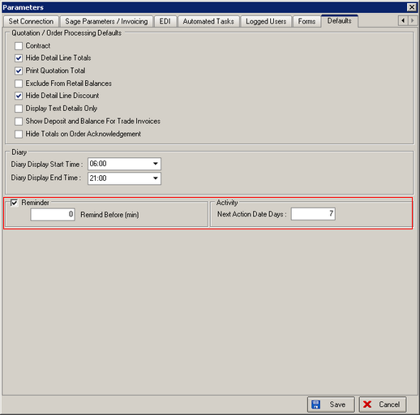

690. Multiple Fittings for Order

Previously it was only possible for one fitter and one fitting appointment to be allocated to an order. We have made this more flexible, because there may be jobs where two fitters are used. It may also be possible that one fitter is used but for more than one appointment.

We are also able to hold survey appointments in the same way.

Therefore we have created a new tab for ‘Appointments’ in the order entry form. There are options to Add, Amend or Delete appointments. We now hold appointment type, employee name, fitting date, start time and end time. When a record is added or updated here, it is updated in the diary. If a diary appointment is changed, it updates the record in the order. It also creates an order history record saying ‘Fitting Appointment has been created’, ‘Fitting has been amended’ or ‘Fitting has been deleted’ respectively (or Survey Appointment).

This has replaced the selection of a fitter and fitting date and time in the main order entry form. The following fields, therefore, have been removed from the ‘Order Entry’ form.

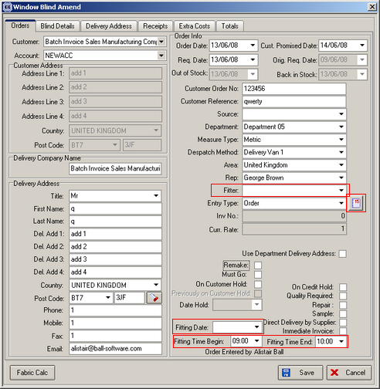

We have also changed other forms where fitting appointments are updated ie ‘Sales Lead’ and ‘Create order from sales lead’.

989. Works Order Portrait

The following now occurs if ‘Use Colour Report Layout’ is true in Report Parameters.

- If quantity > 1, then the quantity prints in colour red.
- If an option is not the default option, then it prints in colour red.

992. Email Message

Previously, when we sent an email quotation or acknowledgement to someone, the body text of the email only said ‘Please see attached’. We have parameterised this so the text can be entered by the user.

We now hold new fields in Administration > Company Detail in a new tab called ‘Email Text’. We hold fields called ‘Email Quotation Text’, ‘Email Acknowledgement Text’, ‘Email Delivery Text’ and ‘Email Invoice Text’.

When the emailed pdf is sent, the body of the text now says:

‘Dear [Title] [First Name] [Last Name],

Body of Text

Regards,

User name

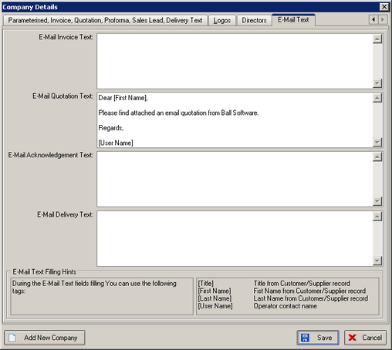

1032. Stock Setup > Stock Items

There is a new field to flag stock items as being non online ie they cannot be uploaded to the online database. The field is called ‘Unavailable Online’. We have also altered the synchronisation program so stock records where ‘Unavailable Online’ = true do not get uploaded to Blindata Online.

1035. Order Processing > Orders > Blind Detail Line Entry

We now have a new facility to enter a new fabric from the order detail line entry form. Once a fabric has been chosen in the detail line entry, a button called ‘Create Fabric’ appears. This button is controlled by a new ‘Advanced Permission’ called ‘Create Fabric’. The code behind this new button uses the ‘duplicate fabric’ functionality from the stock items form.

1066. Order Processing > Order Enquiry

We now have a facility to part dispatch orders. Previously there was a ‘Despatch Blind’ button on the ‘Order Enquiry’ form, but it was only possible to use this if all the blinds on the order had been manufactured. We are now able to despatch individual blinds and then print a delivery docket for them. The delivery docket only shows the blinds that have been dispatched. Once the rest of the order is dispatched, another delivery docket will print with the other blinds on it. In fact, it should be possible to make multiple despatches from one order. At the moment, this has only been done for ‘Delivery Docket – Laser Print Non Itemised’.

To enable this facility, you must switch on the following parameter in Administration > Parameters.

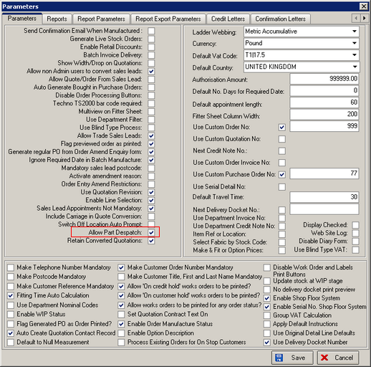

1067. Converting Quotations to Orders

We have a client that wants to keep a record of quotations that have been turned into orders and also be able to copy quotations. Previously, if a quotation was converted into an order, it was not possible to copy that quotation.

We now have a new parameter called ‘Retain Converted Quotations’ in Administration > Parameters. This defaults to false. If it is set to true, then when a quotation is converted to an order, the quotation is retained.

1068. Order Processing > Orders

We now have ‘Cost Price’ as a column choice in ‘Order Amend Enquiry’ and ‘Archive Enquiry’, but only if ‘Display Costs’ = true in Administration > Users > Advanced Permissions’.

1070. Works Order – Label Blind Size

We have incorporated new functionality in this works order label report. . The only difference is that for Venetian blinds, the manufacturing bar code for venetians will appear on the top right hand label, replacing all existing text that was there. The following parameter needs to be switched on.

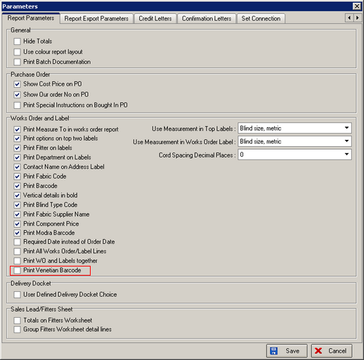

1071. Fitters Sheet / Sales Leads

It is now possible to display a company name on the fitter sheet / diary form. Previously it only displayed the contact surname. We have kept this, but also display the company name if it has been filled in.

