Blindata Release Note 4.0.5 

06 June 2008

Bug Fixes and Enhancements

2319. Blind Details > Blind Types > Cutting Options

This form has been optimised. Previously, If there were a lot of records set up for cutting options, it was very slow moving from one cutting option to another.

2330. Fitters Sheet / Sales Lead

The first and second line of the address field are now validated when entering a sales lead. This means that the survey can be completed because the address fields will be filled in.

New Work and Customer Requests

515. Order Processing

We now have an order history record if an order is set to ‘On Customer Hold’ or is taken off ‘On Customer Hold’. If an order is taken off ‘On Customer Hold’ or placed ‘On Customer Hold’, an order history record is created. It says either’ Taken off customer hold’ or ‘Placed on customer hold’.

967. Order Processing > Orders

It is now possible to hold attachments against quotations and orders. These could be very large (photographs, scale drawings etc) and so they are not held in the database.

There is a new button on the bottom right of the Order Amend Enquiry’ form called ‘File Attachment’. In here you can add, view and delete attachments.

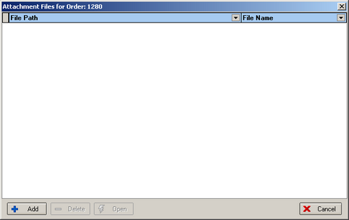

979. Stock Setup > Fabric Optimisation

We have made a couple of minor changes to the fabric optimization. The first change is that it currently calculates optimal fabric usage based on the exact dimensions of fabric required. However, typically you a little extra fabric on each side to ensure that you have a square cut and enough material for the cutter clamps to grip whilst cutting. We need to add a small amount to the cut width and drop for the calculation of fabric required.

Therefore we now have two new fields in the blind type record: ‘Scrap Width Add On’ and ‘Scrap Drop Add On’. These figures are added to the width and drop before the optimization is done.

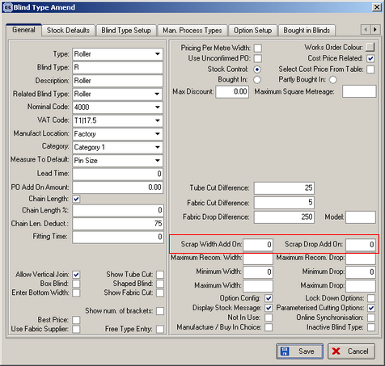

The second change is also to have the blind number (i.e. “x of y”) displayed on the cutting diagram.

1031. Works Order – Label 5

We have moved the options up slightly, put the bar code on the address label and moved the special instructions. This means there will then be room for the Venetian bar code on the bottom of the large label.

1038. Venetian Barcode

This barcode is required for a Venetian blind making machine. The barcode only appears on ‘Works Order – Label 5’ (see dev 1031) and only when blind identifier = Venetian.

The barcode is 27 digits long, made up of the following:

Char 1: fixed – always 1.
Char 2-3: model. We need to hold a new field against the blind type record for mode. It should be a 2 digit character field, called ‘Model’.
Char 4: options. We could hold this in the ‘Special’ field in stock items, and it could be taken from there after the option is chosen and the barcode created.
Char 5: options. We could hold this in the ‘Special’ field in stock items, and it could be taken from there after the option is chosen and the barcode created.
Char 6: options. We could hold this in the ‘Special’ field in stock items, and it could be taken from there after the option is chosen and the barcode created.
Char 7-10: headrail colour – this will be the stock code for the headrail colour (option is called Headrail Code) chosen in options.
Char 11-14: exact width.
Char 15-18: exact drop.
Char 19-22: slat colour – this will be the stock code for the slat colour (option is called Slat Colour) chosen in options.
Char 23-26: tape colour – this will be the stock code for the tape (option is called Cord Code) chosen in options.
Char 27: quantity.

1045. Order Processing > Orders > Blind Details

We now have ‘Location’ as a column option on this form.

1046. Administration > Parameters > Report Export Parameters

There is now an option for report ‘Invoice – Bespoke 19’ here.

