Blindata Release Note 4.0.2 

8 May 2008

Bug Fixes and Enhancements

2305. Fitters Sheet / Sales Lead > Sales Lead Enquiry

If you entered a sales lead with only a title and a last name, the contact name did not display on the ‘Sales Lead Enquiry’ form. It now does. Also, if you enter ‘Mr’ in the title, ‘Smith’ in the last name, the contact name now appears as ‘Mr Smith’, not just ‘Smith’.

2306. Works Order – A4 Packing Slip

The company name is now the customer company name and not the company name from Administration > Company Details.

2307. Order Processing > Quotations > Create Order

The bottom width now gets moved to an order when an order is created from a quotation.

2308. Order Processing > Orders > Extra Costs

It was only possible to enter one extra cost record (temp bug). The buttons were greyed out after one record had been entered. Fixed.

2309. Administration > Users > Copy

Copying a new user automatically granted ‘Check orders’, ‘Allow amendments’ and other permissions even if the original user did not have these permissions. It now copies the permissions exactly.

2310. Order Processing > Orders

If Administration > Parameters > Order Entry Amend Restrictions = true and Administration > Users > ‘Allow Amendments = false, it is no longer possible to delete detail lines after status = Order Entered.

2311. Order Processing > Orders

If ‘Allow Amendments’ = true, it is now possible to amend a detail line until the blind has been manufactured. If you have two blinds on an order but only one is manufactured, it will still allow you to amend that blind until the whole order is manufactured.

2312. Order Processing > Orders

The order source default is now taken from the customer record when an order is being added.

2313. Fitters Sheet / Sales Lead > Convert Sales Lead To Order

When a sales lead is converted to a quotation or an order, the defaults from Administration > Parameters > Defaults are now picked up.

2314. Pricing > Cost Price Table Calculation

The following error occurred when you tried to run this menu option. Fixed.

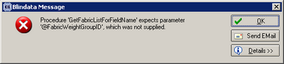

2316. Order Processing > Orders

If a detail line has blind identifier = Cassette, the rules for calculating fabric usage are now the same as for blind identifier = Roller.

2317. Order Processing > Orders > Bill of Materials

If a blind detail line is entered with blind identifier = Velux, the bill of materials is now checking to see if there are any records in Blind Types > Stock Defaults.

New Work and Customer Requests

1020. Label Print – Bespoke 8

There is a new label layout that is identical to ‘Works Order Label Blind Size’.

1023. Order Processing > Quotations

When the quotation form is now opened, it defaults to showing all records that do not have a status of ‘Ordered’.

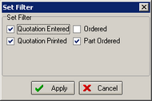

1024. Order Processing > Archive Orders

It is now possible to view an order once it has been changed to ‘Invoice Posted’. This has the same functionality as ‘Amend’ in ‘Order Amend Enquiry’ but with all the advanced permissions switched off (in other words the user can view all the forms in the order but not change anything). There is a new button on the ‘Archive Enquiry’ form called ‘View’ to do this.

1025. Order Processing > Archive Orders

Once an order has been archived (Invoice Posted), it was not easy to find the order if you only have the delivery address to find it. We have improved the ‘Find’ button on this form so the following fields can be looked for.

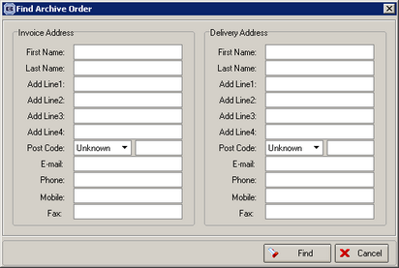

1026. Order Processing > Archive Orders

It is now possible to right click on a record in the archive enquiry to see the extra costs records.

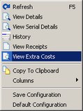

1028. Order Processing > Orders > Enter Component

It is now possible to enter the VAT amount manually in this form. This is useful if an invoice has to be sent to a customer for an insurance claim , for example.

1033. Sage Parameters

We have a client that uses the order number as their invoice number. But when the invoice is updated to Sage, the invoice number is updated to the Ref field. We have therefore created a new parameter in Administration > Parameters > Sage Parameters / Invoicing called ‘Update Order Number to Ref’, which defaults to false. If it is true, then the order number rather than the invoice number will be updated to the Ref field in Sage.

