Blindata Release Note 4.0.0 

18 April 2008

Bug Fixes and Enhancements

2260. EDI Import

When orders are being imported, they now have the same rules for calculating the required date as the order entry program has.

2269. Bought In Purchase Order

If you create a purchase order for a bought in blind, the required date is now generated from the ‘lead time’ field in the ‘Bought In Blinds’ tab in the blind type record.

2275. Order Processing > Orders

There was a problem where the item listing was printing the items in a slightly different order from the detail line entry. If you looked at the window blind amend form, they were in one order, but in a different order on the item listing. This was caused by altering the order of the detail lines in the quotation.

2276. Order Processing > Order Enquiry

The order details are now appearing in blind id order.

2277. Box Assembly Report

The despatch method now comes from the order.

2278. Packing List

In the footer ‘LILAC’ has replaced ‘LOCAL’.

2279. Order Processing > Orders

When a detail line is copied the program now generate new value for the ‘num_batch’ field, using following rule: num_batch for the copied detail line = MAX(num_batch) for this order + 1

2280. Quotation – Bespoke 21

- This total no longer includes the carriage line.
- This now wraps round.
- This is now the entered ‘bottom width’, not the cutting option calculation.

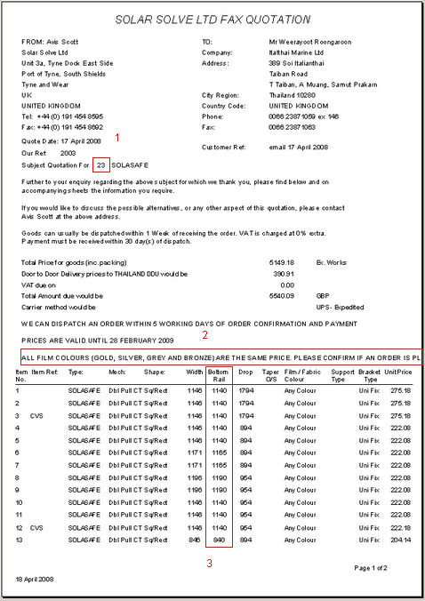

2281. Export Invoice

- The invoice contact name is now the contact name from the customer record, not the order.
- The total now always display to 2 decimal places.

2282. Label Print – Bespoke 18

The carriage line is now ignored in the label numbering.

2283. Packing List

Side channels were still being permanently displayed in the Additional Items box but are now only there if ‘Side Channel’ selected in the order entry screen.

2284. Order Processing > Orders > Create PO (Temp Bug)

If you entered a sales order with 3 detail lines for bought in blinds all from the same supplier, the ‘Create PO’ function created 3 purchase order records. Fixed (only happening in initial release of 4.0.0).

2285. Order Processing > Order Enquiry

‘Customer ?lass’ now says ‘Customer Class’ in the column choice.

2286. Order Processing > Orders

The return size is not required if ‘box blind’ = true in the blind type record. Fixed.

New Work and Customer Requests

562. Order Processing > Order Enquiry

We have changed the rules slightly for deciding if an order status should change to ‘Order Manufactured’. At the moment if you use ‘Blind Made’ in Order Enquiry or ‘Delivered’ in Purchase order Enquiry, there is a function that checks to see if all other detail lines on a sales order are manufactured. If they are, the status of the order gets changed to ‘Order Manufactured’.

There was a slight problem, however. Quite often a user will also enter a detail line for carriage or fitting, for example – this is an item that cannot be manufactured, and so, previously, the order status would never get changed automatically to ‘Order Manufactured’. We have changed this so the order does get changed to ‘Order Manufactured’, providing the ‘Carriage’ flag in the stock record has been set to true.

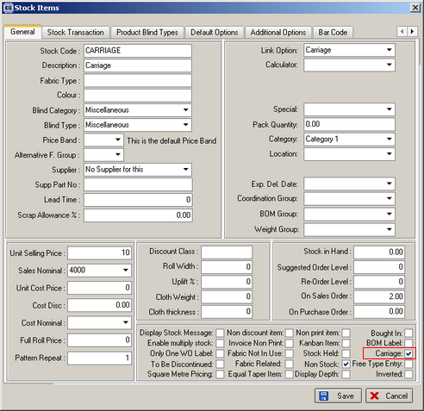

946. Order Processing > Archive Enquiry

In the context menu, we now have the ‘Columns’ choice, the ‘Copy to Clipboard’ choice, and ‘Save Configuration’ and ‘Default Configuration’ options.

The columns choice now also includes Job Reference, Rep, Customer class, Despatch, Area, Quote No, Department, Notes and Actual Total.

981. Invoice – Batch Print A4

A new invoice print has been created for the batch invoice print, called ‘Invoice – Batch Print A4’.

1002. Order Processing > Orders > Measurement

There is a new parameter so the Measurement field in the order detail line can be blank and must be filled in. The parameter should be called ‘Enable Measurement Default’ and should be in Administration > Parameters. It should default to true.

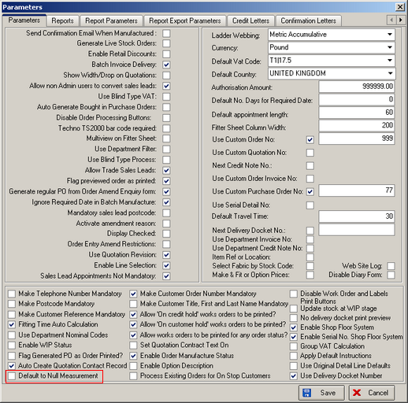

If false, the Measurement field should be blank when a blind detail line is being added. When the user tries to enter a width or drop before entering a Measurement (metric or imperial), a message should appear saying ‘Please enter Metric or Imperial in the Measurement field’.

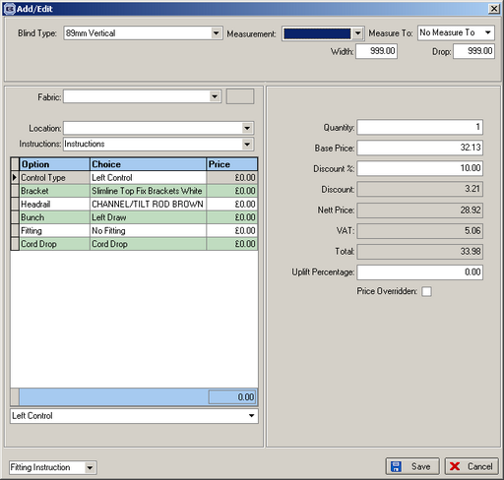

1004. Alternative Blind Type / Fabric Descriptions

We have created new tables so that alternative descriptions can be held for blind type descriptions and fabric descriptions, by customer. The purpose of this is so that one manufacturer can make blinds on behalf of another company. This other company may have their own descriptions for blind types and fabrics, and will want these to appear on the delivery docket.

The following changes have been made.

There is a new tab in the blind type form, called ‘Customer Descriptions’. In it there is a form where you can enter a customer company name (by lookup) and a blind type description (text field).

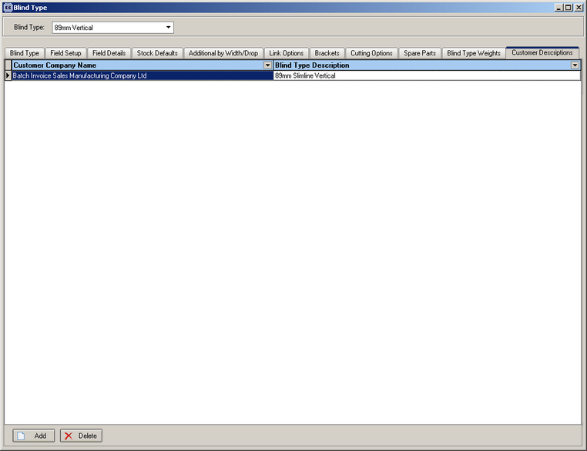

There is a new tab in the stock items form, called ‘Customer Descriptions’. In it there is a form where you can enter a customer company name (by lookup) and a fabric description (text field).

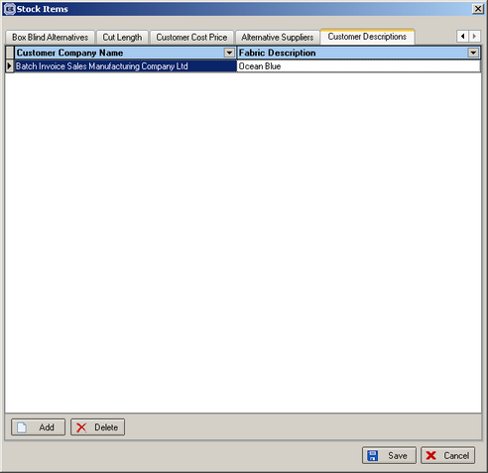

In Delivery Docket – Laser Print (Special), if there is a specific customer blind type description or fabric description set up, these descriptions are used instead of the standard ones.

1005. Pricing > Discount Authorised By

It is now possible to hold an employee id against discount records to identify who has authorised the discount. This will be one of the reps so it should look up the employees table.

There is a new flag called ‘Discount Authorisation’ in the employee record.

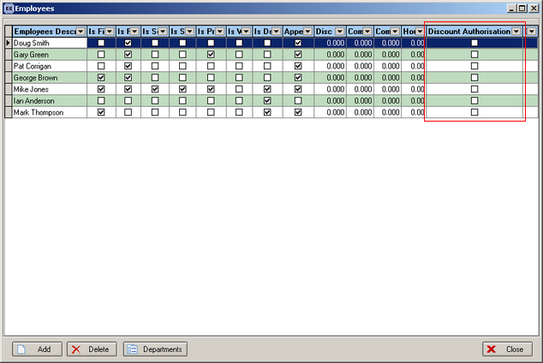

When a discount is added, there is a new field to store the employee id. This looks up the employee table where ‘Discount Authorisation’ = true.

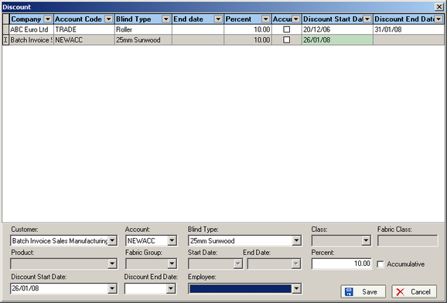

1007. Works Order Label 1

‘Chain’ is now called ‘Ch Drp’.

1009. XML Order Acknowledgement

We have included the width and drop in this file and also the ‘Delivery Company Name’.

1016. Order Processing > Orders > Detail Line Enquiry

We can now display the num_batch on the order detail line. This has been added as a column choice on the context menu. Right click to view the context menu.

