Blindata Release Note 4.0.1 

29 April 2008

Bug Fixes and Enhancements

2287. Order Processing > Orders

If a second line is being entered for a blind type where ‘Enter Bottom Width’ = true, and all the details are being taken from the first line, the bottom width is now copied to the second line.

2288. Invoice For Customs

- The country is now at the bottom of the invoice address.
- The country is now at the bottom of the delivery address and the ‘Customer VAT No’ has been moved to make room for this.

If the postcode is blank, then the country is moved up a line for both invoice and delivery address.

2289. Quotation – Bespoke 21

- The postcode from the Company Details now prints.
- The postcode from the customer address now prints.

2290. Delivery Docket – Bespoke 18

We have done exactly the same as 2288, except in ‘Delivery Docket – Bespoke 18’.

2291. Order Processing > Quotations / Orders

When ‘Fabric Calc’ is used and a cost price is updated, it now update the detail line in the order. If ‘Cost Price Related’ = true for the blind type, then the scrap value is included.

2292. Invoice – Sage Laser Print

The fabric description was overlapping the width. Fixed.

2294. Sales Lead – Bespoke 19

- The postcode now only has one space between the first and second part.
- The telephone number from the sales lead now appears.
- The mobile number from the sales lead now appears.
- If there is no appointment date, then it is blank.

2295. Fitters Sheet / Sales Leads > Add Sales Lead

The house number section now accepts more than one number eg 13-14.

This applies wherever addresses are entered.

2297. Order Processing > Orders > Extra Costs

When adding a new ‘Extra Cost’ record, the date now default to today’s date.

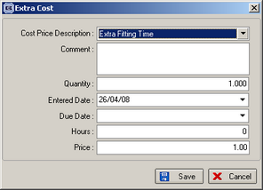

2298. Invoice – Bespoke 19

We have removed ‘Miscellaneous’ from the detail lines on this report.

2299. Quotations > Contact Management Reports > Next Quotation Contact

There is now a filter for ‘Live’ in the Next Contact Date report. On the report we have included customer reference and nett total, but excluded next contact date.

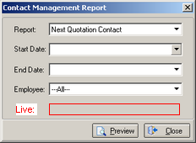

2300. Quotations > Create Orders

When a quotation is entered for a Venetian and then converted to an order, the system did not calculate the number of braids on ‘Works Order – Bespoke 15’. Fixed.

2301. Quotation – Bespoke 15

The totals now only appear on the last page of this report.

2302. Order Processing > Orders > Fitting Time

When arranging a fitting appointment, it is now possible to enter a fitting time after 6pm, if the start and end diary parameters have been set accordingly.

New Work and Customer Requests

999. Order Processing > Quotations > Create Order

Previously, if a quotation contained a detail line for carriage, when the quotation was converted to an order, the carriage line was not converted as well. We have created a new parameter that allows the user to define whether the carriage line be converted to an order or not. The parameter is in Administration > Parameters and is called ‘Include Carriage in Quote Conversion’.

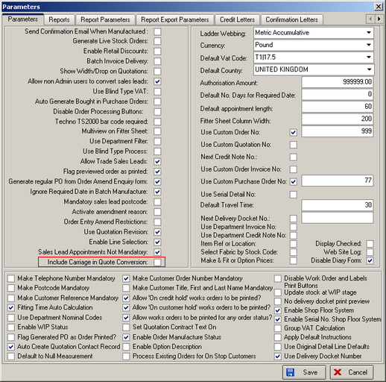

1010. EDI Import

If an order is imported from an EDI file, the ‘Order source’ field is now populated as ‘EDI’. We need to make sure there is an ‘Order Source’ record with description ‘EDI’.

1017. Works Order - A4 Packing Slip

The layout of this report has been significantly altered, and it includes the possibility of putting the bar code on the report.

1018. Blind Types

There is now a ‘Copy to Clipboard’ option on the enquiry form if you right click anywhere on the form.

1019. Invoice – Bespoke 8

If there are discount records for component lines, they now appear on the invoice in the same way as they do for blind detail lines.

1021. Delivery Docket – Van Despatch Totals

This is a new report in Delivery Docket Batch Print called ‘Delivery Docket – Van Despatch Totals. This prints by Despatch method (van) per page and show customer name, total of blinds for customer, and then a space for a customer signature.

Van Despatch Report

Van: Despatch Date:

Customer Number of Blinds Signature

ABC Blinds 8

Cascade Blinds 1

Joe Bloggs Blinds 4

1022. Order Processing > Order Enquiry

We now have ‘Despatch Method’ as a column choice.

1027. Fitters Sheet / Sales Leads > Sales Lead Enquiry

The company name (the manually entered one, not the lookup) now appears as a column choice.

