Blindata Release Note 3.9.8 

7 April 2008

Bug Fixes and Enhancements

2236. Label – Bespoke 18

- ‘INSTALL INVERTED’ is now in bold text.
- Spare parts have been added (from Spare parts table where blind type and customer match).

Also, the line up has been adjusted slightly.

2242. Delivery Docket – Bespoke 15

- The quantity now appears as a column.
- The Required Date, not the Delivery Date, prints in the delivery date box.

2243. Order Processing > Orders

If you had two discounts set up in Discounts, the first, eg, for 50%, and the second for a discount of 0% which is not accumulative, the 0% discount did not get applied. It is now applied regardless of the actual percentage.

2245. Sales Lead Enquiry

If you tried to convert a sales lead to an order for a customer where trade type = trade, the following message appeared. It has been disabled. This ha already been done on the diary form.

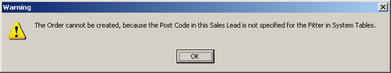

2246. Works Order Portrait Barcode

- There is now more horizontal room for the name and address.
- There is now more horizontal room for the delivery name and address.
- The header section now looks like ‘Works Order Portrait’.
- The word ‘Fabric’ was not being printed properly. Fixed.
- If there was only one detail line with a quantity of 2, it printed 2 detail lines. It now only prints one detail line with quantity = 2.

2247. Purchase Order Enquiry > Display Order > Deliver / Deliver All

We have optimised the ‘Deliver’ and ‘Deliver All’ functionality in the ‘Display Order’ form.

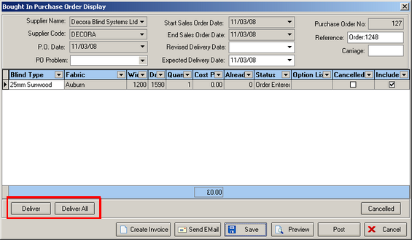

2248. Invoice – Bespoke 19

The invoice number now prints the order number beside it, not the invoice number.

2249. Delivery Docket – Batched Orders

- Carriage no longer appears on delivery dockets
- The ‘x’ is now spaced equally between the quantity and the blind type description.
- There is a page break for each customer.

2250. Works Order Portrait Barcode

- The header now appears on each page of the report.
- Fabric code no longer prints if it is switched off in Report Parameters.
- Special instructions now print with ‘Special Instructions’ as field description.
- There is now a fourth detail line on a page.

2251. Quotation – Laser Print (Letterhead)

If ‘Hide Detail line Totals’ is ticked in the Totals tab for a quotation, the column heading text no longer prints.

2252. Export Order

The boxes are now lined up properly.

2253. Delivery Docket – Bespoke 18

- The Contact text is lined up with the text below.
- The contact name now prints.
- The customer VAT number now prints.
- The boxes are properly aligned.
- There is a gap here between the directors and the footer text.

2254. Quotation – Bespoke 21

- The text now says ‘Door to Door Delivery’.
- The text after this taken from what is entered in the Carriage text field in the totals tab of the quotation.

2255. Film Cutting Sheet

- Sometimes the order of the detail lines was wrong. The order should be by film colour and then item number, but this can cause the order to look odd. It should really sort by film colour then item number, but then print the film colours not in alphabetical order but by which item number is first.
- The ‘Fabric Drop’ cutting option is printed, not ‘Film Drop’.

2256. Order Processing > Orders

If you had an order where ‘Fitting Before Invoice’ = true in the despatch method, and you tried to create an invoice individually before it was fitted, a message appeared saying that the fitting must be done first. But it also displayed the invoice date message as well. It no longer displays the latter.

2257. Delivery Docket – Laser Print (Special)

We have removed the operator name from this delivery docket.

New Work and Customer Requests

973. Works Order – A4 Packing Slip

A new works order layout has been created, called ‘Works Order – A4 Packing Slip.

974. Delivery Docket – Batched Orders

A new delivery docket has been created called ‘Delivery Docket – Batched Orders’. Orders can only appear on the delivery docket if the order status = Fully Manufactured’, but more than one order can appear on a delivery docket. This delivery docket print can only be run from Order Processing > Delivery Docket Batch Print’.

For this report, we generate a delivery docket number. There is a new parameter in Administration > Parameters called ‘Use Delivery Docket Number’. If this is set to true, then the next delivery docket number is written to the Orders table when the delivery docket batch print is done.

Also, if ‘Use Delivery Docket Number’ is true, then the ‘Create Invoices’ routine will create a new invoice number for each delivery docket number.

990. Quotation – Bespoke 15

The layout of this report has been tidied up.

991. Quotation – Bespoke 15 (Email pdf)

This report is now included in Administration > Parameters > Report Export Parameters > PDF Quotation.

993. Fitters Sheet / Sales Lead

If the ‘Company Name’ has been entered in the sales lead, then it now appears here instead of the ‘Last Name’. This could either be the company name that has been entered or the one that has been looked up.

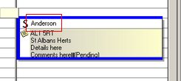

The same rule also applies for a fitting appointment.

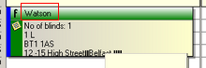

994. Fitters Worksheet

- There is a new parameter in Administration > Parameters > Report Parameters > Sales Lead / Fitter Sheet called ‘Print Totals’. If this is set to false then the totals on this report will not print. The default is set to true.
- If the order trade type = trade, the company name appears.
- The ‘Customer Signature’ and ‘Print Name’ are now on the same line, to give more space for signing.

Customer Print
Signature ___________________ Name ___________________

998. Delivery Docket – Agent

We have created a new delivery docket called ‘Delivery Docket – Agent’. This has the same layout as ‘Delivery Docket – Laser print’ except that the company name and address is replaced by the customer company name and address.

