Blindata Release Note 3.9.7 

28 March 2008

Bug Fixes and Enhancements

2228. Order Processing > EDI Enquiry > EDI Import

With blinds that don’t fit with cord spacing table, the import program fell over when it tried to import one of these blinds. It now to skip it, put an entry in the log and continues with the rest of the order.

2229. Label - Bespoke 22

- On both the Delivery Address lines, Delivery Company Name was showing on the first line. This is now showing Order Contact Name.
- There is now more space for the Blind Type description.

2230. Works Order - Bespoke 22

1. If a detail line has a quantity of 2 or more the line was duplicated on the report and each line shows a quantity of 2. There is now only one line showing the quantity.

2231. Invoice - Bespoke 22

The invoice wasn’t showing any detail line information when the contract text was unticked. Fixed.

2232. Fitters Sheet / Sales Leads

If you tried to convert a sales lead to an order for a customer where trade type = trade, the following message appeared. We do not need this check to take place so it has been disabled.

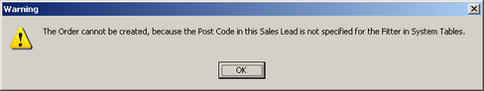

2233. Acknowledgement – Laser Print (Letterhead Logo)

- We have reduced this text in size slightly and space it better vertically.
- The column header text displayed as "Type Colour Width Drop" etc is slightly smaller.
- Text alignment has been centred.
- We have kept the text "Required Date:" but displayed the 'Customer Promised Date' alongside it instead.
- We have allowed a bit more space to print options. If they do go onto a second line, it is spaced better vertically.

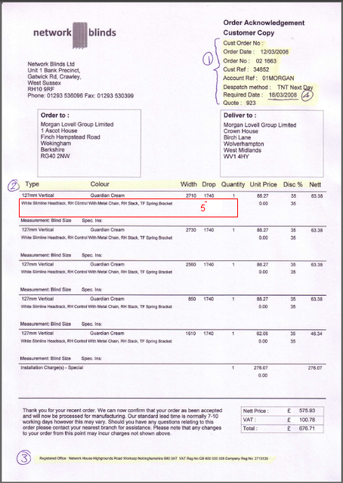

2234. Sales Lead – Bespoke 19

- The invoice address is now on the sales lead.
- ‘Createed’ is now spelt ‘Created’.

2235. Invoice – Bespoke 19

- The VAT number from Company Details now prints out properly.
- ‘Invoice Date’ now says ‘Invoice Date / Tax Point’.

2237. Quotation Technical Sheet

- ‘Boxed Weight For Carriage’ is now multiplied by weights multiplier.

2238. Order Processing > Orders

The weights field in the Totals tab should be multiplied by the weights multiplier.

2239. Packing List

The spare parts are now being generated properly for this report.

2240. Film Cutting Sheet

The column title ‘Film Drop’ has been changed to ‘Fabric Drop’.

2241. Works Order – Bespoke 15

If the contact name is changed in the order, it is now being printed out on the works order.

New Work and Customer Requests

656. Measure To Default

It is now possible to identify a ‘Measure To’ record as being null when an order detail line is being entered.

The purpose of doing this is so the system can be set up in such a way that the user is forced to make an entry in the ‘Measure To’ field in the order detail line entry.

There is a new parameter in the blind type record, called ‘Set Null as Default’.

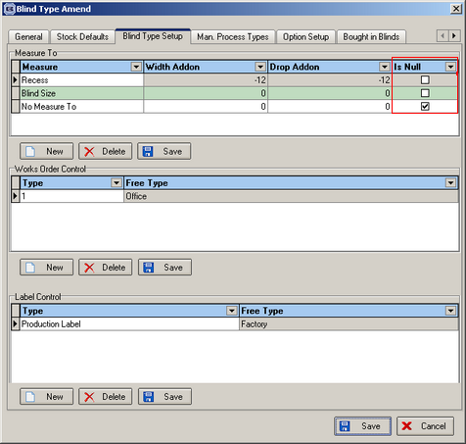

If an order detail line is entered, and the ‘Measure To’ is left as a null record, the following message will appear at the end of an order.

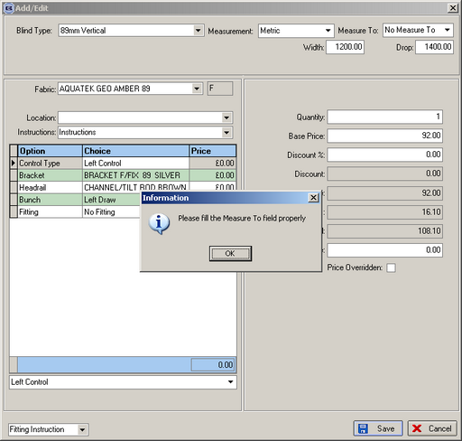

959. Order Processing > Quotations

This button now brings up a form that gives you the choice of ‘Quotation Contact Management’, ‘Next Quotation Contact’ and ‘Last Quotation Contact Report’. The criteria are the same as in Reports > System Reports.

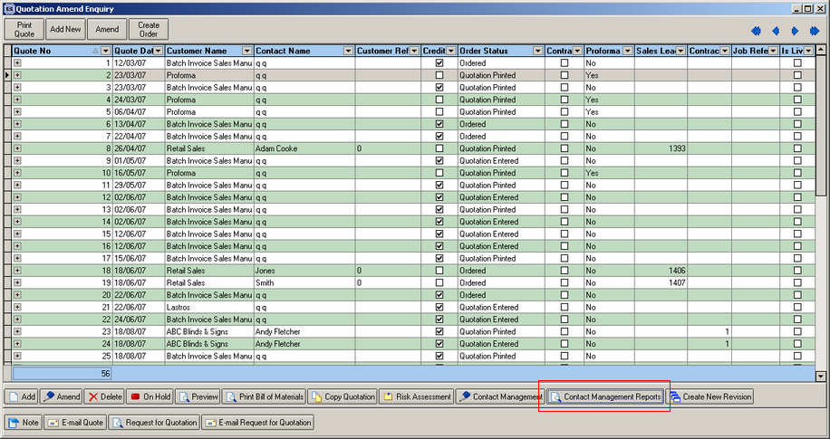

972. Purchase Order Enquiry

This initial display of this form has been speeded up. If there were a lot of purchase orders in the system, it was slow to load. This was because there was not a proper purchase order status field being updated. Fixed.

978. Alternative Account Code

There is a new parameter in Administration > Parameters > Sage Parameters / Invoicing called ‘Check Alternative Account Code’. If this is set to true, then when sales invoices are posted to Sage, the posting program checks to see if ‘Customer Add. Ref.’ is null in sales Files > Customers. If not, then the account code in this field is updated to instead of the normal ‘Account Ref’.

980. Order Processing > Orders – Allow Amendments

If Administration > Parameters > Order Entry Amend Restrictions = true and 'Allow Amendments = true in User > Advanced Permissions, previously the user could not amend an order detail line after 'Work In progress'. We have changed this for a user with this permission, so they can alter the detail line until status = 'Invoice Printed'.

982. Order Processing > Orders

There are two new parameters in Administration > Parameters > Defaults called ‘Show Deposit and Balance For Trade Invoices’, and ‘Hide Totals on Order Acknowledgement’. They both default to false.

These parameters have also been added to the Orders table and are picked up as defaults.

The two reports affected are ‘Invoice – Bespoke 19’ and ‘Acknowledgement – Bespoke 19’.

984. Order Processing > Sales Lead Enquiry

If Administration > Parameters > ‘Disable Diary Form’ is set to true, then the sales lead enquiry form displays as soon as you enter Fitters Sheet / Sales Leads.

If this condition is true, then there is now an ‘Add Sales Lead’ button on the form.

985. Fitters Sheet / Sales Lead

We have added an ‘Invoice Company Name’ field in here.

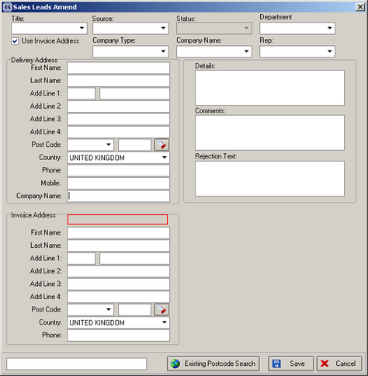

It now prints out on report ‘Sales Lead – Bespoke 19’.

