Blindata Release Note 3.9.3 

3 March 2008

Bug Fixes and Enhancements

2205. Order Processing > Quotations

The ‘Don’t Follow Up’ field is now active for all quotation records. Previously it could only be ticked for records that were for contract quotations (where contract id <> null).

New Work and Customer Requests

941. Purchase Order Processing > Regular PO

It is now possible to access the stock item record from the regular PO form. It is only possible to do this if the user has the permission to access Stock Setup > Stock Items.

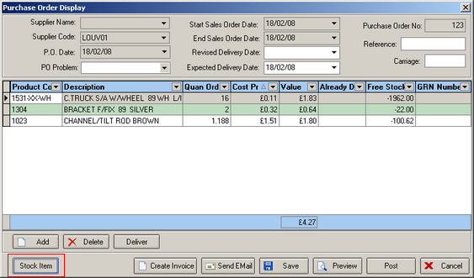

954. Stock Setup > Stock Items

We have added ‘Blind Identifier Code’, ‘Supplier Part No’, ‘Roll Width’, ‘Unit Selling Price’, ‘Sales Nominal Code’, ‘Unit Cost Price’, and ‘Cost Nominal Code’ to the column choices.

