Blindata Release Note 3.9.2 

25 February 2008

Bug Fixes and Enhancements

2194. Label Print – 200 x 24mm

The customer reference field has been moved to the right a bit and the order number moved down to the right of blind type description. The customer field stops before the cust ref.

2196. Order Processing > Quotations

It is no longer possible to create a new revision for a quotation that has already been turned into an order. A message appears saying ‘This quotation has already been converted to an order’.

2197. Label Print – Bespoke 18

- The quantity is now left justified and the description moved slightly to the right (2mm).
- ‘INSTALL INVERTED’ has been made bigger and moved across to the middle of the label. It also appears on the right hand lower label as well.

2198. Fitters Sheet / Sales Leads

When you convert a sales lead to a quotation or an order, the mobile number is now copied across.

2199. Export Order / Invoice

The Company Reg No and VAT Reg No now print on the report.

- The word SLOWCASS has been replaced by VARYSTOP.
- This should be centred (it is slightly to the right at the moment).
- The date, text and page number should be moved down 3mm.

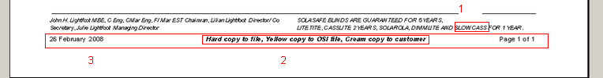

2201. Quotation Technical Data Sheet

- The film drop is now calculated the same way as in the film cutting sheet.
- Bottom width now prints.
- LH Taper Offset now prints.
- Inverted now prints.

2202. Order Processing > Quotations

When a quotation is converted to an order, the email address, if not null, is now copied from the quotation, not the customer record.

New Work and Customer Requests

845. Order Processing > Orders

The fabric bill of material calculation is now being done if the blind type in the detail line = Velux.

907. Administration > Parameters

If a customer is on stop, there is now a parameter to allow existing orders to be processed. The parameter is called ‘Process Existing Orders for On Stop Customers’, and is in Administration > Parameters. The default is false.

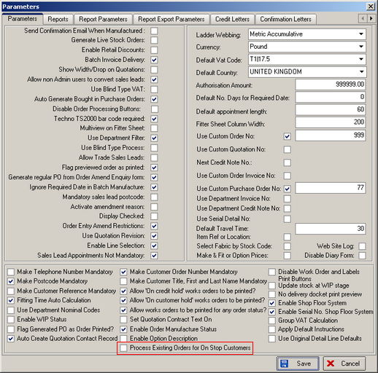

912. Disable Credit Control

There is a new parameter in Administration > Sage Parameters /Invoicing called ‘Disable Sage Credit Control’. If this is set to true, then orders cannot go on credit hold.

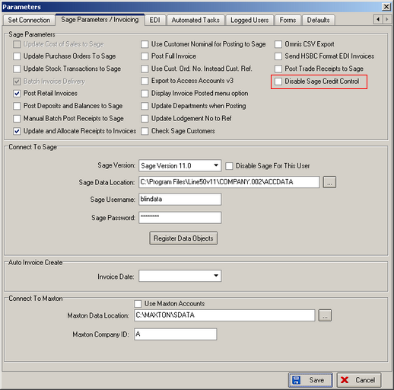

930. Fitter Worksheet

- If ‘Use department Filter = true in Administration > Parameters, then the department name and address now print instead of the company name.
- The customer telephone number now prints below the address.

932. Fitters Sheet / Sales Lead

It is now possible to change the time scale on the fitters/sales lead diary form.

This can be done by setting the default start and end times in Administration > Parameters > Defaults.

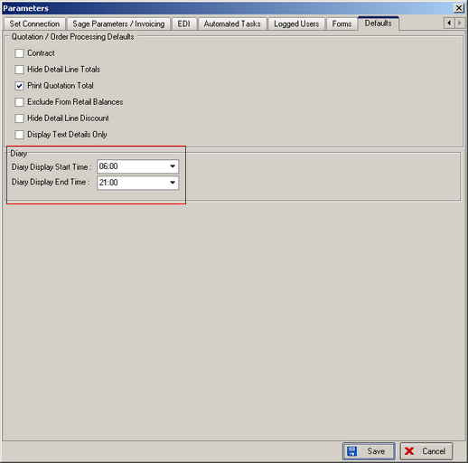

933. Order Processing > Quotations

The job reference field has been increased to 30 characters.

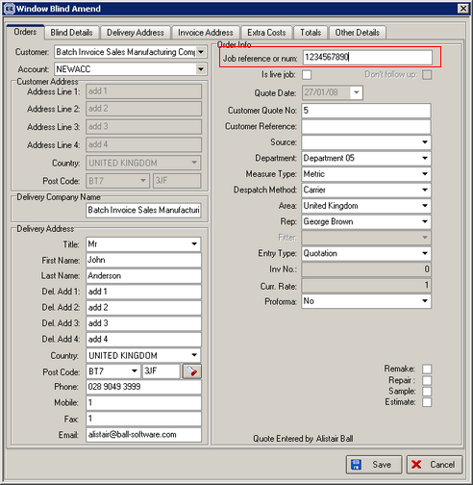

934. Order Processing > Quotations

The risk assessment form is now available on quotes as well as orders. When the quotation is converted to an order, the risk assessment record will go with it.

935. Sales Files > Customers

We have added telephone number, price table and credit limit to the column choice on the customer enquiry form.

936. Reports > Sales Analysis

A new sales analysis report has been created called ‘Sales Analysis by Current Rep by Customer by Month’. This appears in the lookup for reports if ‘By Month Horizontally’ is ticked.

939. Order Processing > Contact Management

There is a new button called ‘All Contact Records’ which appears at the bottom of the order amend enquiry form. When the button is clicked, a new form shows the following:

